­­

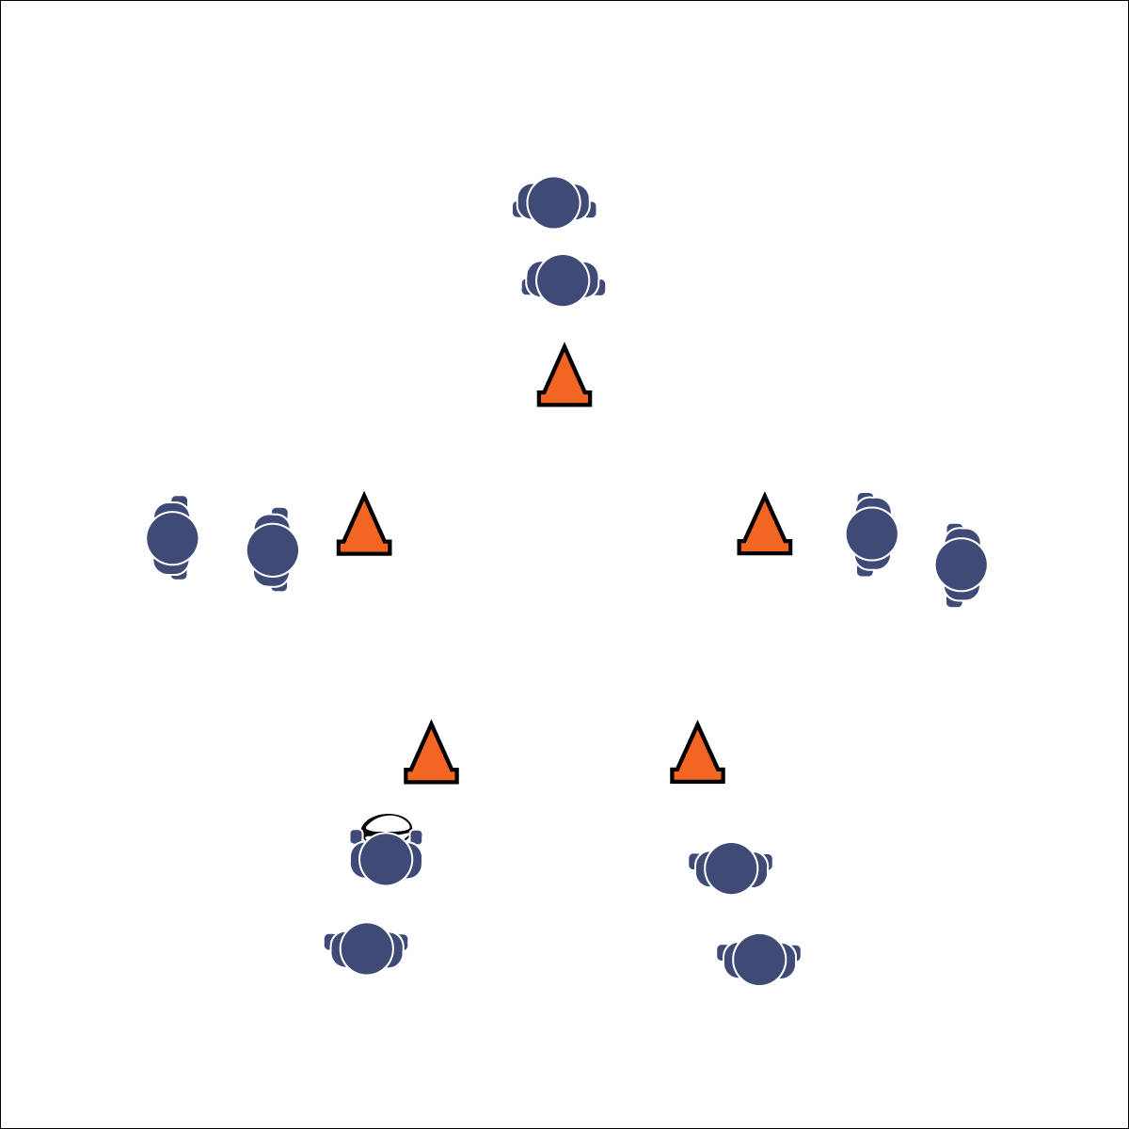

**Equipment:**

* 1 rugby ball per group of 10 students
* 5 cones/floor markers per group

**Set-Up:**

1. Create a large activity grid with 1 square per group of 10 students.
2. In each grid square, set up 5 cones in the shape of a star as well as 1 ball. Designate the cone closest to the front of the room as the “top” point of the star.
3. Organize students in groups of at least 10 with 2 students behind each of their star’s 5 cones.

* Review Pop Pass Cues
* Lead Pass to Where Receiver is Going to Be – Not Where They Are
* **Skill:** I will follow cues for a leading pop pass to make accurate passes to my teammates.
* **Cognitive:** I will follow the proper movement pattern for star passing.
* **Fitness:** I will engage in an effort to build my fitness.
* **Personal & Social Responsibility:** I will communicate with my teammates in an effort to cooperate, problem-solve, and strive for successful performance.

**STAR PASSING DRILL**

**Activity Procedures:**

1. Today’s activity is called Star Passing. The object of the activity is to execute a pop pass while moving in a star pattern.
2. Start the activity with the first player at the bottom left point of the star holding the ball. S/he will run and pop pass to the player at the top point of the star and then go to the end of the top point’s line.
3. The receiving player will then run and pop pass the ball to the player at the bottom right point of the star and then go to the end of that point’s line.
4. The receiving player will then run and pop pass to the player at the diagonal left point of the star and then go to the end of that point’s line.
5. The receiving player will then run and pop pass to the player at the diagonal right point of the star and then go to the end of that point’s line.
6. Finally, that receiving player will run and pop pass to the player at the bottom left point of the star (the line where the ball started) and then go to the end of that point’s line.
7. Repeat this star pattern until you hear the stop signal.

**Grade Level Progression:**

**6:** Focus on proper passing technique and accuracy.

**7:** Expand the distance between star points. Passer and receiver both move (pass to a moving receiver).

**8:** Challenge students to make as many accurate leading passes as possible in a set amount of time.



* Slow the pace of the activity.
* Use Velcro gloves and/or a variety of balls of various shapes and construction.
* Group students who work well together.



**Help students process content:** The Star Passing Drill is another cooperative learning opportunity that can be easily missed for the sake of staying on schedule and increasing activity time. Processing is an essential ingredient to learning. Take the time to allow students to discuss the above debrief questions, explore their collective experience, and process concepts that transfer across a variety of sport possibilities.



* **DOK 1:** What is a pattern?
* **DOK 2:** What do you know about patterns in sports? Provide examples.
* **DOK 3:** What facts would you select to support the importance of patterns in sports? Can you elaborate on why you chose those facts?



* **Standard 1 [M5.6-8]** Throws, while stationary, a leading pass to a moving receiver (6); Throws, while moving, a leading pass to a moving receiver (7); Throws a lead pass to a moving partner off a dribble or pass (8).
* **Standard 4 [M5.6-8]** Cooperates with a small group of classmates during adventure activities, game play, or team-building activities (6); Problem-solves with a small group of classmates during adventure activities, small-group initiatives, or game play (7); Cooperates with multiple classmates on problem-solving initiatives including adventure activities, large-group initiatives, and game play (8).



Cooperation, Fitness, Leading Pass, Pattern, Pop Pass

**STAR PASSING DRILL**