­­

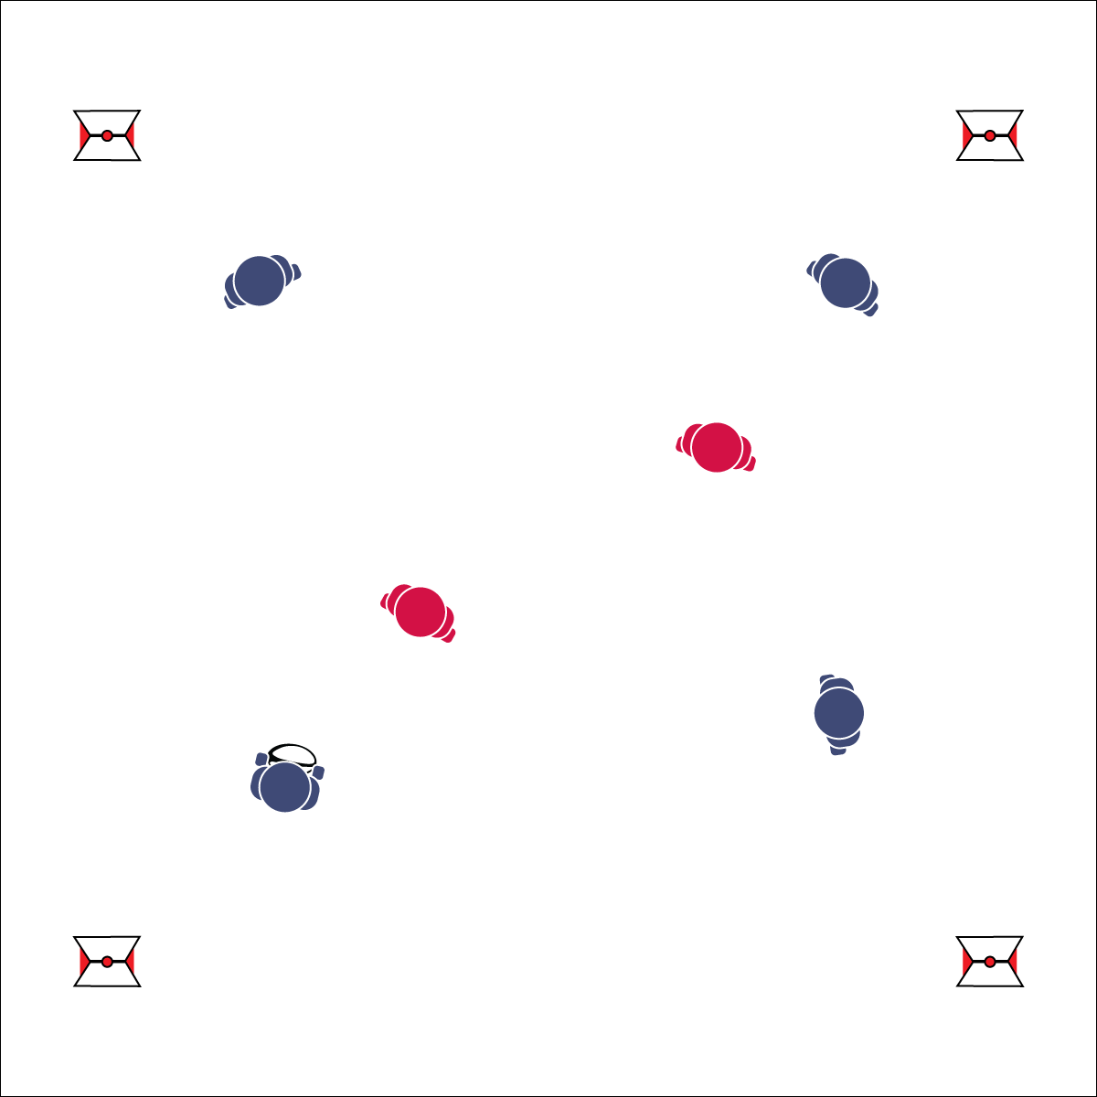

**Activity Procedures:**

1. Activity Today’s activity is called Monkey in the Middle. The object of the activity is for:
   1. Offensive players to maintain possession of the ball.
   2. Defensive players to gain possession of the ball.
2. Within the groups, allow students to decide which 4 players will start on offense and which 2 players will start on defense (or pre-determine this for your students).
3. On the signal, offensive players will try to complete passes to their teammates while defensive players try to intercept the passes. Offensive players with possession of the ball can pivot and jab, but they cannot take any steps.
4. If/when a pass is intercepted, the player who threw it becomes a defender and the intercepting player goes to offense (or keep offense and defense for a set time, then rotate positions).
5. *Teachers, you may want to include a 3 second stationary possession rule.*
6. Continue playing until you hear the stop signal.

**Grade Level Progression:**

**6:** Implement the activity as described above.

**7:** Allow players with possession of the ball to take 3 steps before passing.

**8:** Add an additional defender to create a 4 v 3 game.

**MONKEY IN THE MIDDLE**

* **Skill:** I will execute pivots, fakes, and jab steps in an effort to create open space.
* **Cognitive:** I will anticipate passing and movement and work to close space to deny passes.
* **Fitness:** I will engage in the activity and increase my heart rate.
* **Personal & Social Responsibility:** I will demonstrate respect for my opponents and honor the Spirit of   
  the Game.
* Pivot Foot Stays Planted, Rotate on Ball of Foot
* Head Fake with Quick Move with Head and Shoulder in One Direction, Then Cut Away
* Jab Step with Hard/Short Step to The Front

**Equipment:**

* 1 rugby ball per group of 6 students
* Optional: 1 flag belt per student

**Set-Up:**

1. Create a large activity grid with 1 square per group of 6 students.
2. Students in groups of 6 (4 v 2), with 1 group in each square.

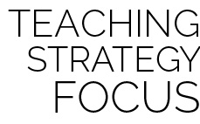

**Help students elaborate on content:** Monkey in the Middle is a classic game that can be used to illustrate the importance of offensive and defensive movement, or it can be a frustrating mess for students just developing skills and knowledge. Teach in chunks. Start the activity and then pause after a few minutes to discuss the first question above. Allow students to process what denying a pass means and how it can be applied in the next round of play. Restart the game and continue for several minutes before pausing and covering the next debrief question. Prompt students to elaborate on their responses by providing details from game play that just occurred. Turn and Talk is a great way to help students generate the details needed for this type of elaboration.



* **DOK 1:** What does denying a pass mean?
* **DOK 2:** How do open and closed spaces apply to defensive denial?
* **DOK 3:** How would you change defensive positioning to reduce open space for your opponent? Can you describe positioning when the ball is close to your defender? How is that different from when the ball is far away from your defender?



* **Standard 1 [M6.6-8]** Performs pivots, fakes, and jab steps designed to create open space during practice tasks (6); Executes at least one of the following designed to create open space during small-sided game play: pivots, fakes, jab steps (7); Executes at least two of the following to create open space during modified game play: pivots, fakes, jab steps, screens (8).
* **Standard 2 [M5.6-8]** Reduces open space by not allowing the catch (denial) or by allowing the catch but not the return pass (6); Reduces open space by not allowing the catch (denial) or anticipating the speed of the object or person for the purpose of interception or deflection (7); Reduces open space by not allowing the catch (denial) and anticipating the speed of the object or person for the purpose of interception or deflection (8).
* **Standard 5 [M6.6-8]** Demonstrates respect for self and others in activities and games by following the rules, encouraging others, and playing within the spirit of the game or activity (6); Demonstrates the importance of social interaction by helping and encouraging others, avoiding trash talk, and providing support to classmates (7); Demonstrates respect for self by asking for help and helping others in various physical activities (8).



Anticipate, Deny, Fake, Jab Step, Open Space, Pivot, Reduce Open Space, Respect, Spirit of the Game

**MONKEY IN THE MIDDLE**



* Change roles often.
* Adjust the number of students on offense/defense.
* Slow the pace of the activity.
* Use Velcro gloves and/or a variety of balls of various shapes and construction.
* Group students who work well together.