­­

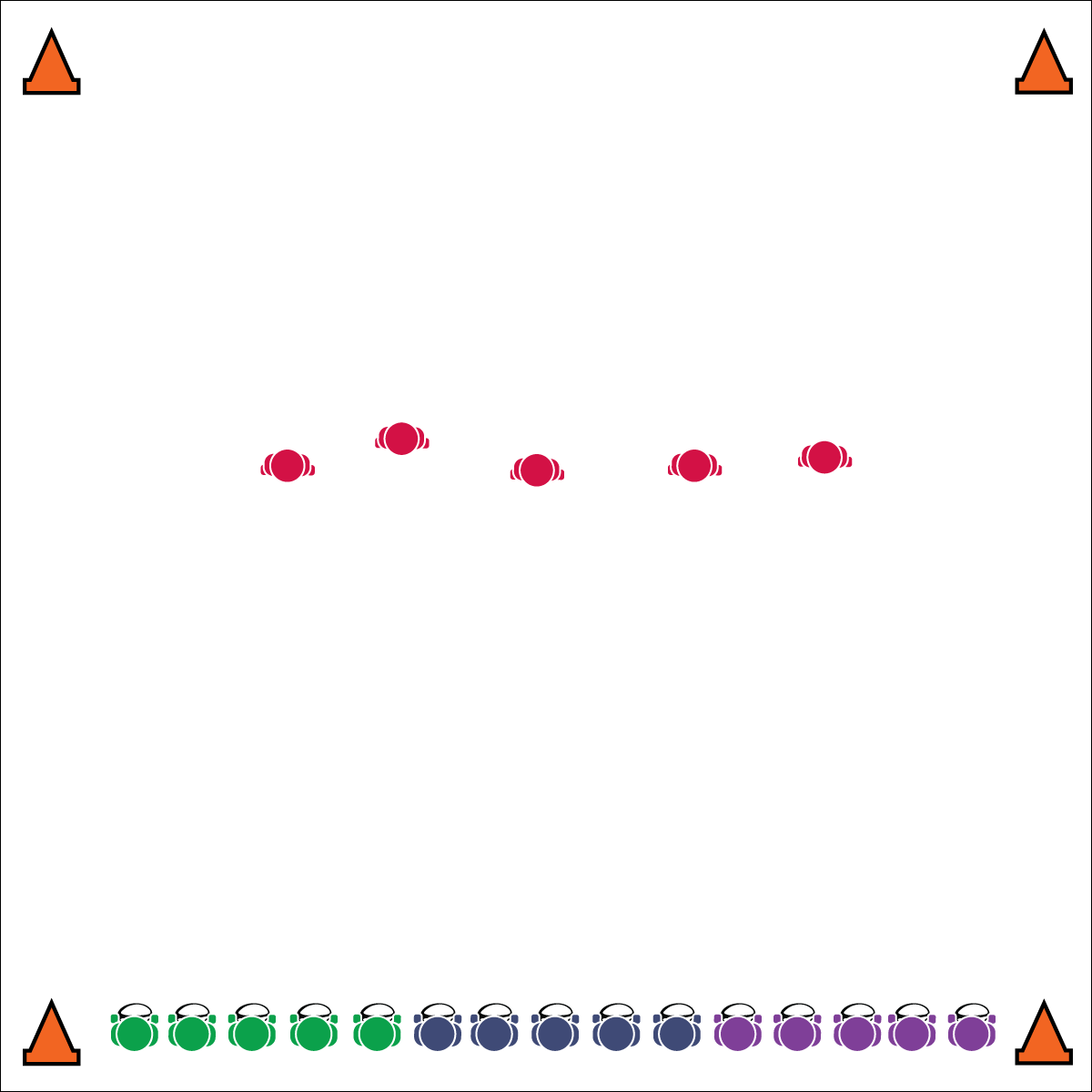

**SHARKS & MINNOWS**

**Equipment:**

* 1 flag belt per student
* 1 rugby ball or football for all but 5 students (the “Taggers”)
* 4 cones to mark the playing area

**Set-Up:**

1. Create a large activity area (approx. 30x30 ft.) with 1 cone in each corner.
2. Give each student a flag (color does not matter).
3. Organize students in teams of 4 or 5, each team assigned a number.
4. 1 team starts in the middle of the playing field (without balls) as the Taggers.
5. All other students line up shoulder-to-shoulder on 1 end line, each non-tagging student with a ball.

* Head on a Swivel, Eyes Alert and Active
* Move to Open Space
* Be Ready to Change Direction
* **Skill:** I will move safely from one end to the other, watching out for other players and moving in open space.
* **Cognitive:** I will discuss strategies for finding/creating open space on offense and closing space on defense.
* **Fitness:** I will engage and increase my heart rate.
* **Personal & Social Responsibility:** I will avoid negative language and provide support to my classmates.

**Activity Procedures:**

1. Today’s activity is called Sharks and Minnows.
2. The object of the activity is for ball carriers to practice running with the ball, moving to open space, and making it across the playing field without having their flag pulled by a Tagger.
3. To start the activity, I will call out an “if command” (e.g., “if you were born in January or February–GO!”).
4. If the “if command” applies to you, try to run across the field without having your flag pulled by a Tagger.
5. If your flag gets pulled, retrieve it and continue on to the other end line.
6. Next, the teacher calls another “if command” and all players the command applies to will make an attempt to cross. This continues until all students have run from the initial end line. At that point, a new team comes to the middle to be Taggers. Repeat until all teams have had a chance to tag.

**Grade Level Progression:**

**6:** Implement the activity as described above.

**7:** Add another team of Taggers to the middle of the playing field.

**8:** Each team of “minnows” has 1 ball. Taggers (“sharks”) attempt to pull the ball carriers’ belts. Teams may use proper passing to avoid being tagged. If a pass is dropped, receiving player is automatically tagged.



Avoid, Defense, Offense, Strategy, Safe, Support



* **Standard 1 [M6.6-8]** Performs pivots, fakes, and jab steps designed to create open space during practice tasks (6); Executes at least one of the following designed to create open space during small-sided game play: pivots, fakes, jab steps (7); Executes at least two of the following to create open space during modified game play: pivots, fakes, jab steps, screens (8).
* **Standard 2 [M5.6-8]** Reduces open space by not allowing the catch (denial) or by allowing the catch but not the return pass (6); Reduces open space by not allowing the catch (denial) or anticipating the speed of the object or person for the purpose of interception or deflection (7); Reduces open space by not allowing the catch (denial) and anticipating the speed of the object or person for the purpose of interception or deflection (8).
* **Standard 5 [M6.6-8]** Demonstrates respect for self and others in activities and games by following the rules, encouraging others, and playing within the spirit of the game or activity (6); Demonstrates the importance of social interaction by helping and encouraging others, avoiding trash talk, and providing support to classmates (7); Demonstrates respect for self by asking for help and helping others in various physical activities (8).



* **DOK 1:** What would you include on a list about open space as it related to rugby? What would you include on a list about closed space?
* **DOK 2:** Can you compare and contrast open space with closed space?
* **DOK 3:** What defensive strategy can be applied to our game of Sharks & Minnows to help the defenders close space for the minnows?
* **DOK 3:** What skill-related fitness components are related to a defender’s ability to close space?

**SHARKS & MINNOWS**



* Allow students to use pool noodles for tagging.
* Set up mats in areas where students may fall.
* Slow the pace of the game.



**Manage response rate with tiered questioning:** At this point in the module you’ve already used tiered questioning debrief strategies. However, it’s important to reflect on how your technique is benefiting all students. Are all students getting an opportunity to respond? This is impossible in a single meeting unless you use Turn and Talk sessions and monitor each group to be sure everyone is participating. Even then, the likelihood of 100% participation is slim, so mix the “cold call” technique into your sessions. Make a mental note of students who typically don’t participate and then call on them without asking for volunteers. Try to do this at a time when they’re likely to have a response, and praise their responses while encouraging them to elaborate with details.