­­

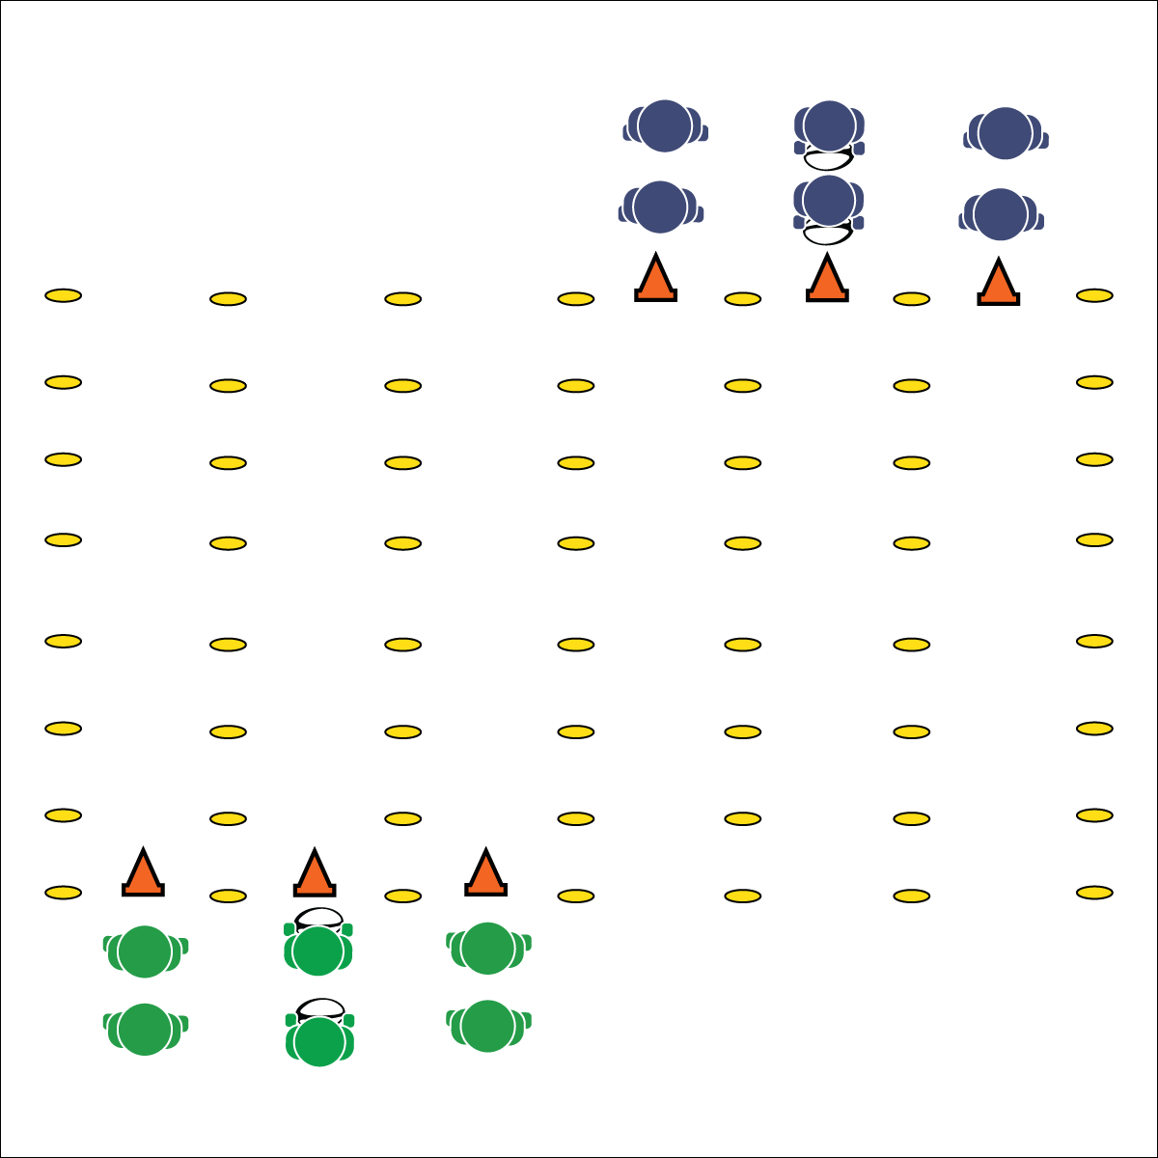

**GAUNTLET**

**Activity Procedures:**

1. Today’s activity is called Gauntlet. The object is to practice passing and receiving on the move.
2. On the start signal, the groups at the starting line will begin to jog down their lanes.
3. The middle player will start by passing the ball to the player on her/his right using a pendulum pass or a pop pass. That player passes back to the middle player.
4. The middle player then passes to the player on her/his left, who then passes back to the middle player.
5. This passing/receiving pattern continues all the way down to the opposite end line. When a group reaches the end line, they move to the end of the opposite starting line (students from the 1st, 2nd, and 3rd lanes move to the end of the lines in the 4th, 5th, and 6th lanes and vice-versa). Students switch positions so a new player is in the middle line and follow the same passing pattern.
6. Keep lines moving by starting as soon as the group in front of you reaches the center of the activity area. Stop when you hear the signal.

**Grade Level Progression:**

**6:** Implement the activity as described above.

**7 & 8:** Implement a 3-person weave formation. Players pass and then follow their pass with a cut behind the receiver. This pattern continues down the length of the activity area.

* **Skill:** I will perform accurate passes with a focus on proper form to a moving receiver.
* **Cognitive:** I will discuss how teamwork can improve performance.
* **Fitness:** I will engage in an effort to improve my fitness.
* **Personal & Social Responsibility:** I will display teamwork and focus my effort on group success.
* Review All Passing Cues
* Work Hard with a Focus on Form

**Equipment:**

* 1 rugby ball per group of 3 students
* 6 cones
* 12 to 24 low profile cones

**Set-Up:**

1. Create a rectangular activity area (30’X60’).
2. Use low profile cones to divide the rectangle into 6 lanes (length-wise).
3. Place 3 cones at one end of the 1st, 2nd, and 3rd lanes to create a starting line. Place the other 3 cones at the opposite end of the 4th, 5th, and 6th lanes to create a starting line at the opposite end.
4. Students all line up behind the cones at every lane to create groups of 3 (the students who are first in line in the 1st, 2nd, and 3rd lanes are a group; the students who are first in line in the 4th, 5th, and 6th lanes are a group; etc.).
5. Each group has a ball. The ball starts in the center lanes (lanes 2 and 5).



* Slow the pace of the activity.
* Use Velcro gloves and/or a variety of balls of various shapes and construction.
* Group students who work well together.



Ball Movement, Cut, Effort, Leading Pass, Teamwork



* **Standard** **1 [M4.6]** Passes and receives with hands in combination with locomotor patterns of running and change of direction & speed with competency in invasion games such as basketball, flag football, speedball, or team handball (6).
* **Standard 1 [M5.6-8]** Throws, while stationary, a leading pass to a moving receiver (6); Throws, while moving, a leading pass to a moving receiver (7); Throws a lead pass to a moving partner off a dribble or pass (8).
* **Standard 4 [M5.6-8]** Cooperates with a small group of classmates during adventure activities, game play, or team-building activities (6); Problem-solves with a small group of classmates during adventure activities, small-group initiatives, or game play (7); Cooperates with multiple classmates on problem-solving initiatives including adventure activities, large-group initiatives, and game play (8).



* **DOK 1:** What would you include on a list about teamwork?
* **DOK 2:** How does teamwork affect your team’s ability to move quickly down the gauntlet?
* **DOK 3:** What behaviors contribute to teamwork? What behaviors weaken teamwork?
* **DOK 4**: What experiences did you have today that can be used as evidence to support your ideas about teamwork? Elaborate on each experience.

**GAUNTLET**



**Help students record and represent knowledge:** Use the debrief questions above as an opportunity to collect a quick writing sample. Transfer each question onto a worksheet or exit slip, or post them where all can see. Then prompt students to take 5 minutes to answer each question in writing. This strategy will offer a break from your normal debrief routine, allow students to create their own representation of what they’re learning, and provide an artifact of student work that illustrates an important affective concept (teamwork) that is essential to 21st century learning.