­­

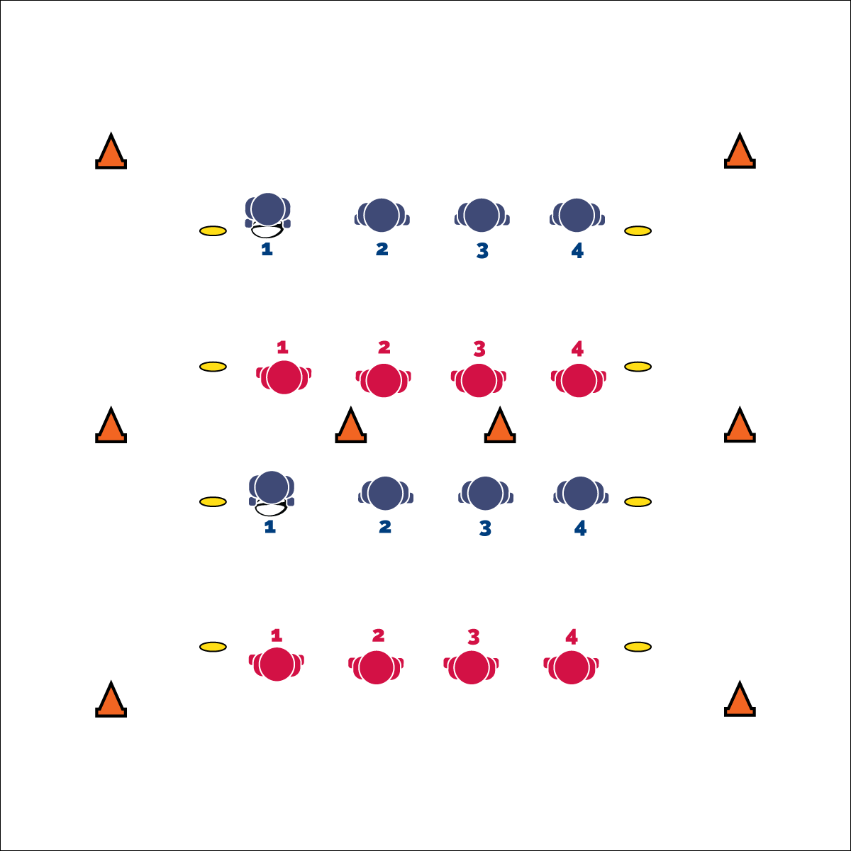

* **Skill:** I will change direction and speed in an effort to avoid having my flag pulled.
* **Cognitive:** I will identify strategies for closing space on defense.
* **Fitness:** I will identify skill-related fitness components important to successful participation in this activity.
* **Personal & Social Responsibility:** I will focus on safety and fair play.

**Activity Procedures:**

1. Today’s activity is called Partner Score. The object of the activity is for:
   1. offensive players to score by running the ball across either end line.
   2. defensive players to keep their opponent from scoring by pulling her/his flag.
2. You all have numbers. It’s important for you to know who has the same number as you on the opposite team. We have 2 games playing at the same time, using the same start and stop signals.
3. On the signal, player #1 on one team will start with the ball and pass it to player #1 in the opposite team. That player then passes the ball across to player #2 on the first team. Continue in this way until you hear a whistle. If the ball reaches the end of the line, it continues back down the line in reverse order.
4. On the whistle, the player with the ball (the offensive player) runs into the center alley between the two teams, and the player with the matching number (the defensive player) also runs in to the alley.
5. The offensive player tries to score by crossing the farthest end line. The defensive player tries to pull her/his flag before s/he can score.
6. Reset by bringing the ball back to the line. On the signal, continue passing until another whistle blows.

**Grade Level Progression:**

**6:** Implement the activity as described above.

**7 & 8:** Allow offensive players to make 1 pass to any sideline player in order to avoid a flag pull. The pass must be return successfully within 3 seconds. If a pass is dropped the play is over.

**Equipment:**

* 2 rugby balls
* 1 flag belt per student (color does not matter)
* 8 cones
* 8 low profile cones

**Set-Up:**

1. Use cones to create a rectangular activity area (approx. 40x60 ft.) and divide it in half down its length, creating 2 separate narrow activity areas.
2. Use low profile cones to create 2 parallel lines in each area, approximately 15 feet apart.
3. Divide students into 4 equal teams, every student with a flag belt. Each team lines up on a separate line (created by low profile cones).
4. Give every student a number (each line starts with the number 1) so that students on opposite teams have the same number as the player across from them. The ball begins with player #1.

**PARTNER SCORE**

* Head Fake, Move to Open Space
* Watch Offensive’s Belly Button, Close Angles to End Zone



* **Standard 1 [M4.6]** Passes and receives with hands in combination with locomotor patterns of running and change of direction & speed with competency in invasion games such as basketball, flag football, speedball, or team handball (6).
* **Standard 2 [M2.6-8]** Creates open space by using locomotor movements (e.g., walking, running, jumping & landing) in combination with movement (e.g., varying pathways; change of speed, direction, or pace) (6); Reduces open space by using locomotor movements (e.g., walking, running, jumping & landing, changing size and shape of the body) in combination with movement concepts (e.g., reducing the angle in the space, reducing distance between player and goal) (7); Opens and closes space during small-sided game play by combining locomotor movements with movement concepts (8).



* **DOK 1:** What are the components of skill-related fitness?
* **DOK 2:** How would you apply [*name component*] in the activity Partner Score?
* **DOK 3:** Choose a component of skill-related fitness. Can you formulate a theory of importance for this component of skill-related fitness as it relates to performance in partner score? How would you test this theory?



**Review content:** Returning to the components of skill- and health-related fitness within the context of each instructional content area will highlight the importance of these concepts and will frame them within the “big picture” of the physical education curriculum.

**PARTNER SCORE**



* Increase/decrease the size of the activity area.
* Use mats as boundaries.
* Designate/predetermine offense and defense.
* Use an auditory cue behind goal areas.



Angle, Direction, Close Space, Fair Play, Open Space, Speed