­­

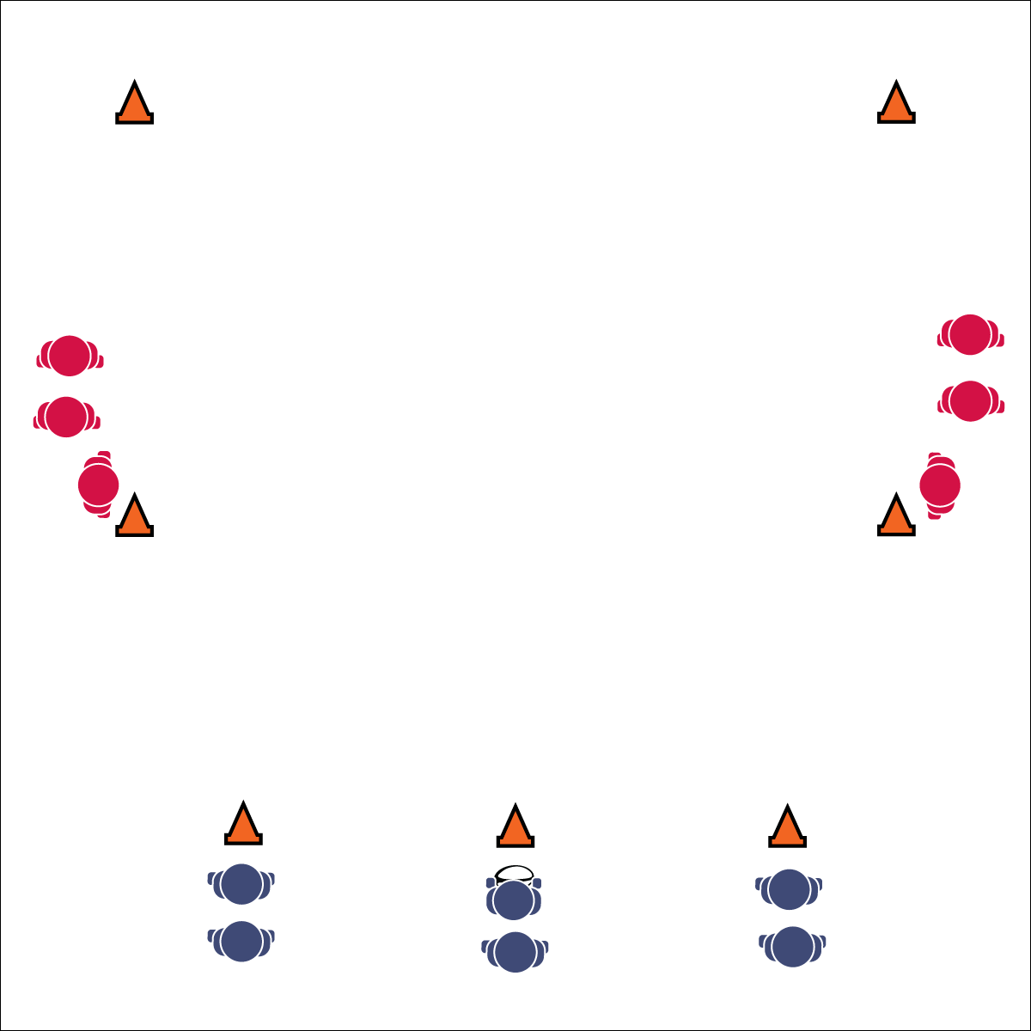

**LEARNING LANES**

* **Skill:** I will maintain defensive ready position with my eyes on the midsection (belly button) of the offense.
* **Cognitive:** I will spread the defense with proper spacing on offense.
* **Fitness:** I will engage in an effort to improve my fitness.
* **Personal & Social Responsibility:** I will participate with a focus on safety and fair play.
* Defensive Ready Position: Weight on Balls of Feet, Arms Extended, Palms Up, Eyes on Midsection of Offensive Player
* Spread the Defense: Move to Space, Not to the Ball

**Equipment:**

* 7 cones per area
* 1 rugby ball
* 1 flag belt per player

**Set-Up:**

1. Use cones to create rectangular activity areas (approx. 30x50 ft.). Increase student activity by creating 2 identical activity set-ups side-by-side.
2. Divide the playing area into 3 lanes (length-wise). Put 1 cone at the starting end line to designate each lane. This is where offensive players start (3 at a time). Put 1 cone on each sideline at midfield. This is where defensive players start (2 at a time). Put 2 cone on the sides of the opposite end line to identify the “end zone.”
3. Divide class in half (½ offense, ½ defense).
4. Students line up evenly behind cones.
5. Students stay in offense or defense lines until the teacher switches student roles.

**Activity Procedures:**

1. Today’s activity is called Learning Lanes. The object of the activity is for:
   1. Offensive players to work together to move into the end zone.
   2. Defensive teams to work together to prevent the offense from scoring.
2. To start, an offensive player hands the ball off to a teammate and all 3 players start advancing up the field. As soon as the hand-off is made, 2 defenders can enter the field from their cones.
3. Next, the offense applies offensive moves, passes, and strategies in an attempt to score. A turnover occurs when a ball is dropped or a flag is pulled. Then, the ball goes back to the offense at that spot and play resumes. Offense gets 3 turnovers per round.
4. Offense gets 1 point if they score a try. Defense gets 1 point if they prevent a score.
5. After 3 turnovers or a try is scored, players reset and new players begin with a hand-off.

**Grade Level Progression:**

**6:** Implement the activity as described above.

**7 & 8:** Decrease the allowed turnovers until offense has only 1 chance to score a try.



* **Standard 1[M6.6-8]** Performs pivots, fakes, and jab steps designed to create open space during practice tasks (6); Executes at least one of the following designed to create open space during small-sided game play: pivots, fakes, jab steps (7); Executes at least two of the following to create open space during modified game play: pivots, fakes, jab steps, screens (8).
* **Standard 1 [M11.6-8]** Maintains defensive ready position, with weight on balls of feet, arms extended and eyes on midsection of the offensive player (6); Slides in all directions while on defense without crossing feet (7); Drop-steps in the direction of the pass during player-to-player defense (8).
* **Standard 2 [M3.6-8]** Creates open space by using the width and length of the field/court on offense (6); Creates open space by staying spread on offense, and cutting and passing quickly (7); Creates open space by staying spread on offense, cutting and passing quickly, and using fakes off the ball (8).



* **DOK 1:** How would you describe defensive ready position?
* **DOK 2:** How are the eyes and focus related to defensive ready position?
* **DOK 3:** How is offensive spacing related to defensive ready position?
* **DOK 4:** Create a choreographed performance of how the defense would adjust to offensive ball movement.



**Help students engage in cognitively complex tasks:** There is a lot happening in this Learning Lanes activity. Students on defense are focused on positioning, proper locomotor technique, as well as movement on the floor. Students on offense are applying the passing, catching, and grip skills learned while trying to process and demonstrate proper floor spacing. This is all in addition to learning and following the flow and organization of the activity. PERFECT! Be patient. This type of complexity is necessary practice for the dynamic complexity of successful rugby participation.

**LEARNING LANES**



* Increase or decrease the size of the activity area to meet needs of all students.
* Allow defense to tag with pool noodles.
* Slow the pace of the activity.
* Use auditory cues in end zones.
* Allow students to choose the style of ball used.
* Set up mats in areas where students may fall.



Defensive Ready Position, Drop Step, Score a Try, Slide, Spread the Defense