­­

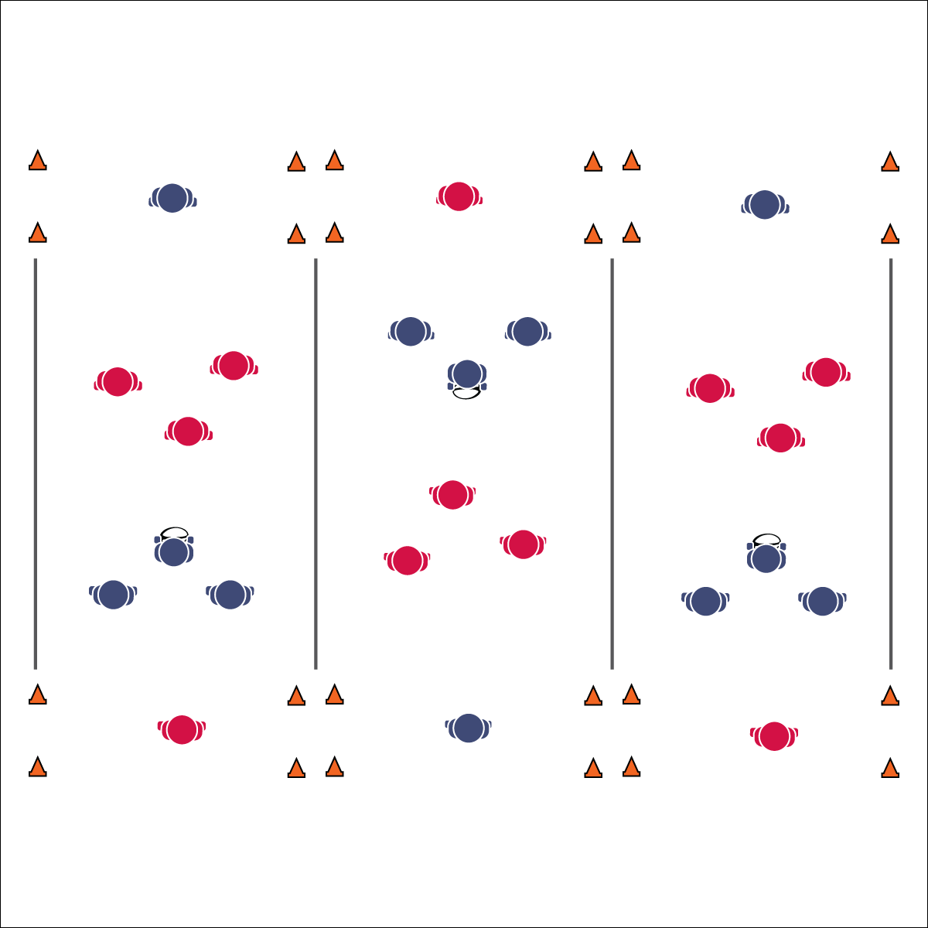

**Activity Procedures:**

1. Today’s activity is called Ultimate End Ball. The object of the activity is for:
   1. Offensive players to implement offensive skills, strategies, and teamwork to score.
   2. Defensive players to implement defensive skills, strategies, and teamwork to prevent scoring.
2. One player from each team is chosen/assigned as the “catcher.” The catcher from each team goes to his assigned end zone and her/his teammates scatter on the opposite half of the area. The catcher can move around freely in the end zone but must stay within the sidelines of the activity area.
3. Next, teams play rock, paper, scissors to determine possession. The winning team starts with the ball. They can move in any direction but cannot move more than 3 steps while holding the ball. Passes can be made in any direction. Teams must make at least 3 passes before scoring.
4. Score by completing a rugby pass (pendulum or pop) across the end line to your team’s catcher.
5. If offense drops the ball, completes a non-rugby pass (i.e., a “football pass” or a “baseball throw”), drops a pass, or throws it out of bounds, possession changes on the spot. If defense intercepts a pass or pulls the ball carrier’s flag, possession changes on the spot.
6. After 4 minutes, rotate teams based on a round robin bracket schedule.

**Grade Level Progression:**

**6:** Implement the activity as described above.

**7 & 8:** Play “invasion” style by removing the catcher and allowing teams to run and/or pass the ball to teammates in the end zone.

**Equipment:**

* 1 flag belt per student (belts being a different color for each of the 6 teams)
* 1 rugby ball per activity area
* 8 cones per activity area
* Round robin tournament bracket

**Set-Up:**

1. Create a minimum of 3 activity areas (20’x30’).
2. Set up cones to mark the corners of each field, as well as the corners of the end zones.
3. Divide students into 6 even teams; assign each team a number. 2 teams to each activity area.
4. Schedule games using a 6-team round robin bracket.
5. All students on a team need the same color flag.

* Review Skill Cues and Strategies
* **Skill:** I will use both offensive and defensive strategy during game play.
* **Cognitive:** I will identify and discuss how both health- and skill-related fitness are related to successful rugby performance.
* **Fitness:** I will engage in an effort to improve my fitness.
* **Personal & Social Responsibility:** I will honor the Spirit of the Game and self-officiate game play.

**ULTIMATE END BALL**



* **Standard 2 [M1.6-8]** Creates open space by using locomotor movements (e.g., walking, running, jumping & landing) in combination with movement (e.g., varying pathways; change of speed, direction, or pace) (6); Reduces open space by using locomotor movements (e.g., walking, running, jumping & landing, changing size and shape of the body) in combination with movement concepts (e.g., reducing the angle in the space, reducing distance between player and goal) (7); Opens and closes space during small-sided game play by combining locomotor movements with movement concepts (8).
* **Standard 2 [M4.6-8]** Reduces open space on defense by making the body larger and reducing passing angles (6); Reduces open space on defense by staying close to the opponent as he/she nears the goal (7); Reduces open space on defense by staying on the goal side of the offensive player and reducing the distance to him/her (third-party perspective) (8).
* **Standard 3 [M7.6-8]** Identifies the components of skill-related fitness (6); Distinguishes between health-related and skill-related fitness (7); Compares and contrasts health-related fitness components (8).



* Everyone must touch the ball before a score.
* Increase or decrease the size of the activity area to meet needs of all students.
* Allow defense to tag with pool noodles.
* Slow the pace of the activity.
* Use auditory cues in end zones.
* Allow students to choose the style of ball used.
* Use brightly colored area markers.
* Do not keep score.

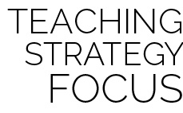

**Help students examine their reasoning:** It is often difficult for students to reflect on their own performance and personal areas in need of improvement. Use Growth Mindset language in an effort to help students examine their reasoning in a positive, yet meaningful way. Many times students will shy away from recognizing deficiencies and defend their insecurities with logic that does not match reality. Be gentle but consistent while you help them explore the need for further skill development.

**ULTIMATE END BALL**



* **DOK 1:** What would you include on a list about health-related fitness? About skill-related fitness?
* **DOK 2:** How would you summarize how health-related fitness affects rugby performance? How skill-related fitness affects performance?
* **DOK 3:** What facts would you select to support developing health- (or skill-) related fitness? Can you elaborate on why you chose those facts?
* **DOK 4:** Identify areas of health- and skill-related fitness in which you can improve and design a plan for personal improvement.



Health-Related Fitness, Passing Lane, Possession, Self-Officiate, Spirit of the Game, Skill-Related Fitness, Strategy, Teamwork