­­

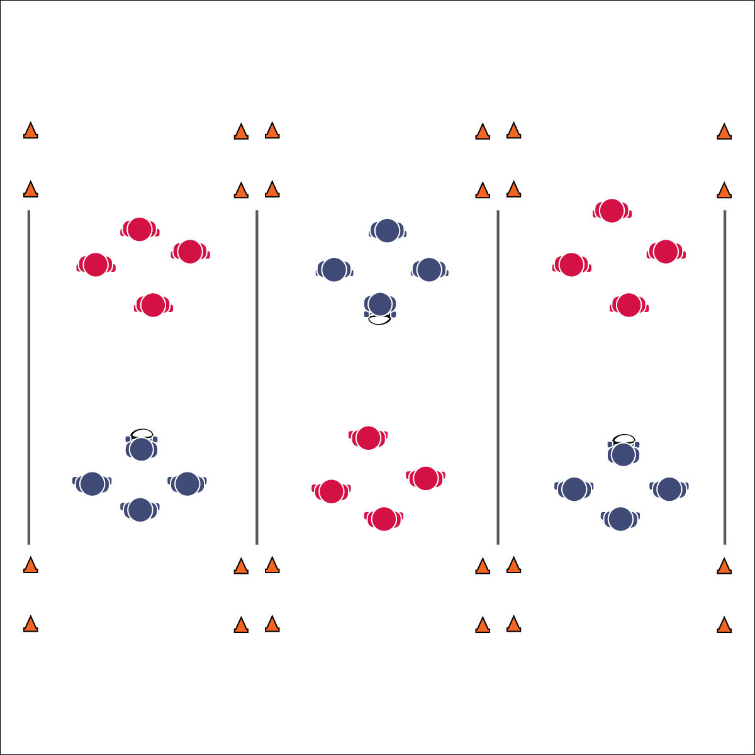

**Equipment:**

* 1 flag belts per student (belts being a different color for each of the 6 teams)
* 1 rugby ball per activity area
* 8 cones per activity area
* Round robin tournament bracket

**Set-Up:**

1. Create a minimum of 3 activity areas, each 20’x30’.
2. Set up cones to mark the corners of each field, as well as the corners of the end zones.
3. Divide students into 6 evenly sized teams; assign each team a number.
4. Schedule games using a 6-team round robin bracket.
5. All players on a team need the same color flag.

* Review Skill Cues and Strategies
* **Skill:** I will combine skills and strategies learned in all previous ruby lessons in order to successfully participate in Flag Rugby.
* **Cognitive:** I will identify and discuss transitions from offense to defense.
* **Fitness:** I will engage in an effort to improve my fitness.
* **Personal & Social Responsibility:** I will honor the Spirit of the Game and self-officiate game play.

**FLAG RUGBY**

**Activity Procedures:**

1. It’s time to play Flag Rugby. The object of the activity is for:
   1. Offensive players to implement offensive skills, strategies, and teamwork to score.
   2. Defensive players to implement defensive skills, strategies, and teamwork to prevent scoring.
2. Play rock, paper, scissors to determine possession.
3. Offense combines offensive skills and strategies in an attempt to score by passing or running the ball across their end line. To score a point, the ball carrier must execute a correct try after crossing the defending team’s end line (down on one knee, both hands touch the ball to the ground).
4. If the offense drops the ball, completes a non-rugby pass (i.e., a “football pass” or a “baseball throw”), drops a pass, or throws it out of bounds, it is considered a lost attempt to score. If defense pulls the ball carrier’s flag it is a lost attempt to score.
5. Offense has 4 attempts to score, and then possession changes. However, if defense intercepts a pass, play does not stop. The defense can run the ball back to score a point (no passing). If the defense fails, possession goes back to the offense to continue their series of tries.
6. After 7 minutes, rotate teams based on the round robin bracket schedule.

**Grade Level Progression:**

**6-8:** Implement the activity as described above.

**FLAG RUGBY**



Select academic language vocabulary to review from previous lessons.



* **Standard 1[M6.6-8]** Performs pivots, fakes, and jab steps designed to create open space during practice tasks (6); Executes at least one of the following designed to create open space during small-sided game play: pivots, fakes, jab steps (7); Executes at least two of the following to create open space during modified game play: pivots, fakes, jab steps, screens (8).
* **Standard 1 [M11.6-8]** Maintains defensive ready position, with weight on balls of feet, arms extended and eyes on midsection of the offensive player (6); Slides in all directions while on defense without crossing feet (7); Drop-steps in the direction of the pass during player-to-player defense (8).
* **Standard 2 [M3.6-8]** Creates open space by using the width and length of the field/court on offense (6); Creates open space by staying spread on offense, and cutting and passing quickly (7); Creates open space by staying spread on offense, cutting and passing quickly, and using fakes off the ball (8).
* **Standard 2 [M6.6-8]** Transitions from offense to defense or defense to offense by recovering quickly (6); Transitions from offense to defense or defense to offense by recovering quickly and communicating with teammates (7); Transitions from offense to defense or defense to offense by recovering quickly, communicating with teammates and capitalizing on an advantage (8).



* **DOK 1:** What does transition mean in relation to offense and defense?
* **DOK 2:** How does this apply to game play in Flag Rugby?
* **DOK 3:** How would you apply all that you’ve learned in Flag Rugby activities to effectively transition from offense to defense (or defense to offense)?



**Help students practice skills, strategies, and processes:** Dynamic game play is an essential component of the learning process in physical education. However, too often PE teachers assume students will learn through this experience with little or no further instruction. This assumption is false and dangerous. It can lead to a buildup of student frustration and ultimately a negative sport experience. It is the teacher’s responsibility to find individual and group teachable moments and then capitalize on those opportunities. Stop a game, take time to discuss what’s happening, and help students connect the dots from previous lessons. At the end of each game, bring students together to discuss and process what you observed and what they experienced.



* Everyone must touch the ball before a score.
* Increase or decrease the size of the activity area to meet needs of all students.
* Allow defense to tag with pool noodles.
* Slow the pace of the activity.
* Use auditory cues in end zones.
* Allow students to choose the style of ball used.
* Use brightly colored area markers.
* Do not keep score.