­­

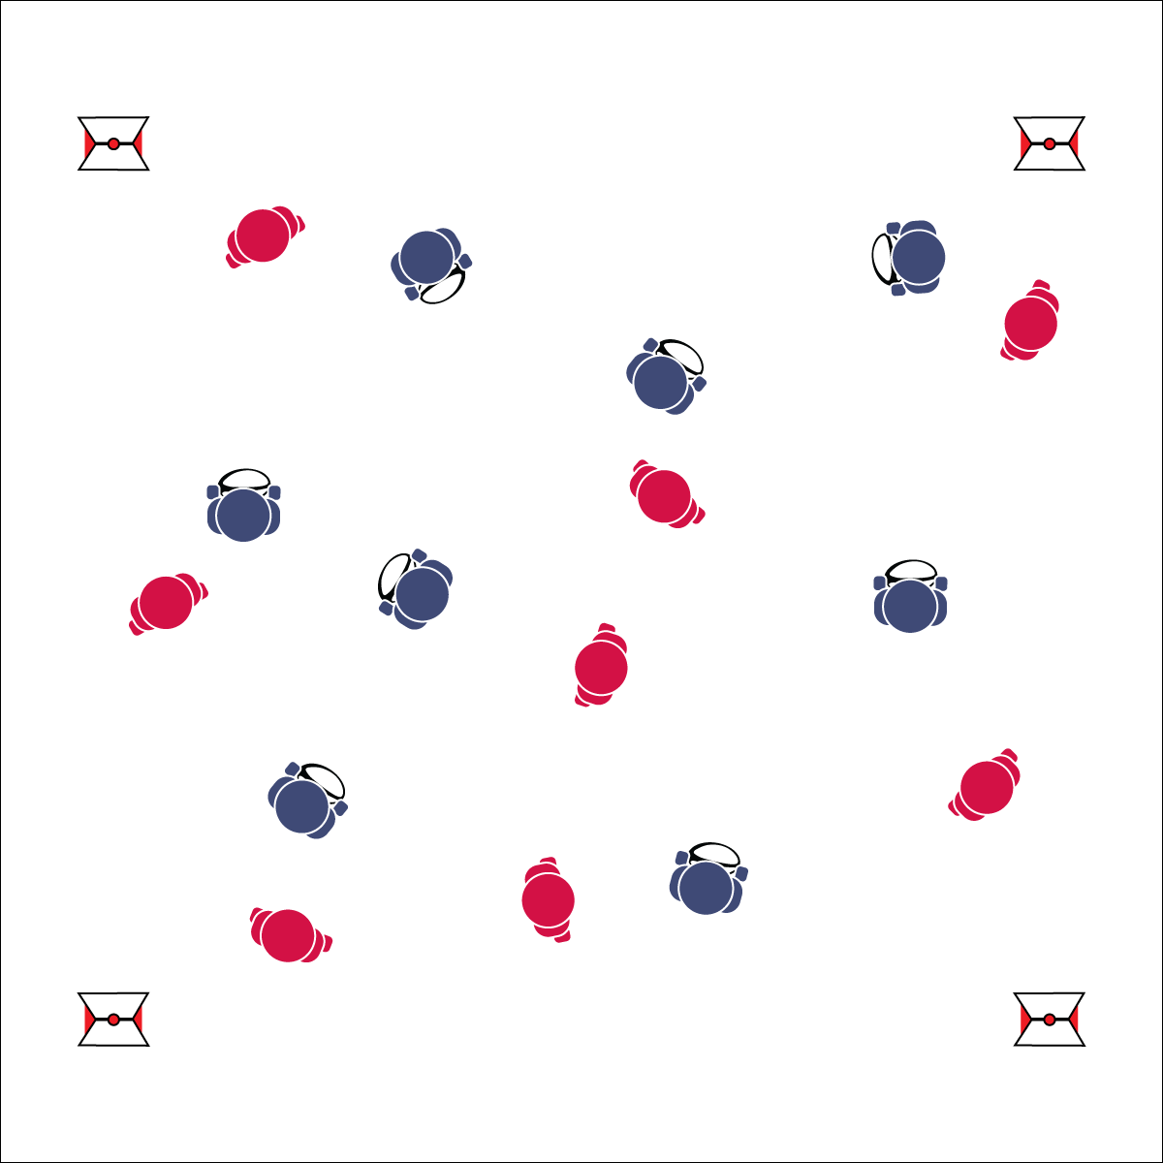

* Cage Grip: Ball Parallel to the Ground, Thumbs on Top Seams, Fingers Spread On Bottom Seams, Create a Firm Cage Around the Ball
* **Skill:** I will avoid taggers by using movement skills such as jab steps while using a cage grip.
* **Cognitive:** I will define and discuss the concept of open space.
* **Fitness:** I will activity participate and increase my heart rate.
* **Personal & Social Responsibility:** I will move safely, avoiding collisions.

**Activity Procedures:**

1. Today’s activity is called Rugby Tag. The object of the activity is for:
   1. Students with a ball to avoid having their flag pulled. They can do this by faking, jabbing, cutting, and running to move to and create open space.
   2. Students without a ball to pull a ball carrier’s flag.
2. I’ll use a signal (whistle, starting the music, etc.) to start round 1 of Rugby Tag. If a ball carrier’s flag gets pulled by their opponent, s/he must freeze, put the flag back on, and hold the ball out in front of her/him using a cage grip.
3. Then a teammate needs to unfreeze the frozen player by touching her/his ball to the frozen player’s ball.
4. Stop when you hear the signal again (whistle, music stops, etc.).
5. Switch roles in Round 2: the flag pullers become ball carriers and the carriers become pullers.
6. Or, when a ball carrier’s flag is pulled, s/he must give the ball to the person that pulled the flag and players switch roles/teams. This eliminates the need for multiple rounds.

**Grade Level Progression:**

**6:** Implement the activity as described above.

**7 & 8:** Teach and prompt students to perform a minimum of 3 jab steps per round of play.

**Equipment:**

* 1 flag belt per student (2 colors for 2 even teams)
* 1 rugby ball per 2 students (can use footballs)
* Cones to mark playing area
* If playing inside, use lines on gym floor

**Set-Up:**

1. Create a large playing area to safely accommodate the entire class for tag (60’x60’).
2. Split the class in half by using belts of 2 different colors. Every student needs a flag belt, and the flag color represents which team they’re on.
3. Give each student on 1 team (half the class) a rugby or similarly shaped ball.
4. All students scatter throughout the playing area.

**RUGBY TAG**

**RUGBY TAG**



* Allow students to use pool noodles for tagging.
* Set up mats in areas where students may fall.
* Slow the pace of the game.

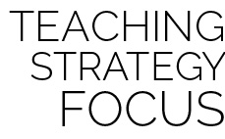

**Preview new content:** Use the first lesson to introduce rugby in a fun and exciting way. There are amazing videos online to capture the essence of Flag Ruby. Go to YouTube.com, search “Flag Rugby Highlights,” and pick your favorite one!



Cage Grip, Fake, Jab Step, Open Space, Rugby



* **Standard 1 [M6.6-8]** Performs pivots, fakes, and jab steps designed to create open space during practice tasks (6); Executes at least one of the following designed to create open space during small-sided game play: pivots, fakes, jab steps (7); Executes at least two of the following to create open space during modified game play: pivots, fakes, jab steps, screens (8).
* **Standard 2 [M1.6-8]** Creates open space by using locomotor movements (e.g., walking, running, jumping & landing) in combination with movement (e.g., varying pathways; change of speed, direction, or pace) (6); Reduces open space by using locomotor movements (e.g., walking, running, jumping & landing, changing size and shape of the body) in combination with movement concepts (e.g., reducing the angle in the space, reducing distance between player and goal) (7); Opens and closes space during small-sided game play by combining locomotor movements with movement concepts (8).



* **DOK 1:** How would you describe open space?
* **DOK 2:** How would you summarize the importance of open space in rugby?
* **DOK 3:** As a defender, how is open space related to your success/failure?
* **DOK 1:** Can you recite the cues for a cage grip?
* **DOK 2:** How does grip affect your ability to carry the ball?
* **DOK 3:** After playing Rugby Tag and utilizing a cage grip, what facts would you select/identify to support the use of a proper grip? Why did you choose those facts?

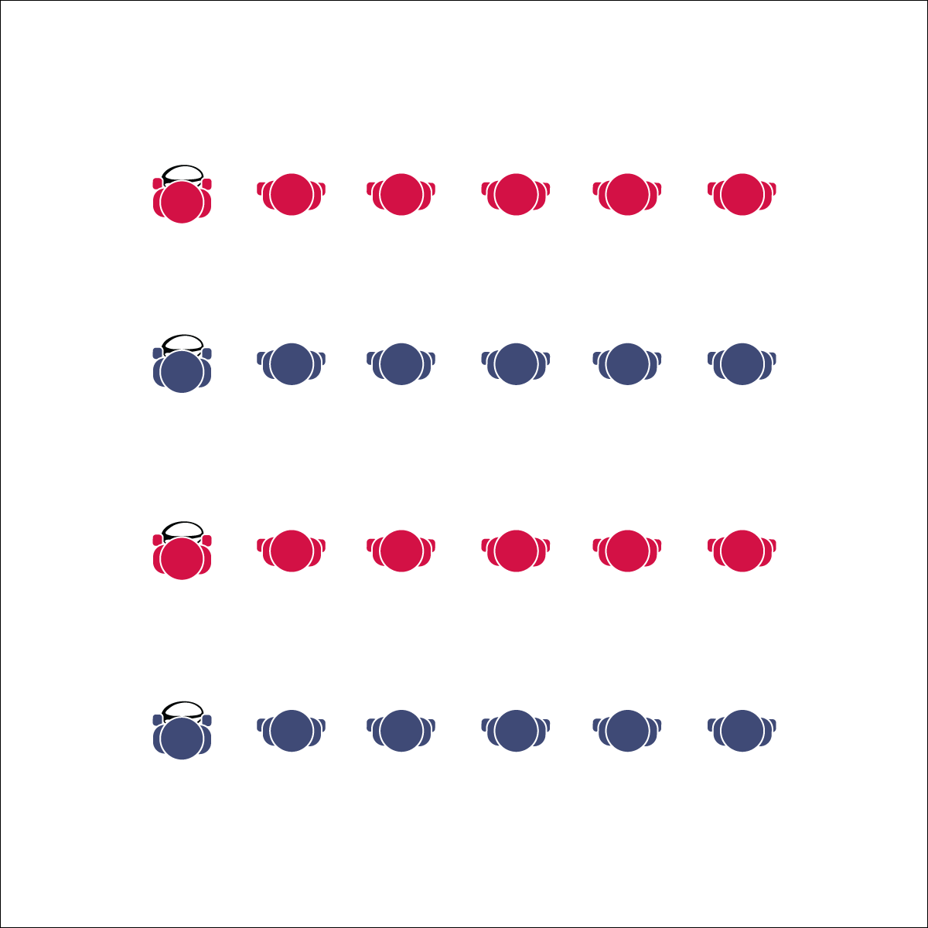

**Equipment:**

* 1 rugby ball per group of 5 or 6 students

**Set-Up:**

1. Create a large activity area (approx. 30’x30’).
2. Place 1 rugby ball on the ground where you want each line to start.
3. Create groups of 5 or 6 students in relay lines. Students are spaced arms-length away from the next teammate in line.

* Basic Pass: Cage Thumbs Down, Hip Level, Side to Target, Step Laterally, Pendulum Swing
* Pop Pass: Cage Thumbs Up, Chest Level, Chest to Target, Step and Push to Target
* **Skill:** I will perform a hand-off, a basic rugby pass, and a pop pass following all skill cues.
* **Cognitive:** I will discuss the importance of purposeful practice.
* **Fitness:** I will engage in an effort to build skill-related fitness.
* **Personal & Social Responsibility:** I will cooperate with my teammates by making accurate passes and focusing on clean catches.

**Activity Procedures:**

1. Today’s activity is called Stationary Passing. The object of the activity is to learn and practice the basic rugby pass and the pop pass by using each skill to move the ball down the line and then back again.
2. Round 1: (Hand-offs only) Start the activity with the first person in line holding the ball with a cage grip. On the start signal, s/he will hand the ball off to the next person in line by side stepping toward the next player and using a pendulum motion to execute a hand off.
3. The receiving player grips the ball with a cage grip and executes this same hand off to the next player. This continues all the way down the line and then reverses all the way back to the first player. There should be no “flight” of the ball; hand-offs allow us to practice the cage grip and the pendulum motion.
4. Round 2: (Basic ruby pass) Spread out with about 2 arms’ lengths between each player. It’s time to practice the basic rugby pass. Now there will be flight! Same grip and step, same pendulum motion, but the next player will catch the pass instead of receiving a hand-off.
5. Round 3: (Pop pass) Same set-up and grip, but the ball is held in a position similar to a basketball chest pass. There should be enough elevation on the pass for the ball to clear a defensive player’s head.
6. Stop when you hear the signal (whistle, music stops, etc.).

**Grade Level Progression:**

**6:** Focus on handoffs and a basic pass. Revisit the activity in the next class with a focus on the pop pass.

**7 & 8:** Challenge students by adding a timed element to the activity. For example, can all teams move their ball down and back in less than 1 minute?

**STATIONARY PASSING**

**STATIONARY PASSING**



* Use larger balls of various shapes and construction.
* Use Velcro gloves and compatible balls.



* **DOK 1:** What is purposeful practice?
* **DOK 2:** How would you compare and contrast purposeful practice with unfocused participation?
* **DOK 3:** How is purposeful practice related to skill development? How is it related to performance?
* **DOK 4:** Develop a purposeful practice plan that you can implement at home in order to improve your rugby skills.



Basic Ruby Pass, Cooperation, Hand-Off, Pendulum Motion, Pop Pass, Purposeful Practice, Skill-Related Fitness, Trajectory



* **Standard 1 [M3.6-7]** Catches with a mature pattern from a variety of trajectories using different objects in varying practice tasks (6); Catches with a mature pattern from a variety of trajectories using different objects in small-sided game play (7).
* **Standard 4 [M5.6-8]** Cooperates with a small group of classmates during adventure activities, game play, or team-building activities (6); Problem-solves with a small group of classmates during adventure activities, small-group initiatives, or game play (7); Cooperates with multiple classmates on problem-solving initiatives including adventure activities, large-group initiatives, and game play (8).



**Identify critical content:** Grip and passing techniques are the fundamentals needed for rugby success. Give students time to practice and become competent passers while providing fun, high-MVPA activities in which you can focus no grip technique. Define purposeful practice, and then create opportunities for students to experience it.

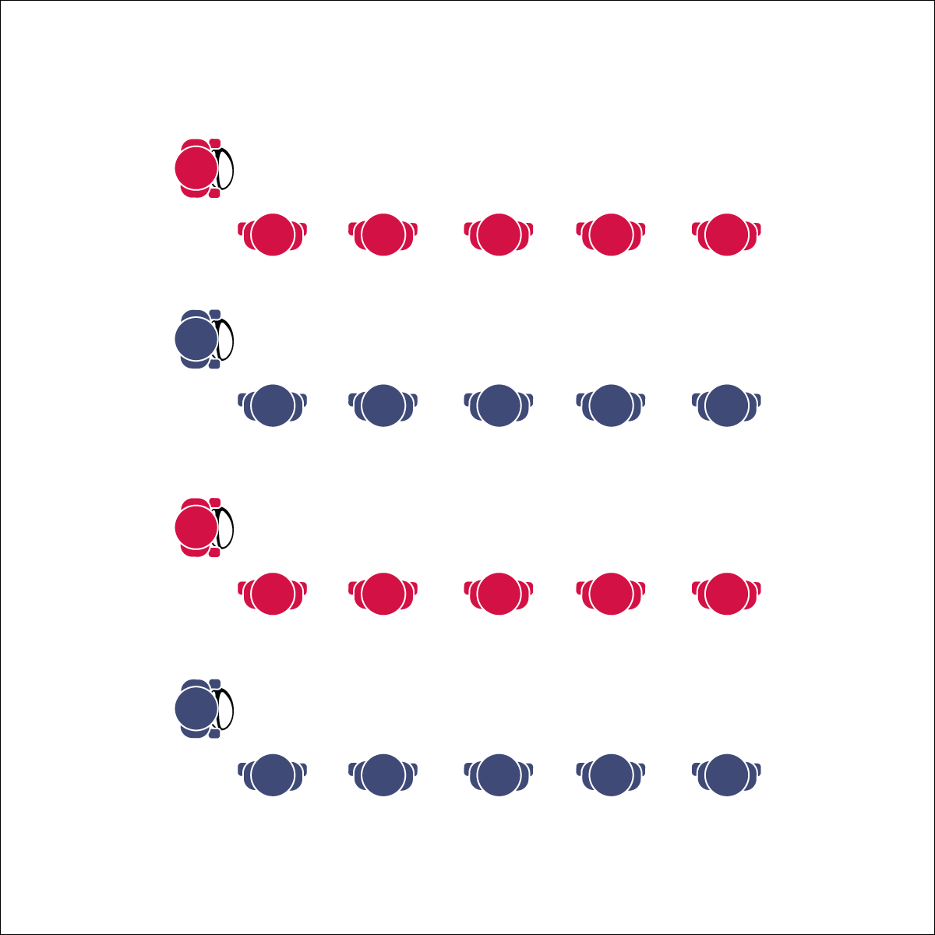

**Activity Procedures:**

1. Today’s activity is called Leader Ball. The object of the activity is to practice the basic rugby pass and the pop pass by using each skill to move the ball down the line as quickly as you can.
2. Start the activity with the line leader holding the ball and the other group members in line, arms-length away from one another.
3. On the start signal, the line leader executes a basic rugby pass (pendulum pass) to the first person in line. The person receiving the pass catches it, passes it back, and then begins doing jumping jacks. The line leader then moves to make a basic rugby pass to the second person in line. The receiver catches it, passes it back, and then begins doing jumping jacks with the first person.
4. This pattern continues until everyone in line is doing jumping jacks. The line leader then goes to the end of the line and the next player moves up to be the new leader. The ball is quickly handed off down the line to the new leader. This continues until everyone in the group has been a line leader.
5. When everyone has had a turn as the line leader, repeat the activity practicing the pop pass.
6. Stop when you hear the signal (whistle, music stops, etc.).

**Grade Level Progression:**

**6:** Perform the activity with stationary receivers. Then challenge students to pass to a moving receiver.

**7 & 8:** Focus on leading passes and catching on the move.

**Equipment:**

* 1 rugby ball per group of 5 or 6 students

**Set-Up:**

1. Create a large activity area (approx. 30’x30’).
2. Place 1 rugby ball on the floor/ground where you want each line to start.
3. Create groups of 5 or 6 students in relay lines. Students are spaced arms-length away from the next teammate in line.

**LEADER BALL**

* **Skill:** I will perform a leading pass to a moving teammate.
* **Cognitive:** I will define and discuss a leading pass.
* **Fitness:** I will engage in an effort to build skill-related fitness.
* **Personal & Social Responsibility:** I will use encouraging language in an effort to support my teammates.
* Lead Pass to Where Receiver is Going to Be – Not Where They Are

**LEADER BALL**



* Slow the pace of the activity.
* Use Velcro gloves and/or a variety of balls of various shapes and construction.
* Group students who work well together.



Encouragement, Lead Passing, Skill-Related Fitness



* **Standard** **1 [M4.6]** Passes and receives with hands in combination with locomotor patterns of running and change of direction & speed with competency in invasion games such as basketball, flag football, speedball, or team handball (6).
* **Standard 1 [M5.6-8]** Throws, while stationary, a leading pass to a moving receiver (6); Throws, while moving, a leading pass to a moving receiver (7); Throws a lead pass to a moving partner off a dribble or pass (8).
* **Standard 3 [M7.6-8]** Identifies the components of skill-related fitness (6); Distinguishes between health-related and skill-related fitness (7); Compares and contrasts health-related fitness components (8).
* **Standard 5 [M6.6-8]** Demonstrates respect for self and others in activities and games by following the rules, encouraging others, and playing within the spirit of the game or activity (6); Demonstrates the importance of social interaction by helping and encouraging others, avoiding trash talk, and providing support to classmates (7); Demonstrates respect for self by asking for help and helping others in various physical activities (8).



* **DOK 1:** How can you recognize a leading pass?
* **DOK 2:** When would you apply/use a leading pass in rugby?
* **DOK 3:** Can you predict the outcome of a rugby game if a team cannot execute a leading pass?
* **DOK 4:** Create a choreographed rugby play that includes a lead pass beating a defender.



**Organize students to interact with content:** One essential component to a student-centered class is cooperative learning. Leader Ball provides a small-group structure for active participation as well as discussion. Use a “Turn and Talk” strategy during this activity’s debrief to allow groups to discuss, explore, and collaborate on answers.

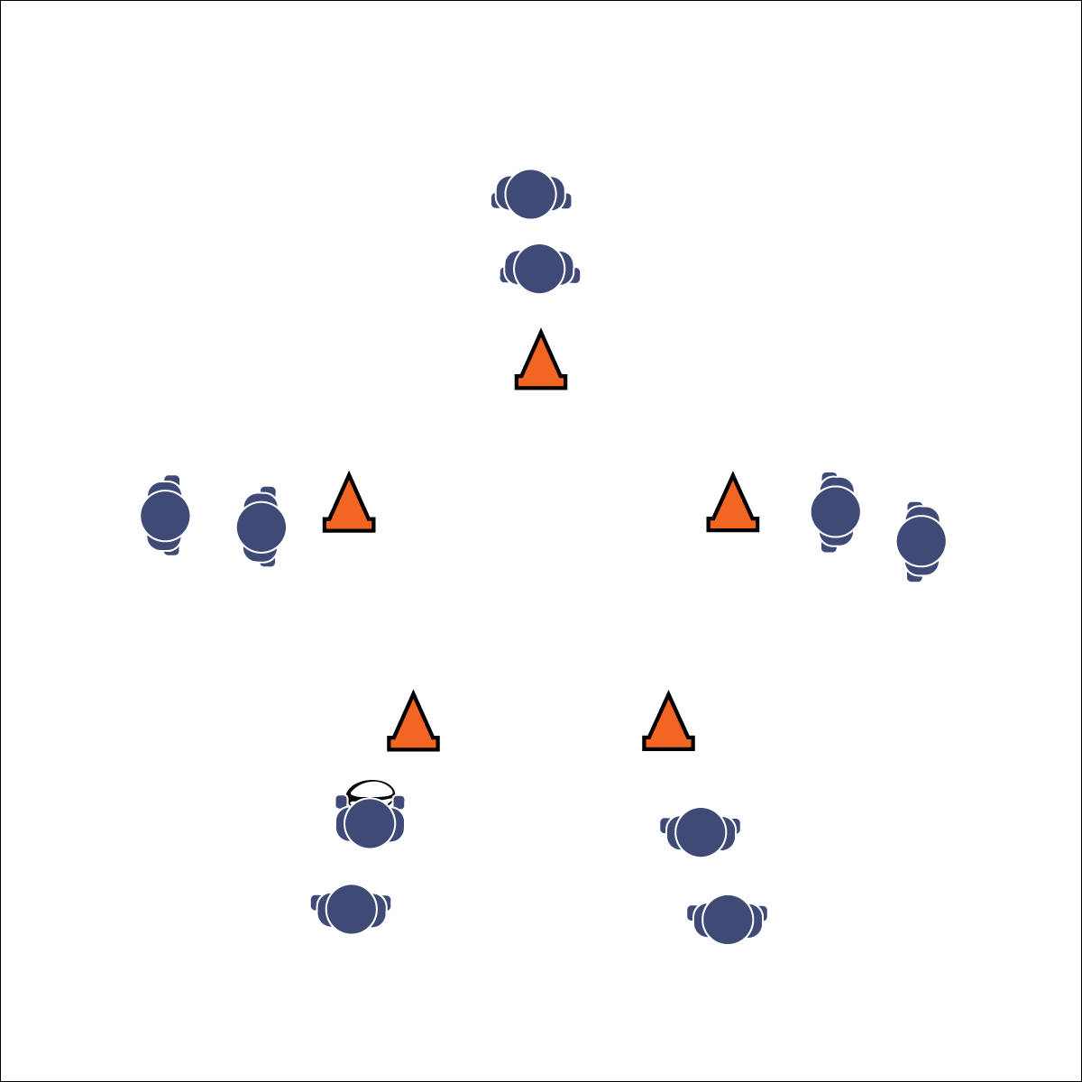

**Activity Procedures:**

1. Today’s activity is called Star Passing. The object of the activity is to execute a pop pass while moving in a star pattern.
2. Start the activity with the first player at the bottom left point of the star holding the ball. S/he will run and pop pass to the player at the top point of the star and then go to the end of the top point’s line.
3. The receiving player will then run and pop pass the ball to the player at the bottom right point of the star and then go to the end of that point’s line.
4. The receiving player will then run and pop pass to the player at the diagonal left point of the star and then go to the end of that point’s line.
5. The receiving player will then run and pop pass to the player at the diagonal right point of the star and then go to the end of that point’s line.
6. Finally, that receiving player will run and pop pass to the player at the bottom left point of the star (the line where the ball started) and then go to the end of that point’s line.
7. Repeat this star pattern until you hear the stop signal.

**Grade Level Progression:**

**6:** Focus on proper passing technique and accuracy.

**7:** Expand the distance between star points. Passer and receiver both move (pass to a moving receiver).

**8:** Challenge students to make as many accurate leading passes as possible in a set amount of time.

**STAR PASSING DRILL**

* Review Pop Pass Cues
* Lead Pass to Where Receiver is Going to Be – Not Where They Are
* **Skill:** I will follow cues for a leading pop pass to make accurate passes to my teammates.
* **Cognitive:** I will follow the proper movement pattern for star passing.
* **Fitness:** I will engage in an effort to build my fitness.
* **Personal & Social Responsibility:** I will communicate with my teammates in an effort to cooperate, problem-solve, and strive for successful performance.

**Equipment:**

* 1 rugby ball per group of 10 students
* 5 cones/floor markers per group

**Set-Up:**

1. Create a large activity grid with 1 square per group of 10 students.
2. In each grid square, set up 5 cones in the shape of a star as well as 1 ball. Designate the cone closest to the front of the room as the “top” point of the star.
3. Organize students in groups of at least 10 with 2 students behind each of their star’s 5 cones.

**STAR PASSING DRILL**



* Slow the pace of the activity.
* Use Velcro gloves and/or a variety of balls of various shapes and construction.
* Group students who work well together.



Cooperation, Fitness, Leading Pass, Pattern, Pop Pass



* **Standard 1 [M5.6-8]** Throws, while stationary, a leading pass to a moving receiver (6); Throws, while moving, a leading pass to a moving receiver (7); Throws a lead pass to a moving partner off a dribble or pass (8).
* **Standard 4 [M5.6-8]** Cooperates with a small group of classmates during adventure activities, game play, or team-building activities (6); Problem-solves with a small group of classmates during adventure activities, small-group initiatives, or game play (7); Cooperates with multiple classmates on problem-solving initiatives including adventure activities, large-group initiatives, and game play (8).



* **DOK 1:** What is a pattern?
* **DOK 2:** What do you know about patterns in sports? Provide examples.
* **DOK 3:** What facts would you select to support the importance of patterns in sports? Can you elaborate on why you chose those facts?



**Help students process content:** The Star Passing Drill is another cooperative learning opportunity that can be easily missed for the sake of staying on schedule and increasing activity time. Processing is an essential ingredient to learning. Take the time to allow students to discuss the above debrief questions, explore their collective experience, and process concepts that transfer across a variety of sport possibilities.

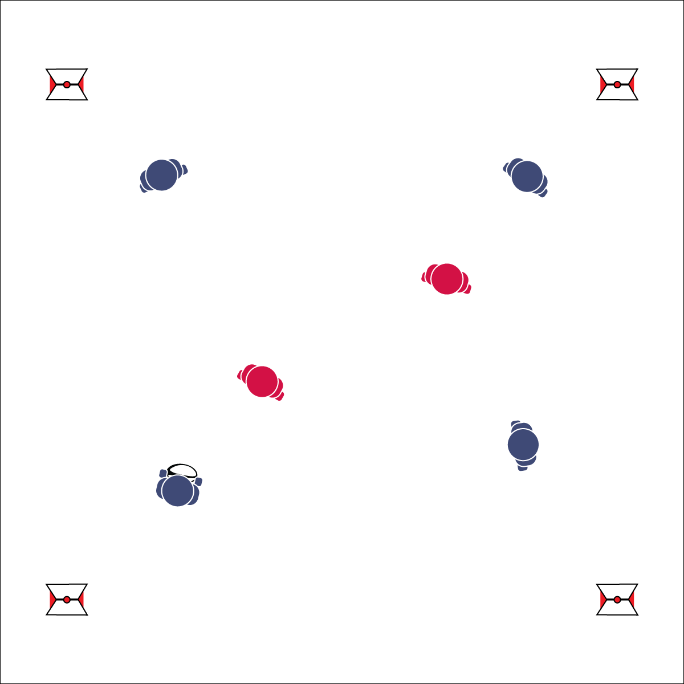

**Activity Procedures:**

1. Activity Today’s activity is called Monkey in the Middle. The object of the activity is for:
   1. Offensive players to maintain possession of the ball.
   2. Defensive players to gain possession of the ball.
2. Within the groups, allow students to decide which 4 players will start on offense and which 2 players will start on defense (or pre-determine this for your students).
3. On the signal, offensive players will try to complete passes to their teammates while defensive players try to intercept the passes. Offensive players with possession of the ball can pivot and jab, but they cannot take any steps.
4. If/when a pass is intercepted, the player who threw it becomes a defender and the intercepting player goes to offense (or keep offense and defense for a set time, then rotate positions).
5. *Teachers, you may want to include a 3 second stationary possession rule.*
6. Continue playing until you hear the stop signal.

**Grade Level Progression:**

**6:** Implement the activity as described above.

**7:** Allow players with possession of the ball to take 3 steps before passing.

**8:** Add an additional defender to create a 4 v 3 game.

* Pivot Foot Stays Planted, Rotate on Ball of Foot
* Head Fake with Quick Move with Head and Shoulder in One Direction, Then Cut Away
* Jab Step with Hard/Short Step to The Front

**Equipment:**

* 1 rugby ball per group of 6 students
* Optional: 1 flag belt per student

**Set-Up:**

1. Create a large activity grid with 1 square per group of 6 students.
2. Students in groups of 6 (4 v 2), with 1 group in each square.

* **Skill:** I will execute pivots, fakes, and jab steps in an effort to create open space.
* **Cognitive:** I will anticipate passing and movement and work to close space to deny passes.
* **Fitness:** I will engage in the activity and increase my heart rate.
* **Personal & Social Responsibility:** I will demonstrate respect for my opponents and honor the Spirit of   
  the Game.

**MONKEY IN THE MIDDLE**

**MONKEY IN THE MIDDLE**



* Change roles often.
* Adjust the number of students on offense/defense.
* Slow the pace of the activity.
* Use Velcro gloves and/or a variety of balls of various shapes and construction.
* Group students who work well together.



**Help students elaborate on content:** Monkey in the Middle is a classic game that can be used to illustrate the importance of offensive and defensive movement, or it can be a frustrating mess for students just developing skills and knowledge. Teach in chunks. Start the activity and then pause after a few minutes to discuss the first question above. Allow students to process what denying a pass means and how it can be applied in the next round of play. Restart the game and continue for several minutes before pausing and covering the next debrief question. Prompt students to elaborate on their responses by providing details from game play that just occurred. Turn and Talk is a great way to help students generate the details needed for this type of elaboration.



Anticipate, Deny, Fake, Jab Step, Open Space, Pivot, Reduce Open Space, Respect, Spirit of the Game



* **Standard 1 [M6.6-8]** Performs pivots, fakes, and jab steps designed to create open space during practice tasks (6); Executes at least one of the following designed to create open space during small-sided game play: pivots, fakes, jab steps (7); Executes at least two of the following to create open space during modified game play: pivots, fakes, jab steps, screens (8).
* **Standard 2 [M5.6-8]** Reduces open space by not allowing the catch (denial) or by allowing the catch but not the return pass (6); Reduces open space by not allowing the catch (denial) or anticipating the speed of the object or person for the purpose of interception or deflection (7); Reduces open space by not allowing the catch (denial) and anticipating the speed of the object or person for the purpose of interception or deflection (8).
* **Standard 5 [M6.6-8]** Demonstrates respect for self and others in activities and games by following the rules, encouraging others, and playing within the spirit of the game or activity (6); Demonstrates the importance of social interaction by helping and encouraging others, avoiding trash talk, and providing support to classmates (7); Demonstrates respect for self by asking for help and helping others in various physical activities (8).



* **DOK 1:** What does denying a pass mean?
* **DOK 2:** How do open and closed spaces apply to defensive denial?
* **DOK 3:** How would you change defensive positioning to reduce open space for your opponent? Can you describe positioning when the ball is close to your defender? How is that different from when the ball is far away from your defender?

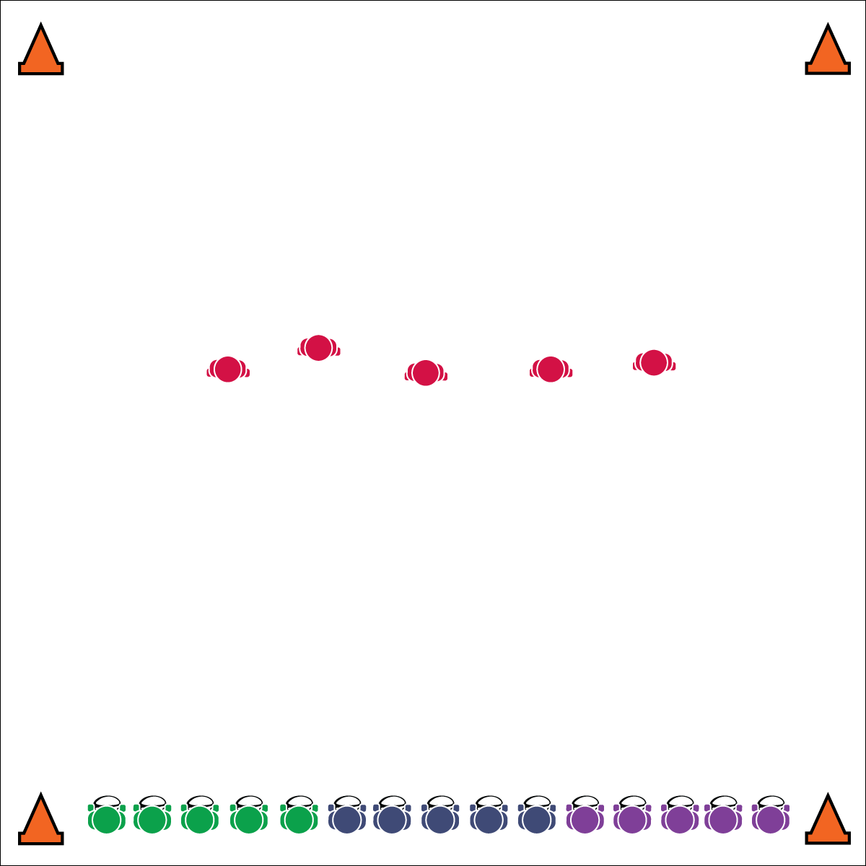

**Equipment:**

* 1 flag belt per student
* 1 rugby ball or football for all but 5 students (the “Taggers”)
* 4 cones to mark the playing area

**Set-Up:**

1. Create a large activity area (approx. 30x30 ft.) with 1 cone in each corner.
2. Give each student a flag (color does not matter).
3. Organize students in teams of 4 or 5, each team assigned a number.
4. 1 team starts in the middle of the playing field (without balls) as the Taggers.
5. All other students line up shoulder-to-shoulder on 1 end line, each non-tagging student with a ball.

**SHARKS & MINNOWS**

* **Skill:** I will move safely from one end to the other, watching out for other players and moving in open space.
* **Cognitive:** I will discuss strategies for finding/creating open space on offense and closing space on defense.
* **Fitness:** I will engage and increase my heart rate.
* **Personal & Social Responsibility:** I will avoid negative language and provide support to my classmates.
* Head on a Swivel, Eyes Alert and Active
* Move to Open Space
* Be Ready to Change Direction

**Activity Procedures:**

1. Today’s activity is called Sharks and Minnows.
2. The object of the activity is for ball carriers to practice running with the ball, moving to open space, and making it across the playing field without having their flag pulled by a Tagger.
3. To start the activity, I will call out an “if command” (e.g., “if you were born in January or February–GO!”).
4. If the “if command” applies to you, try to run across the field without having your flag pulled by a Tagger.
5. If your flag gets pulled, retrieve it and continue on to the other end line.
6. Next, the teacher calls another “if command” and all players the command applies to will make an attempt to cross. This continues until all students have run from the initial end line. At that point, a new team comes to the middle to be Taggers. Repeat until all teams have had a chance to tag.

**Grade Level Progression:**

**6:** Implement the activity as described above.

**7:** Add another team of Taggers to the middle of the playing field.

**8:** Each team of “minnows” has 1 ball. Taggers (“sharks”) attempt to pull the ball carriers’ belts. Teams may use proper passing to avoid being tagged. If a pass is dropped, receiving player is automatically tagged.

**SHARKS & MINNOWS**



* Allow students to use pool noodles for tagging.
* Set up mats in areas where students may fall.
* Slow the pace of the game.



**Manage response rate with tiered questioning:** At this point in the module you’ve already used tiered questioning debrief strategies. However, it’s important to reflect on how your technique is benefiting all students. Are all students getting an opportunity to respond? This is impossible in a single meeting unless you use Turn and Talk sessions and monitor each group to be sure everyone is participating. Even then, the likelihood of 100% participation is slim, so mix the “cold call” technique into your sessions. Make a mental note of students who typically don’t participate and then call on them without asking for volunteers. Try to do this at a time when they’re likely to have a response, and praise their responses while encouraging them to elaborate with details.



* **Standard 1 [M6.6-8]** Performs pivots, fakes, and jab steps designed to create open space during practice tasks (6); Executes at least one of the following designed to create open space during small-sided game play: pivots, fakes, jab steps (7); Executes at least two of the following to create open space during modified game play: pivots, fakes, jab steps, screens (8).
* **Standard 2 [M5.6-8]** Reduces open space by not allowing the catch (denial) or by allowing the catch but not the return pass (6); Reduces open space by not allowing the catch (denial) or anticipating the speed of the object or person for the purpose of interception or deflection (7); Reduces open space by not allowing the catch (denial) and anticipating the speed of the object or person for the purpose of interception or deflection (8).
* **Standard 5 [M6.6-8]** Demonstrates respect for self and others in activities and games by following the rules, encouraging others, and playing within the spirit of the game or activity (6); Demonstrates the importance of social interaction by helping and encouraging others, avoiding trash talk, and providing support to classmates (7); Demonstrates respect for self by asking for help and helping others in various physical activities (8).



Avoid, Defense, Offense, Strategy, Safe, Support



* **DOK 1:** What would you include on a list about open space as it related to rugby? What would you include on a list about closed space?
* **DOK 2:** Can you compare and contrast open space with closed space?
* **DOK 3:** What defensive strategy can be applied to our game of Sharks & Minnows to help the defenders close space for the minnows?
* **DOK 3:** What skill-related fitness components are related to a defender’s ability to close space?

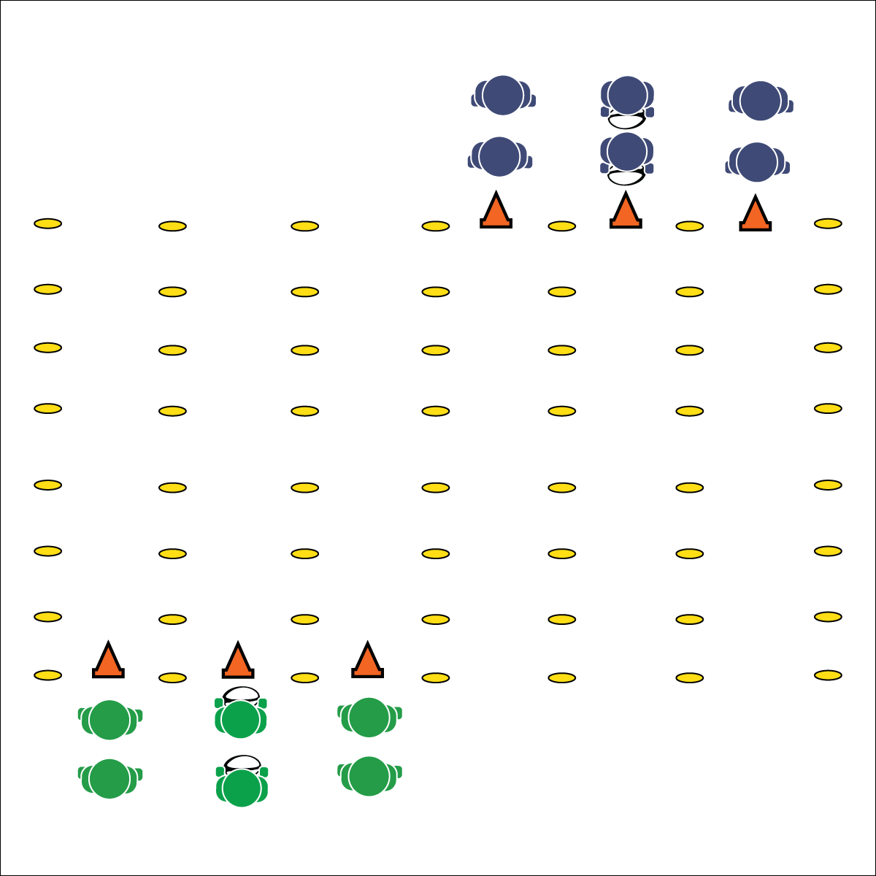

* **Skill:** I will perform accurate passes with a focus on proper form to a moving receiver.
* **Cognitive:** I will discuss how teamwork can improve performance.
* **Fitness:** I will engage in an effort to improve my fitness.
* **Personal & Social Responsibility:** I will display teamwork and focus my effort on group success.

**Equipment:**

* 1 rugby ball per group of 3 students
* 6 cones
* 12 to 24 low profile cones

**Set-Up:**

1. Create a rectangular activity area (30’X60’).
2. Use low profile cones to divide the rectangle into 6 lanes (length-wise).
3. Place 3 cones at one end of the 1st, 2nd, and 3rd lanes to create a starting line. Place the other 3 cones at the opposite end of the 4th, 5th, and 6th lanes to create a starting line at the opposite end.
4. Students all line up behind the cones at every lane to create groups of 3 (the students who are first in line in the 1st, 2nd, and 3rd lanes are a group; the students who are first in line in the 4th, 5th, and 6th lanes are a group; etc.).
5. Each group has a ball. The ball starts in the center lanes (lanes 2 and 5).

**Activity Procedures:**

1. Today’s activity is called Gauntlet. The object is to practice passing and receiving on the move.
2. On the start signal, the groups at the starting line will begin to jog down their lanes.
3. The middle player will start by passing the ball to the player on her/his right using a pendulum pass or a pop pass. That player passes back to the middle player.
4. The middle player then passes to the player on her/his left, who then passes back to the middle player.
5. This passing/receiving pattern continues all the way down to the opposite end line. When a group reaches the end line, they move to the end of the opposite starting line (students from the 1st, 2nd, and 3rd lanes move to the end of the lines in the 4th, 5th, and 6th lanes and vice-versa). Students switch positions so a new player is in the middle line and follow the same passing pattern.
6. Keep lines moving by starting as soon as the group in front of you reaches the center of the activity area. Stop when you hear the signal.

**Grade Level Progression:**

**6:** Implement the activity as described above.

**7 & 8:** Implement a 3-person weave formation. Players pass and then follow their pass with a cut behind the receiver. This pattern continues down the length of the activity area.

**GAUNTLET**

* Review All Passing Cues
* Work Hard with a Focus on Form

**GAUNTLET**



* Slow the pace of the activity.
* Use Velcro gloves and/or a variety of balls of various shapes and construction.
* Group students who work well together.



**Help students record and represent knowledge:** Use the debrief questions above as an opportunity to collect a quick writing sample. Transfer each question onto a worksheet or exit slip, or post them where all can see. Then prompt students to take 5 minutes to answer each question in writing. This strategy will offer a break from your normal debrief routine, allow students to create their own representation of what they’re learning, and provide an artifact of student work that illustrates an important affective concept (teamwork) that is essential to 21st century learning.



* **DOK 1:** What would you include on a list about teamwork?
* **DOK 2:** How does teamwork affect your team’s ability to move quickly down the gauntlet?
* **DOK 3:** What behaviors contribute to teamwork? What behaviors weaken teamwork?
* **DOK 4**: What experiences did you have today that can be used as evidence to support your ideas about teamwork? Elaborate on each experience.



Ball Movement, Cut, Effort, Leading Pass, Teamwork



* **Standard** **1 [M4.6]** Passes and receives with hands in combination with locomotor patterns of running and change of direction & speed with competency in invasion games such as basketball, flag football, speedball, or team handball (6).
* **Standard 1 [M5.6-8]** Throws, while stationary, a leading pass to a moving receiver (6); Throws, while moving, a leading pass to a moving receiver (7); Throws a lead pass to a moving partner off a dribble or pass (8).
* **Standard 4 [M5.6-8]** Cooperates with a small group of classmates during adventure activities, game play, or team-building activities (6); Problem-solves with a small group of classmates during adventure activities, small-group initiatives, or game play (7); Cooperates with multiple classmates on problem-solving initiatives including adventure activities, large-group initiatives, and game play (8).

## 

* **Skill:** I will change direction and speed in an effort to avoid having my flag pulled.
* **Cognitive:** I will identify strategies for closing space on defense.
* **Fitness:** I will identify skill-related fitness components important to successful participation in this activity.
* **Personal & Social Responsibility:** I will focus on safety and fair play.

**Activity Procedures:**

1. Today’s activity is called Partner Score. The object of the activity is for:
   1. offensive players to score by running the ball across either end line.
   2. defensive players to keep their opponent from scoring by pulling her/his flag.
2. You all have numbers. It’s important for you to know who has the same number as you on the opposite team. We have 2 games playing at the same time, using the same start and stop signals.
3. On the signal, player #1 on one team will start with the ball and pass it to player #1 in the opposite team. That player then passes the ball across to player #2 on the first team. Continue in this way until you hear a whistle. If the ball reaches the end of the line, it continues back down the line in reverse order.
4. On the whistle, the player with the ball (the offensive player) runs into the center alley between the two teams, and the player with the matching number (the defensive player) also runs in to the alley.
5. The offensive player tries to score by crossing the farthest end line. The defensive player tries to pull her/his flag before s/he can score.
6. Reset by bringing the ball back to the line. On the signal, continue passing until another whistle blows.

**Grade Level Progression:**

**6:** Implement the activity as described above.

**7 & 8:** Allow offensive players to make 1 pass to any sideline player in order to avoid a flag pull. The pass must be return successfully within 3 seconds. If a pass is dropped the play is over.

**Equipment:**

* 2 rugby balls
* 1 flag belt per student (color does not matter)
* 8 cones
* 8 low profile cones

**Set-Up:**

1. Use cones to create a rectangular activity area (approx. 40x60 ft.) and divide it in half down its length, creating 2 separate narrow activity areas.
2. Use low profile cones to create 2 parallel lines in each area, approximately 15 feet apart.
3. Divide students into 4 equal teams, every student with a flag belt. Each team lines up on a separate line (created by low profile cones).
4. Give every student a number (each line starts with the number 1) so that students on opposite teams have the same number as the player across from them. The ball begins with player #1.

**PARTNER SCORE**

* Head Fake, Move to Open Space
* Watch Offensive’s Belly Button, Close Angles to End Zone



* Increase/decrease the size of the activity area.
* Use mats as boundaries.
* Designate/predetermine offense and defense.
* Use an auditory cue behind goal areas.



**Review content:** Returning to the components of skill- and health-related fitness within the context of each instructional content area will highlight the importance of these concepts and will frame them within the “big picture” of the physical education curriculum.



* **DOK 1:** What are the components of skill-related fitness?
* **DOK 2:** How would you apply [*name component*] in the activity Partner Score?
* **DOK 3:** Choose a component of skill-related fitness. Can you formulate a theory of importance for this component of skill-related fitness as it relates to performance in partner score? How would you test this theory?



* **Standard 1 [M4.6]** Passes and receives with hands in combination with locomotor patterns of running and change of direction & speed with competency in invasion games such as basketball, flag football, speedball, or team handball (6).
* **Standard 2 [M2.6-8]** Creates open space by using locomotor movements (e.g., walking, running, jumping & landing) in combination with movement (e.g., varying pathways; change of speed, direction, or pace) (6); Reduces open space by using locomotor movements (e.g., walking, running, jumping & landing, changing size and shape of the body) in combination with movement concepts (e.g., reducing the angle in the space, reducing distance between player and goal) (7); Opens and closes space during small-sided game play by combining locomotor movements with movement concepts (8).



Angle, Direction, Close Space, Fair Play, Open Space, Speed

**PARTNER SCORE**

­­

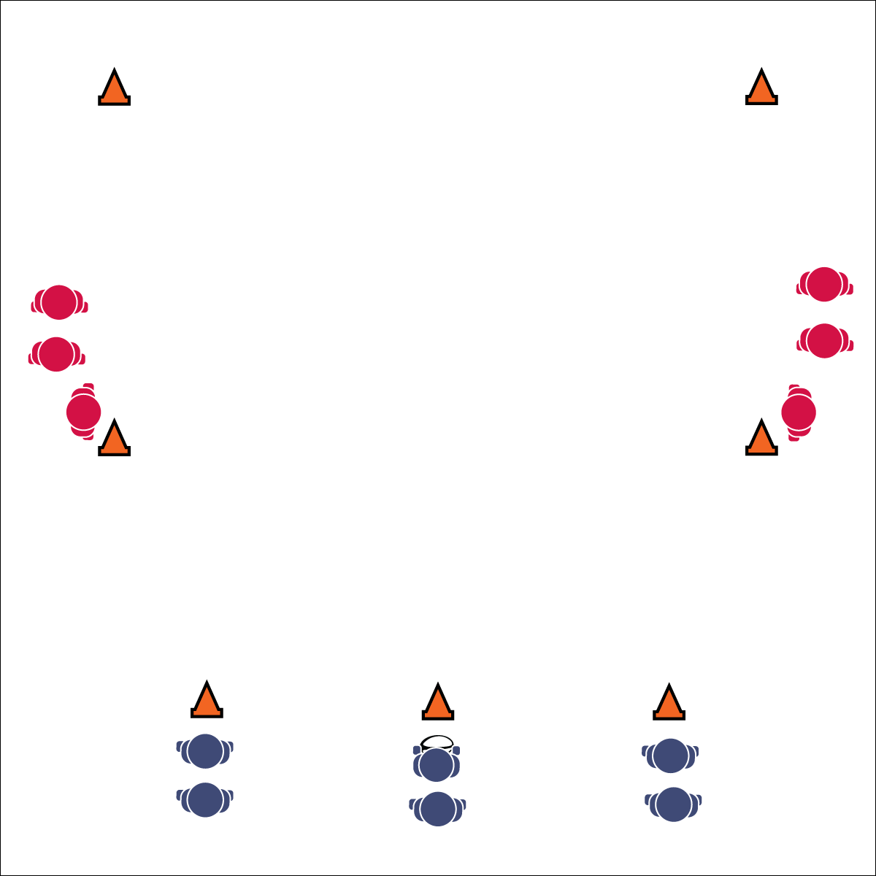

**LEARNING LANES**

**Equipment:**

* 7 cones per area
* 1 rugby ball
* 1 flag belt per player

**Set-Up:**

1. Use cones to create rectangular activity areas (approx. 30x50 ft.). Increase student activity by creating 2 identical activity set-ups side-by-side.
2. Divide the playing area into 3 lanes (length-wise). Put 1 cone at the starting end line to designate each lane. This is where offensive players start (3 at a time). Put 1 cone on each sideline at midfield. This is where defensive players start (2 at a time). Put 2 cone on the sides of the opposite end line to identify the “end zone.”
3. Divide class in half (½ offense, ½ defense).
4. Students line up evenly behind cones.
5. Students stay in offense or defense lines until the teacher switches student roles.

* **Skill:** I will maintain defensive ready position with my eyes on the midsection (belly button) of the offense.
* **Cognitive:** I will spread the defense with proper spacing on offense.
* **Fitness:** I will engage in an effort to improve my fitness.
* **Personal & Social Responsibility:** I will participate with a focus on safety and fair play.

**Activity Procedures:**

1. Today’s activity is called Learning Lanes. The object of the activity is for:
   1. Offensive players to work together to move into the end zone.
   2. Defensive teams to work together to prevent the offense from scoring.
2. To start, an offensive player hands the ball off to a teammate and all 3 players start advancing up the field. As soon as the hand-off is made, 2 defenders can enter the field from their cones.
3. Next, the offense applies offensive moves, passes, and strategies in an attempt to score. A turnover occurs when a ball is dropped or a flag is pulled. Then, the ball goes back to the offense at that spot and play resumes. Offense gets 3 turnovers per round.
4. Offense gets 1 point if they score a try. Defense gets 1 point if they prevent a score.
5. After 3 turnovers or a try is scored, players reset and new players begin with a hand-off.

**Grade Level Progression:**

**6:** Implement the activity as described above.

**7 & 8:** Decrease the allowed turnovers until offense has only 1 chance to score a try.

* Defensive Ready Position: Weight on Balls of Feet, Arms Extended, Palms Up, Eyes on Midsection of Offensive Player
* Spread the Defense: Move to Space, Not to the Ball

**LEARNING LANES**



* Increase or decrease the size of the activity area to meet needs of all students.
* Allow defense to tag with pool noodles.
* Slow the pace of the activity.
* Use auditory cues in end zones.
* Allow students to choose the style of ball used.
* Set up mats in areas where students may fall.



Defensive Ready Position, Drop Step, Score a Try, Slide, Spread the Defense



* **Standard 1[M6.6-8]** Performs pivots, fakes, and jab steps designed to create open space during practice tasks (6); Executes at least one of the following designed to create open space during small-sided game play: pivots, fakes, jab steps (7); Executes at least two of the following to create open space during modified game play: pivots, fakes, jab steps, screens (8).
* **Standard 1 [M11.6-8]** Maintains defensive ready position, with weight on balls of feet, arms extended and eyes on midsection of the offensive player (6); Slides in all directions while on defense without crossing feet (7); Drop-steps in the direction of the pass during player-to-player defense (8).
* **Standard 2 [M3.6-8]** Creates open space by using the width and length of the field/court on offense (6); Creates open space by staying spread on offense, and cutting and passing quickly (7); Creates open space by staying spread on offense, cutting and passing quickly, and using fakes off the ball (8).



* **DOK 1:** How would you describe defensive ready position?
* **DOK 2:** How are the eyes and focus related to defensive ready position?
* **DOK 3:** How is offensive spacing related to defensive ready position?
* **DOK 4:** Create a choreographed performance of how the defense would adjust to offensive ball movement.



**Help students engage in cognitively complex tasks:** There is a lot happening in this Learning Lanes activity. Students on defense are focused on positioning, proper locomotor technique, as well as movement on the floor. Students on offense are applying the passing, catching, and grip skills learned while trying to process and demonstrate proper floor spacing. This is all in addition to learning and following the flow and organization of the activity. PERFECT! Be patient. This type of complexity is necessary practice for the dynamic complexity of successful rugby participation.

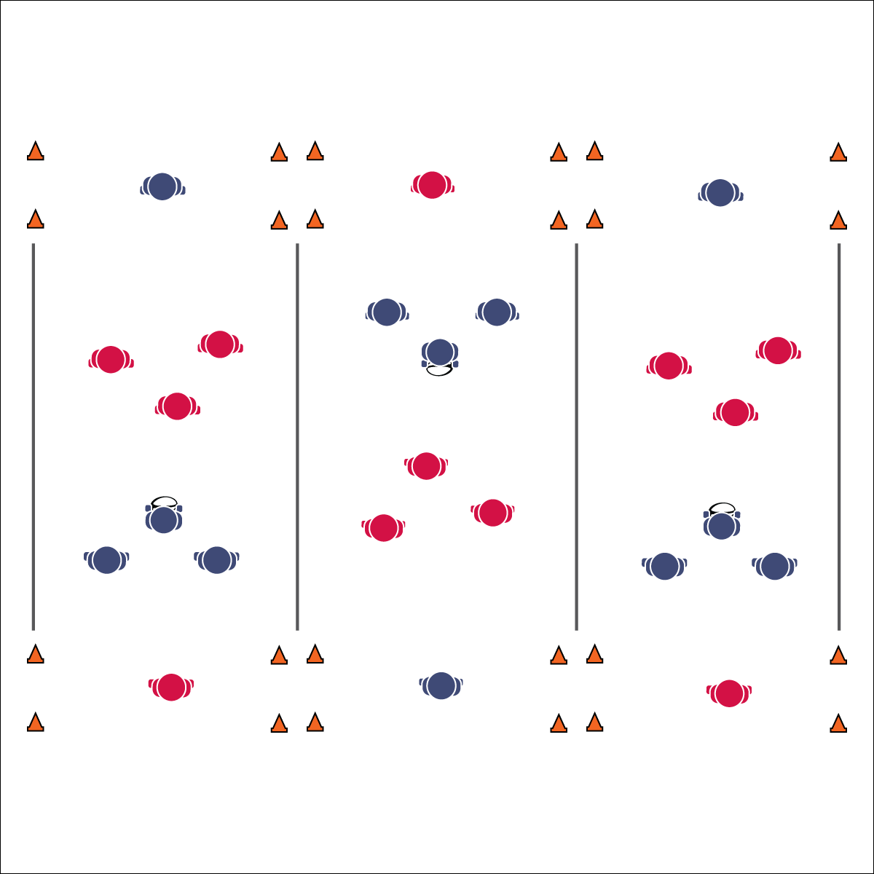

* Review Skill Cues and Strategies

**Equipment:**

* 1 flag belt per student (belts being a different color for each of the 6 teams)
* 1 rugby ball per activity area
* 8 cones per activity area
* Round robin tournament bracket

**Set-Up:**

1. Create a minimum of 3 activity areas (20’x30’).
2. Set up cones to mark the corners of each field, as well as the corners of the end zones.
3. Divide students into 6 even teams; assign each team a number. 2 teams to each activity area.
4. Schedule games using a 6-team round robin bracket.
5. All students on a team need the same color flag.

* **Skill:** I will use both offensive and defensive strategy during game play.
* **Cognitive:** I will identify and discuss how both health- and skill-related fitness are related to successful rugby performance.
* **Fitness:** I will engage in an effort to improve my fitness.
* **Personal & Social Responsibility:** I will honor the Spirit of the Game and self-officiate game play.

**Activity Procedures:**

1. Today’s activity is called Ultimate End Ball. The object of the activity is for:
   1. Offensive players to implement offensive skills, strategies, and teamwork to score.
   2. Defensive players to implement defensive skills, strategies, and teamwork to prevent scoring.
2. One player from each team is chosen/assigned as the “catcher.” The catcher from each team goes to his assigned end zone and her/his teammates scatter on the opposite half of the area. The catcher can move around freely in the end zone but must stay within the sidelines of the activity area.
3. Next, teams play rock, paper, scissors to determine possession. The winning team starts with the ball. They can move in any direction but cannot move more than 3 steps while holding the ball. Passes can be made in any direction. Teams must make at least 3 passes before scoring.
4. Score by completing a rugby pass (pendulum or pop) across the end line to your team’s catcher.
5. If offense drops the ball, completes a non-rugby pass (i.e., a “football pass” or a “baseball throw”), drops a pass, or throws it out of bounds, possession changes on the spot. If defense intercepts a pass or pulls the ball carrier’s flag, possession changes on the spot.
6. After 4 minutes, rotate teams based on a round robin bracket schedule.

**Grade Level Progression:**

**6:** Implement the activity as described above.

**7 & 8:** Play “invasion” style by removing the catcher and allowing teams to run and/or pass the ball to teammates in the end zone.

**ULTIMATE END BALL**

**ULTIMATE END BALL**



* Everyone must touch the ball before a score.
* Increase or decrease the size of the activity area to meet needs of all students.
* Allow defense to tag with pool noodles.
* Slow the pace of the activity.
* Use auditory cues in end zones.
* Allow students to choose the style of ball used.
* Use brightly colored area markers.
* Do not keep score.



* **DOK 1:** What would you include on a list about health-related fitness? About skill-related fitness?
* **DOK 2:** How would you summarize how health-related fitness affects rugby performance? How skill-related fitness affects performance?
* **DOK 3:** What facts would you select to support developing health- (or skill-) related fitness? Can you elaborate on why you chose those facts?
* **DOK 4:** Identify areas of health- and skill-related fitness in which you can improve and design a plan for personal improvement.



* **Standard 2 [M1.6-8]** Creates open space by using locomotor movements (e.g., walking, running, jumping & landing) in combination with movement (e.g., varying pathways; change of speed, direction, or pace) (6); Reduces open space by using locomotor movements (e.g., walking, running, jumping & landing, changing size and shape of the body) in combination with movement concepts (e.g., reducing the angle in the space, reducing distance between player and goal) (7); Opens and closes space during small-sided game play by combining locomotor movements with movement concepts (8).
* **Standard 2 [M4.6-8]** Reduces open space on defense by making the body larger and reducing passing angles (6); Reduces open space on defense by staying close to the opponent as he/she nears the goal (7); Reduces open space on defense by staying on the goal side of the offensive player and reducing the distance to him/her (third-party perspective) (8).
* **Standard 3 [M7.6-8]** Identifies the components of skill-related fitness (6); Distinguishes between health-related and skill-related fitness (7); Compares and contrasts health-related fitness components (8).



Health-Related Fitness, Passing Lane, Possession, Self-Officiate, Spirit of the Game, Skill-Related Fitness, Strategy, Teamwork



**Help students examine their reasoning:** It is often difficult for students to reflect on their own performance and personal areas in need of improvement. Use Growth Mindset language in an effort to help students examine their reasoning in a positive, yet meaningful way. Many times students will shy away from recognizing deficiencies and defend their insecurities with logic that does not match reality. Be gentle but consistent while you help them explore the need for further skill development.

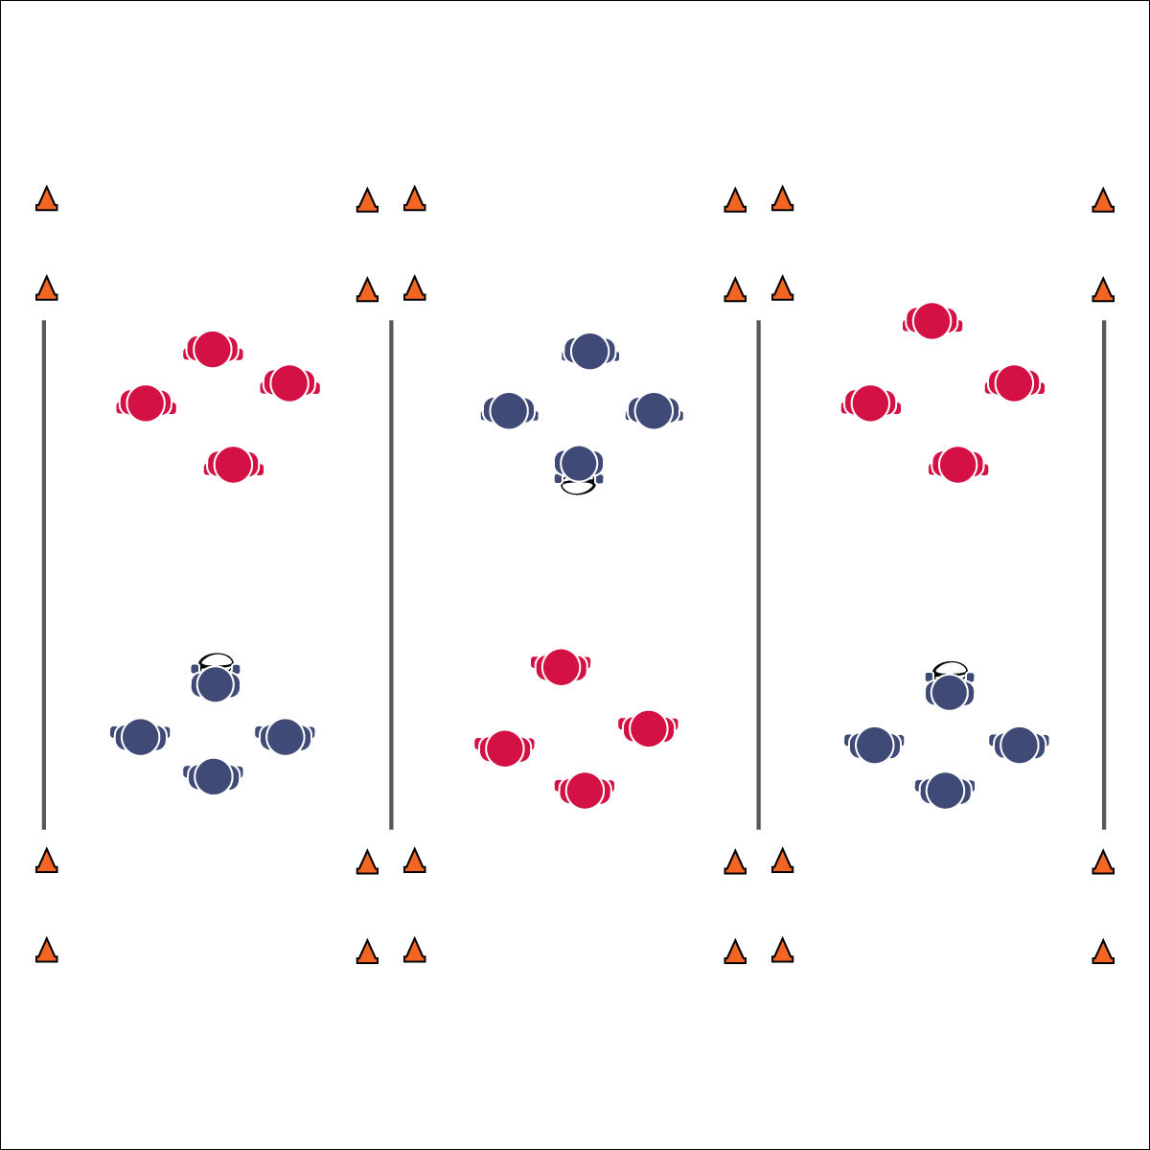

* **Skill:** I will combine skills and strategies learned in all previous ruby lessons in order to successfully participate in Flag Rugby.
* **Cognitive:** I will identify and discuss transitions from offense to defense.
* **Fitness:** I will engage in an effort to improve my fitness.
* **Personal & Social Responsibility:** I will honor the Spirit of the Game and self-officiate game play.

**Equipment:**

* 1 flag belts per student (belts being a different color for each of the 6 teams)
* 1 rugby ball per activity area
* 8 cones per activity area
* Round robin tournament bracket

**Set-Up:**

1. Create a minimum of 3 activity areas, each 20’x30’.
2. Set up cones to mark the corners of each field, as well as the corners of the end zones.
3. Divide students into 6 evenly sized teams; assign each team a number.
4. Schedule games using a 6-team round robin bracket.
5. All players on a team need the same color flag.

**Activity Procedures:**

1. It’s time to play Flag Rugby. The object of the activity is for:
   1. Offensive players to implement offensive skills, strategies, and teamwork to score.
   2. Defensive players to implement defensive skills, strategies, and teamwork to prevent scoring.
2. Play rock, paper, scissors to determine possession.
3. Offense combines offensive skills and strategies in an attempt to score by passing or running the ball across their end line. To score a point, the ball carrier must execute a correct try after crossing the defending team’s end line (down on one knee, both hands touch the ball to the ground).
4. If the offense drops the ball, completes a non-rugby pass (i.e., a “football pass” or a “baseball throw”), drops a pass, or throws it out of bounds, it is considered a lost attempt to score. If defense pulls the ball carrier’s flag it is a lost attempt to score.
5. Offense has 4 attempts to score, and then possession changes. However, if defense intercepts a pass, play does not stop. The defense can run the ball back to score a point (no passing). If the defense fails, possession goes back to the offense to continue their series of tries.
6. After 7 minutes, rotate teams based on the round robin bracket schedule.

**Grade Level Progression:**

**6-8:** Implement the activity as described above.

**FLAG RUGBY**

* Review Skill Cues and Strategies

**FLAG RUGBY**



* **DOK 1:** What does transition mean in relation to offense and defense?
* **DOK 2:** How does this apply to game play in Flag Rugby?
* **DOK 3:** How would you apply all that you’ve learned in Flag Rugby activities to effectively transition from offense to defense (or defense to offense)?



* **Standard 1[M6.6-8]** Performs pivots, fakes, and jab steps designed to create open space during practice tasks (6); Executes at least one of the following designed to create open space during small-sided game play: pivots, fakes, jab steps (7); Executes at least two of the following to create open space during modified game play: pivots, fakes, jab steps, screens (8).
* **Standard 1 [M11.6-8]** Maintains defensive ready position, with weight on balls of feet, arms extended and eyes on midsection of the offensive player (6); Slides in all directions while on defense without crossing feet (7); Drop-steps in the direction of the pass during player-to-player defense (8).
* **Standard 2 [M3.6-8]** Creates open space by using the width and length of the field/court on offense (6); Creates open space by staying spread on offense, and cutting and passing quickly (7); Creates open space by staying spread on offense, cutting and passing quickly, and using fakes off the ball (8).
* **Standard 2 [M6.6-8]** Transitions from offense to defense or defense to offense by recovering quickly (6); Transitions from offense to defense or defense to offense by recovering quickly and communicating with teammates (7); Transitions from offense to defense or defense to offense by recovering quickly, communicating with teammates and capitalizing on an advantage (8).



Select academic language vocabulary to review from previous lessons.



* Everyone must touch the ball before a score.
* Increase or decrease the size of the activity area to meet needs of all students.
* Allow defense to tag with pool noodles.
* Slow the pace of the activity.
* Use auditory cues in end zones.
* Allow students to choose the style of ball used.
* Use brightly colored area markers.
* Do not keep score.



**Help students practice skills, strategies, and processes:** Dynamic game play is an essential component of the learning process in physical education. However, too often PE teachers assume students will learn through this experience with little or no further instruction. This assumption is false and dangerous. It can lead to a buildup of student frustration and ultimately a negative sport experience. It is the teacher’s responsibility to find individual and group teachable moments and then capitalize on those opportunities. Stop a game, take time to discuss what’s happening, and help students connect the dots from previous lessons. At the end of each game, bring students together to discuss and process what you observed and what they experienced.