­­­

* Basic Rugby Pass
* Pendulum Motion
* Pop Pass
* Purposeful Practice
* Skill-Related Fitness

­

* **Skill:** I will perform a hand-off, a basic rugby pass, and a pop pass following all skill cues.
* **Cognitive:** I will discuss the importance of purposeful practice.
* **Fitness:** I will engage in an effort to build skill-related fitness.
* **Personal & Social Responsibility:** I will cooperate with my teammates by making accurate passes and focusing on clean catches.
* **Standard 1 [M5.6-8]** Throws, while stationary, a leading pass to a moving receiver (6).
* **Standard 3 [M7.6-8]** Identifies the components of skill-related fitness (6).
* **Standard 5 [M6.6-8]** Demonstrates respect for self and others in activities and games by following the rules, encouraging others, and playing within the spirit of the game or activity (6); Demonstrates the importance of social interaction by helping and encouraging others, avoiding trash talk, and providing support to classmates (7).
* Purposeful Practice Plans

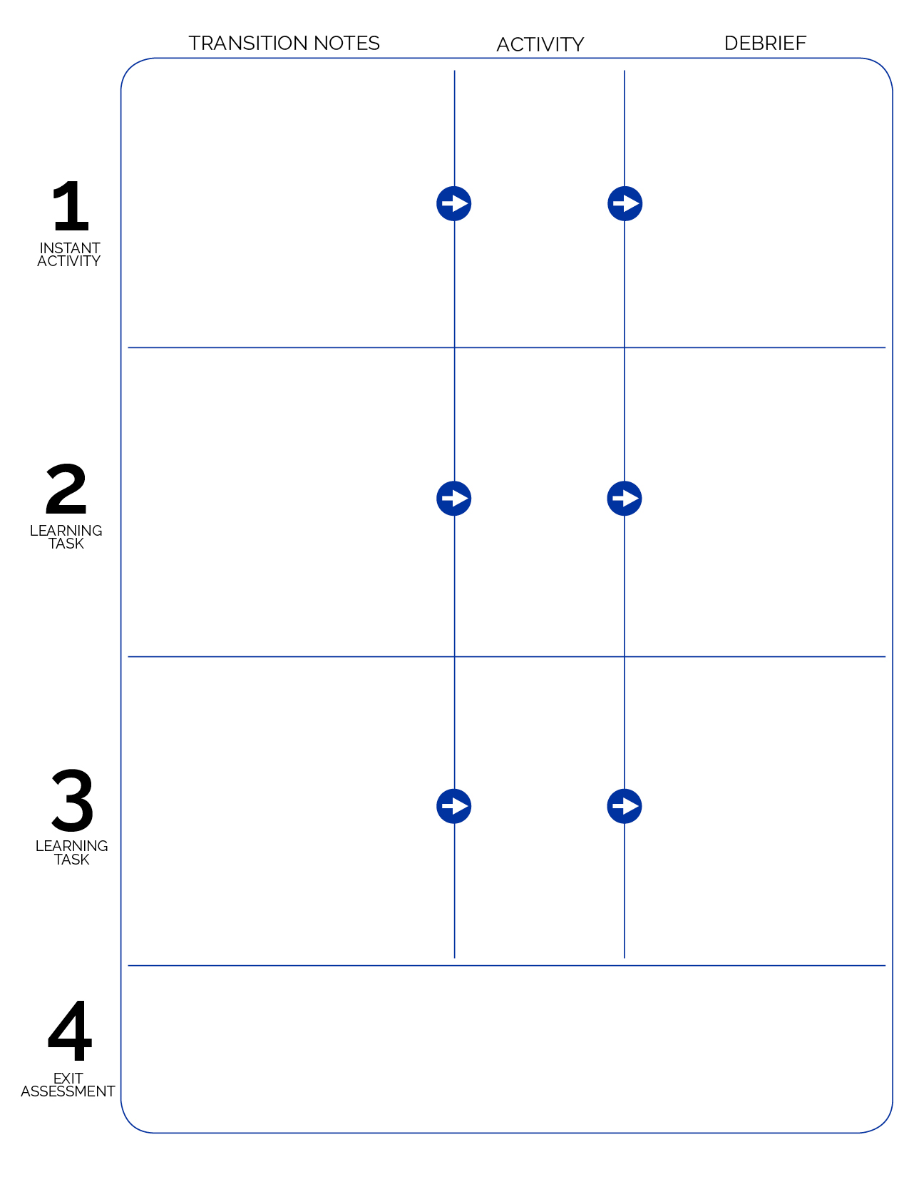

Set the hook for Rugby with Flag Rugby Highlight Videos from YouTube. (Search “Flag Ruby” and preview/select videos prior to class.) Teach Cage Grip with Skill Cue Chart, then begin Rugby Tag.

Organize stationary passing activity lines. Teach pendulum motion, hand-offs, then passing technique in layers. Display skill cue charts as you layer instruction. Use same group formations to play leader ball (time permitting).

**1:** What is purposeful practice?

**2:** Compare and contrast purposeful practice with unfocused participation.

**3:** How is purposeful practice related to skill development?

**4:** Develop a rugby practice plan to implement at home.

**Purposeful Practice Plan** – Use 5 to 7 minutes at the end of the lesson to complete and then collect Purposeful Practice Plan. Encourage students to follow these plans outside of PE. Place finished plans in student portfolios.

**1:** Can you recite the cues for a cage grip?

**2:** How does grip affect your ability to carry the ball?

**3:** What facts would you select/identify to support the use of a proper grip? Why did you choose those facts?

Empire Tag

As students enter the activity area they put on a flag belt (any color). Modify Empire Tag – when a flag is pulled that person joins the Empire and leaves flag belt off.

**1:** What are the components of skill-related fitness?  
**2:** How does skill-related fitness affect a person’s ability to reach physical activity/sport goals?

Stationary Passing / Leader Ball

Rugby Tag