­­

ABC’s of Movement

**BALANCE SHUFFLE**

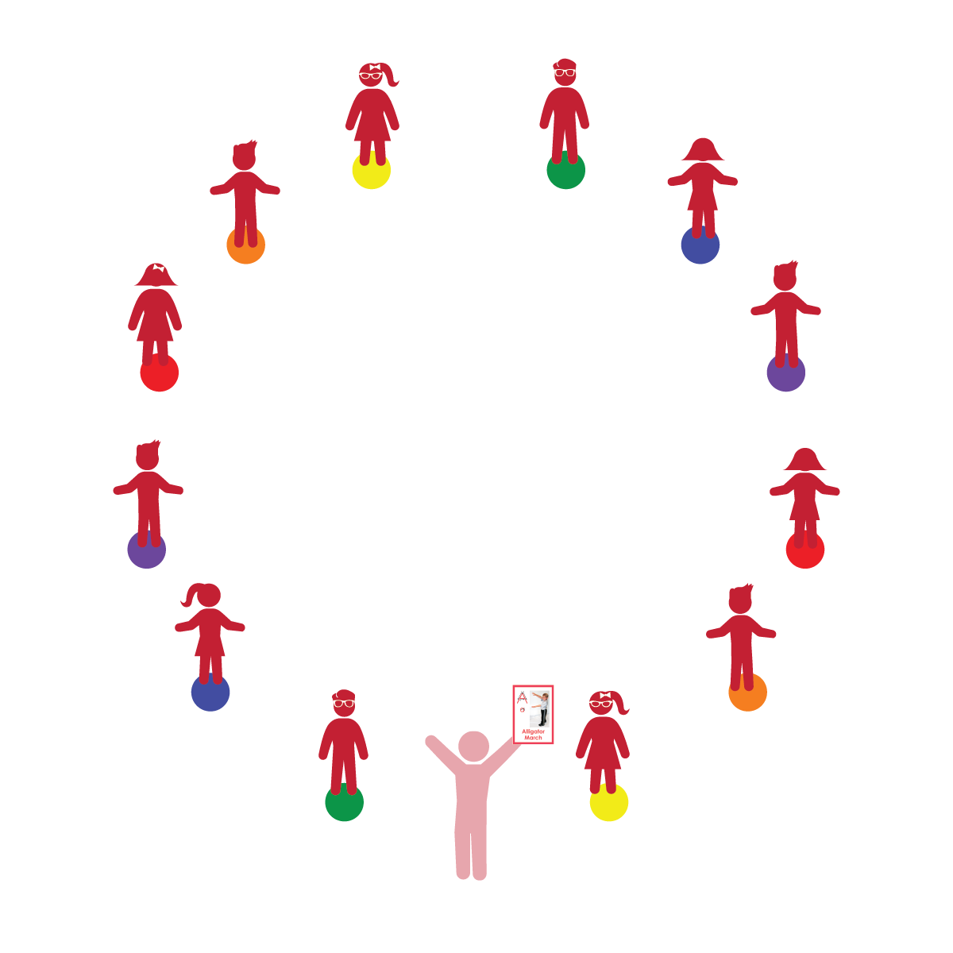­

**Things You Need:**

* ABC’s of Movement Cards: H, L, T, X
* 1 spot marker per student
* Music (optional)

**Set-Up:**

1. Use spot markers to create a large circle in the activity area.
2. Provide enough space between spots for movement on and around each spot.
3. Arrange students in a circle, each student on a spot.

**Activity Procedures:**

1. This activity will allow students to practice and develop both dynamic and static balance.
2. The teacher shuffles the selected movement cards. Students take turns picking a card.
3. Next, all students identify the letter on the card and then perform the activity on or around their spots for 30 to 60 seconds.
4. When the teacher calls out, “FREEZE!” (or the music stops), all students must freeze and hold their body position for 5 seconds.

**Universal Design Modifications:**

* Look through all of the ABC’s of Movement Cards and choose the cards that meet the needs and abilities of your students.
* Practice static and dynamic balance separately. For basic static balance practice, prompt students to stand tall with feet together, stand on 1 foot, or balance on hands and feet (bear position).
* **Gross Motor:** Child demonstrates balance in large-muscle movement.
* **Gross Motor:** Child coordinates movements and actions for a purpose.
* **Cognitive Self-Regulation:** Child persists in tasks that are challenging.

* I will follow directions and hold my body still when I hear the FREEZE signal.
* I will control my body and move with balance.
* I will try my best, even if a movement or balance is difficult.