­­

**WATERFALL**

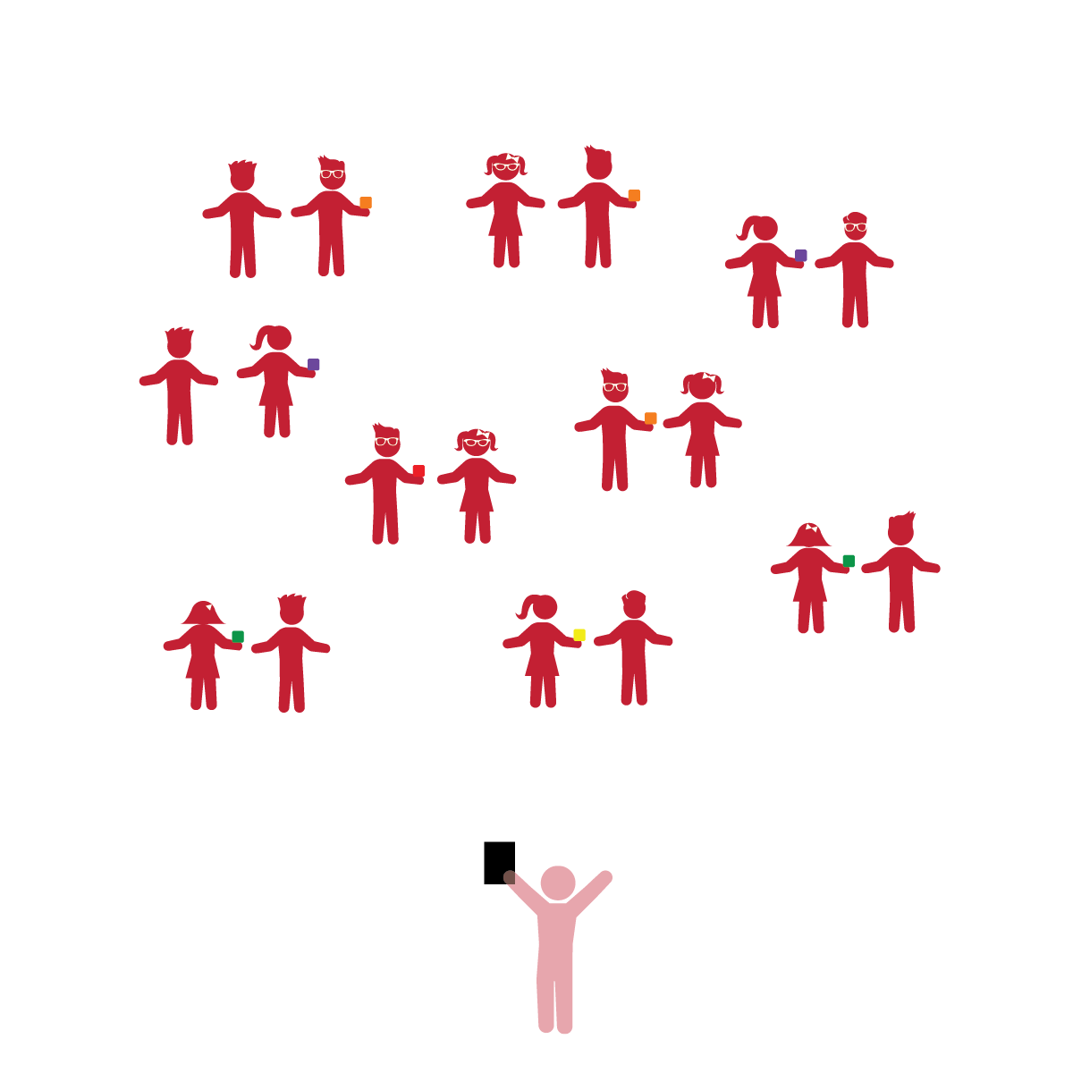­

**Activity Procedures:**

1. The objective of this activity is for students to work together while pretending to be a waterfall.
2. We’re going to play a game called *Waterfall.* Before we start, look around and take note of your personal space.
3. We’re going to pretend that the bean bags are water in a waterfall. When I say “GO,” 1 student from each pair will hold the bean bag and stand tall. Their partner will crouch down. The tall student will drop the bean bag, and the low student will catch it.
4. Once the bean bag is caught, the low student becomes the tall student and the tall student becomes the low student.

**Universal Design Modifications:**

* Once students have mastered the movement, add a fitness focus by challenging them to move up and down quickly.
* Instead of switching places after each catch, have students stay in their positions for 30 seconds and count how many catches they get. Next time, try to beat your own score.
* **Gross Motor Development:** Demonstrates control, strength, and coordination of large muscles.
* **Relationships with Others:** Engages in cooperative play with other children.
* **Creativity:** Uses imagination in play and interactions with others.

**Things You Need:**

* 1 bean bag per 2 students
* Cones to create boundaries

**Set-Up:**

1. Pair students, each pair with a bean bag. Scatter pairs in general space.
2. Be sure spacing between students is safe.

* I will play cooperatively with my classmates.
* I will use my body to drop or catch the bean bag.
* I will use my body to move from a low level to a high level and back to a low level.
* I will move as fast as I can to make my heart beat faster.