­­

**Hygiene Habits**

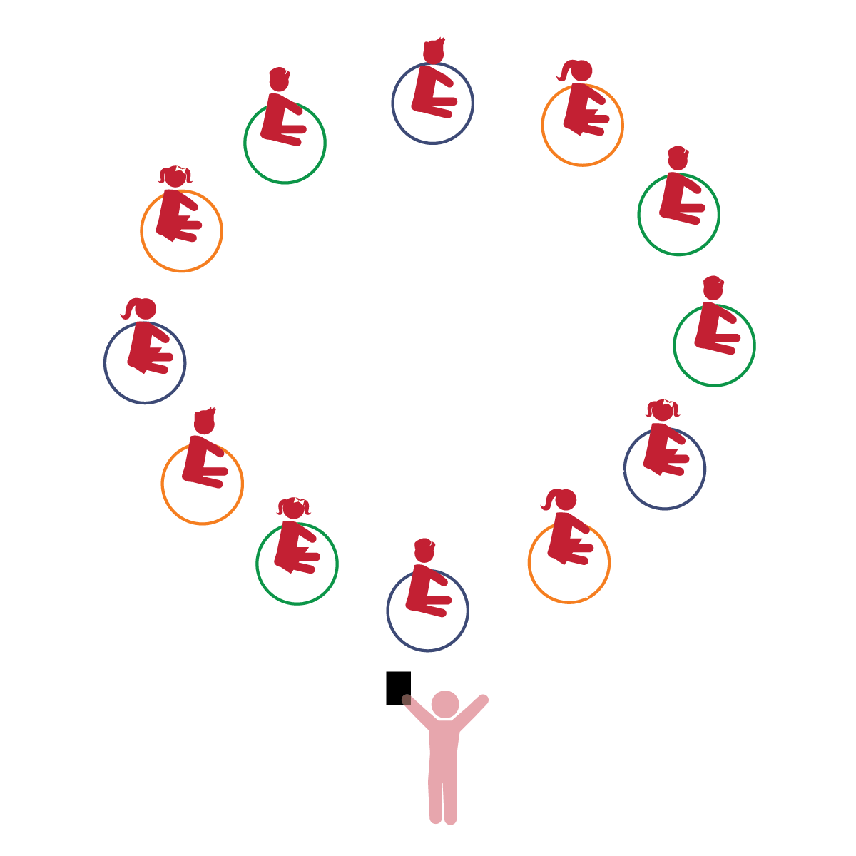­

**Things You Need:**

* 1 hoop per student
* Music
* Cones to create boundaries

**Set-Up:**

1. Scatter students in general space, each student with a hoop.
2. Students place their hoops on the floor at their feet. They begin sitting inside their hoops.
3. Be sure spacing between students is safe for activity.

**Activity Procedures:**

1. The purpose of the activity is to review healthy hygiene habits.
2. Today we’re going to play a game called *Hygiene Habits.* Before we start, look around and take note of your personal space.
3. Discuss healthy hygiene as a class. Explain why these habits are important for kids (and adults).
4. It’s time to act out our healthy habits. Your hoop is your bed. When I say, “Go to sleep,” lie down and pretend to sleep. When you hear a healthy habit, wake up and act it out. Ready to learn?
5. Provide students with prompts such as brush your teeth, take a bath/shower, wash your hands, eat with a fork, put on clothes, drink from a cup, etc. Then provide students with a sequence of events to act out (e.g., One day a tall student got home, washed their hands, ate a small apple for snack, drank a glass of water, and then went for a walk).
6. Progression: Play music and have students move safely inside the playing area using various locomotor skills (walk, gallop, jump, etc.). When the music stops, students can find a new bed to sleep in.

**Universal Design Modifications:**

* Have students watch other students for cues as to what to do.
* Ask students to create their own sequence of healthy habits to act out.
* I will understand the importance of practicing personal hygiene.
* I will understand the fact that eating a variety of foods helps my body grow up healthy.
* I will act out a story, putting events in the appropriate sequence.
* **Health, Safety & Nutrition:** Demonstrates personal hygiene and self-care skills.
* **Health, Safety & Nutrition:** Develops knowledge and skills that help promote nutritious food choices and eating habits.
* **Comprehension and Text Structure**: Demonstrates an understanding of narrative structure through storytelling/re-telling.