­­

**GIVE WITH IT**

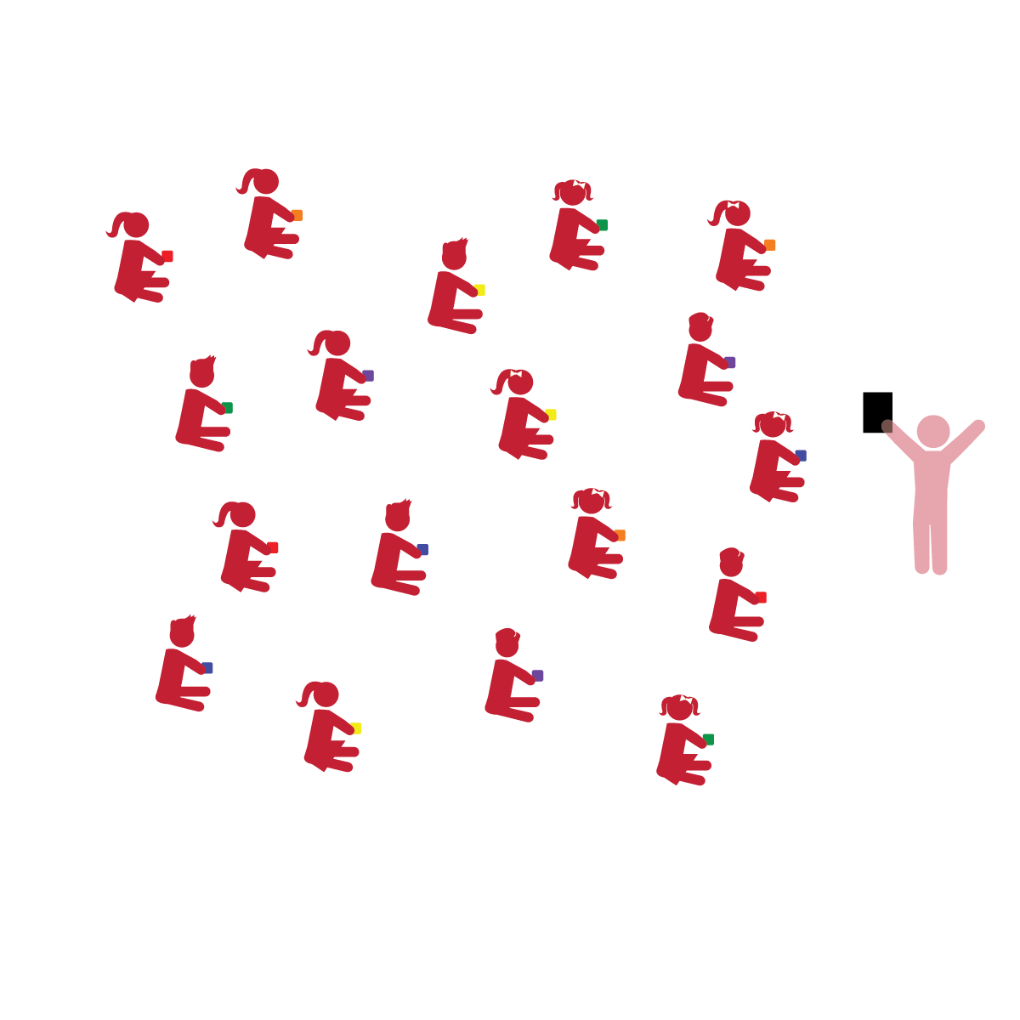­

**Activity Procedures:**

1. The objective of this activity is to learn how to effectively catch a bean bag.
2. We’re going to play a game called *Give With It.* Before we start, look around and take note of your personal space.
3. We’re going to pretend our bean bags are really eggs. We will try to toss the egg and catch it without dropping it. We’ll practice at a low level, a medium level, and a high level.
4. Teachers, demonstrate and explain how to “give with it” to soften the catch.
5. Level 1: sit and toss; Level 2: kneel and toss; Level 3: stand and toss.
6. Add movement concepts when students are ready for a challenge (i.e., catch at a low level, high level, medium level; toss, clap and catch, etc.).

**Universal Design Modifications:**

* Teach children how to catch in the midline and absorb the catch.
* Once standing, students can toss, move, and catch by using a sidestep.
* **Gross Motor Development:** Demonstrates control, strength, and coordination of large muscles.
* **Gross Motor Development:** Uses perceptual information to guide motions and interactions with objects and other people.
* **Emotional and Behavioral Self-Regulation:** Manages actions and behavior with increasing independence.
* **Cognitive Self-Regulation:** Persists in tasks.

**Things You Need:**

* 1 bean bag per student
* Cones to mark boundaries

**Set-Up:**

1. Scatter students in personal space, each sitting on the floor with a bean bag in their hands.
2. Be sure spacing between students is safe.

* I will use control to toss and catch the bean bag.
* I will challenge myself to toss and catch the bean bag at different levels.
* I will complete the tasks independently until the teacher gives me feedback or a different task.