­­

**SCARF PASS SHARE**

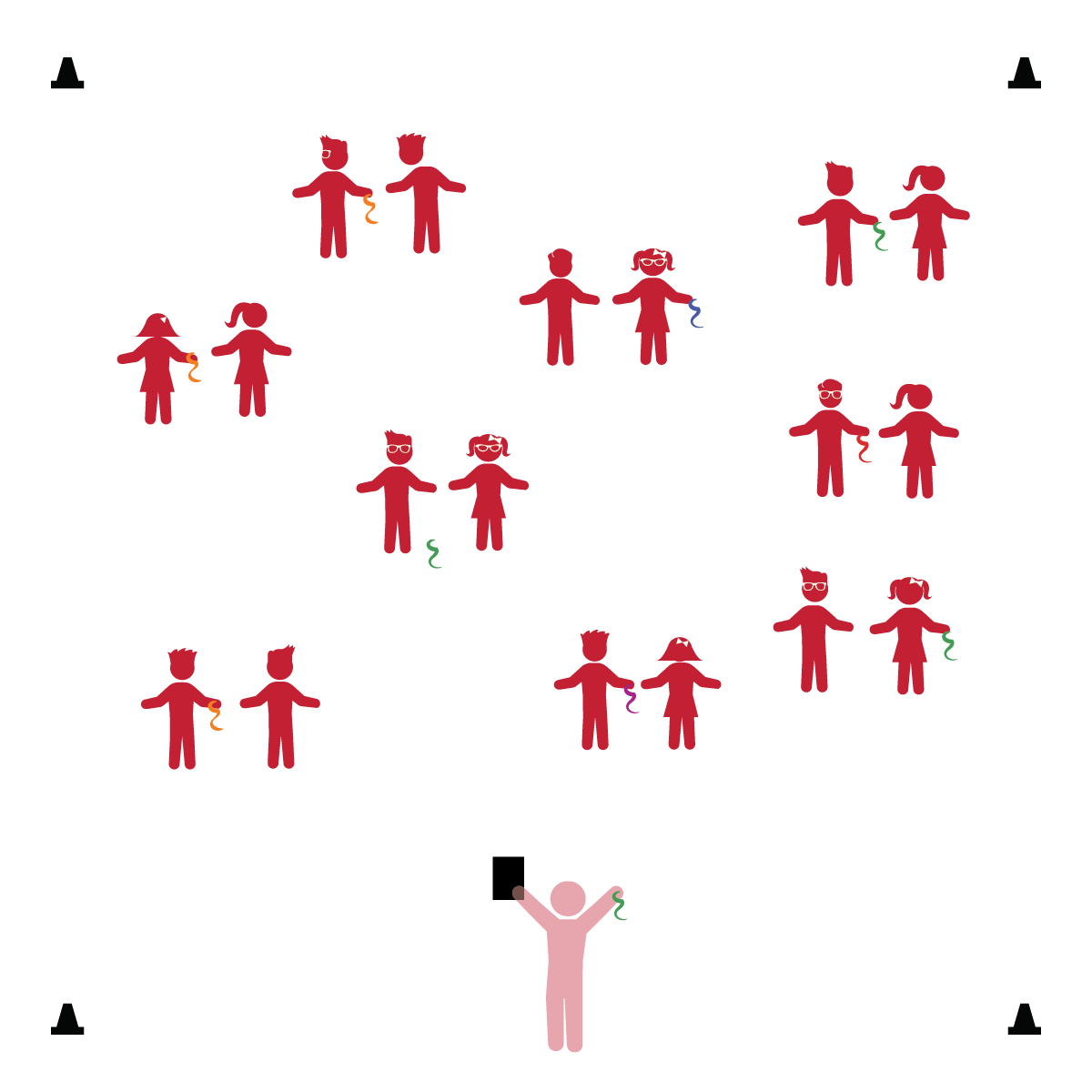­

**Things You Need:**

* 1 scarf per pair of students
* Cones to create boundaries.

**Set-Up:**

1. Pair students. Each pair scattered in general space with a scarf.
2. Be sure spacing between pairs is safe.

* **Gross Motor Development:** Demonstrates control, strength, and coordination of large muscles.
* **Gross Motor Development:** Uses perceptual information to guide motions and interactions with objects and other people.
* **Geometry and Spatial Sense:** Explores the positions of objects in space.
* **Relationship with Other Children:** Engages in cooperative play with other children.

**Activity Procedures:**

1. The objective of this activity is to pass and share the scarf between two friends.
2. We’re going to play a game called *Scarf Pass Share*. Before we start, look around and take note of your personal space.
3. Stand face-to-face with your partner. When I say, “GO,” pass the scarf by throwing it at a low level.
4. Progress to medium and high levels.
5. Next, have students stand back to back and twist their bodies to pass the scarf from side to side.

**Universal Design Modifications:**

* Add more challenges like passing up and down. Ask students to add their own way of passing.
* Pass the scarf without throwing.
* I will pass and share a scarf with a friend.
* I will move and control my body in order to pass the scarf to my friend.