­­

**SIMON SAYS**

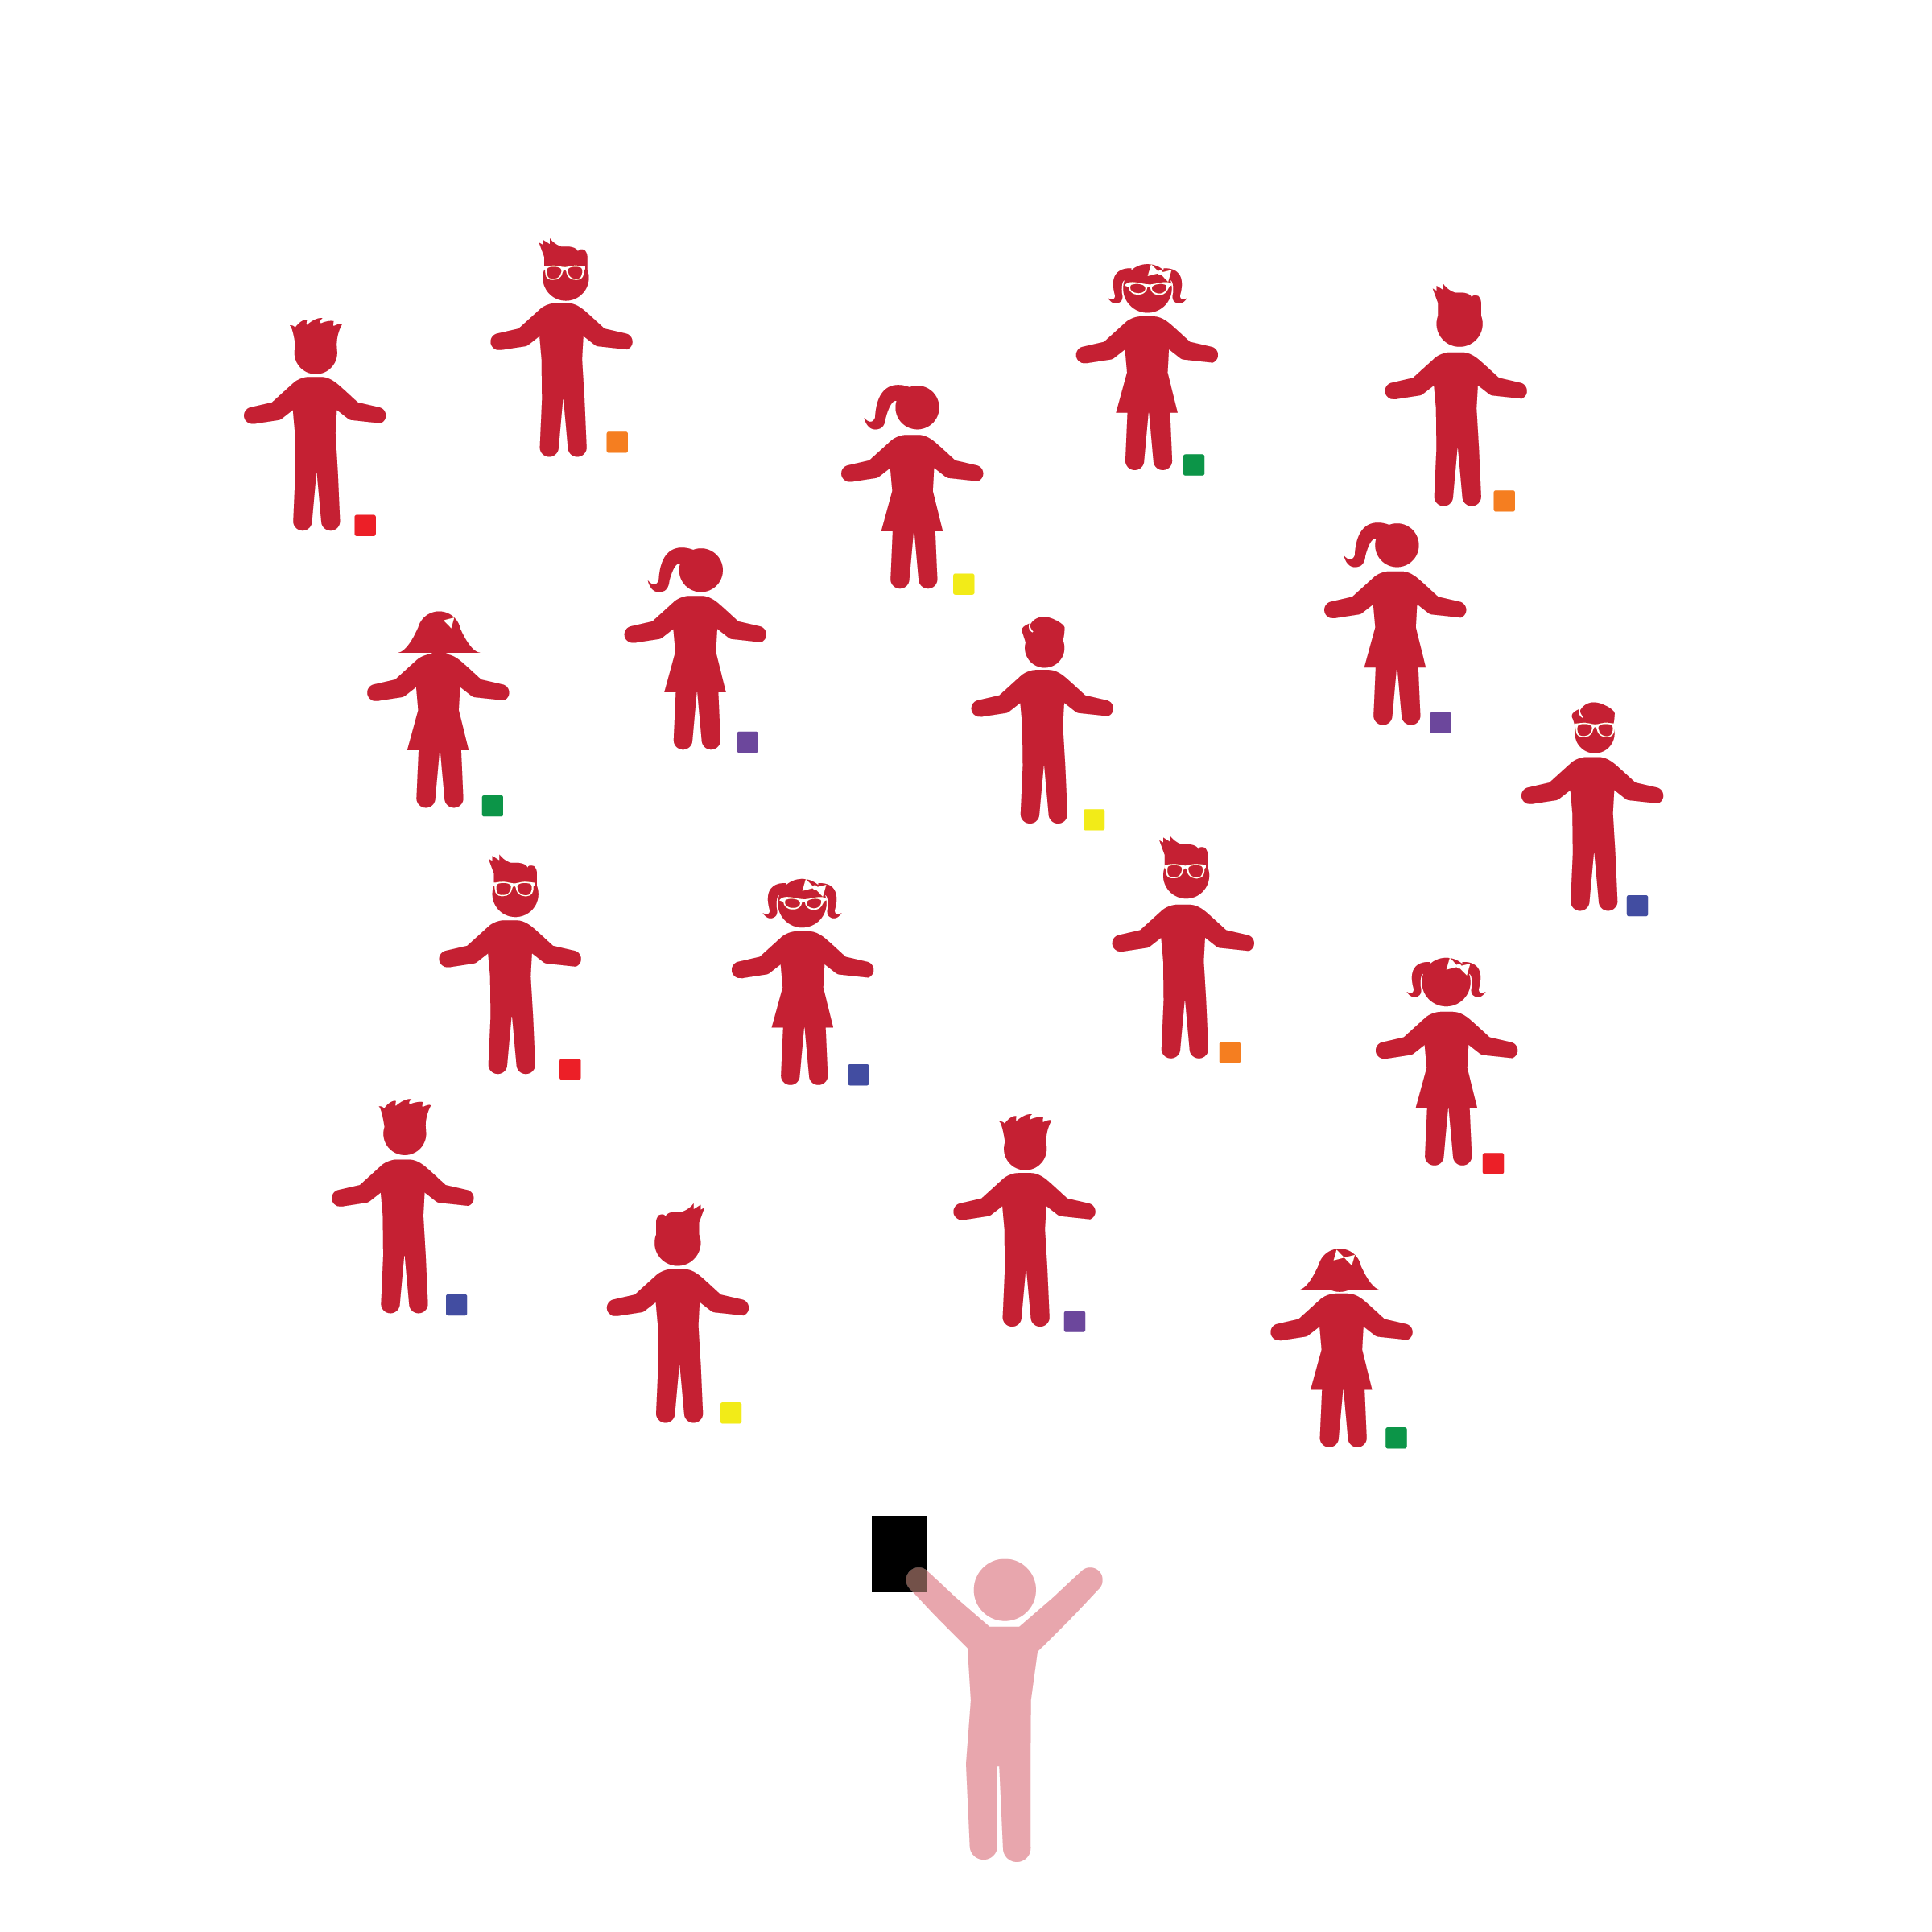­

**Activity Procedures:**

1. The objective of this activity is to listen to and follow the directions of the teacher to perform the task.
2. Today we’re going to play *Simon Says* with our bean bags*.* Before we start, look around and take note of your personal space.
3. We can only perform a task if Simon says it. If I don’t tell you, “Simon says,” stand still and don’t perform the task.
4. Task examples: Stand next to bean bag, stand behind bean bag, stand in front bean bag, stand near the bean bag, stand far from the bean bag and come closer, stand on top of the bean bag, stand under the bean bag, stand over the bean bag.

**Universal Design Modification:**

* Incorporate movement concepts such as curling, bending, stretching, twisting, and swinging.
* **Gross Motor Development:** Demonstrates control, strength, and coordination of large muscles.
* **Attending and Understanding:** Understands and responds to increasingly complex communication and language from others.
* **Vocabulary:** Understands and uses a wide variety of words for a variety of purposes.

**Things You Need:**

* 1 bean bag per student
* Cones to mark boundaries

**Set-Up:**

1. Scatter students in personal space, each standing with a bean bag on the floor in front of them.
2. Be sure spacing between students is safe.

* I will remember different vocabulary words and follow directions to move my body in relationship to the bean bag.
* I will move my body only when “Simon” asks me to do so.