­­

**GOTCHA!**

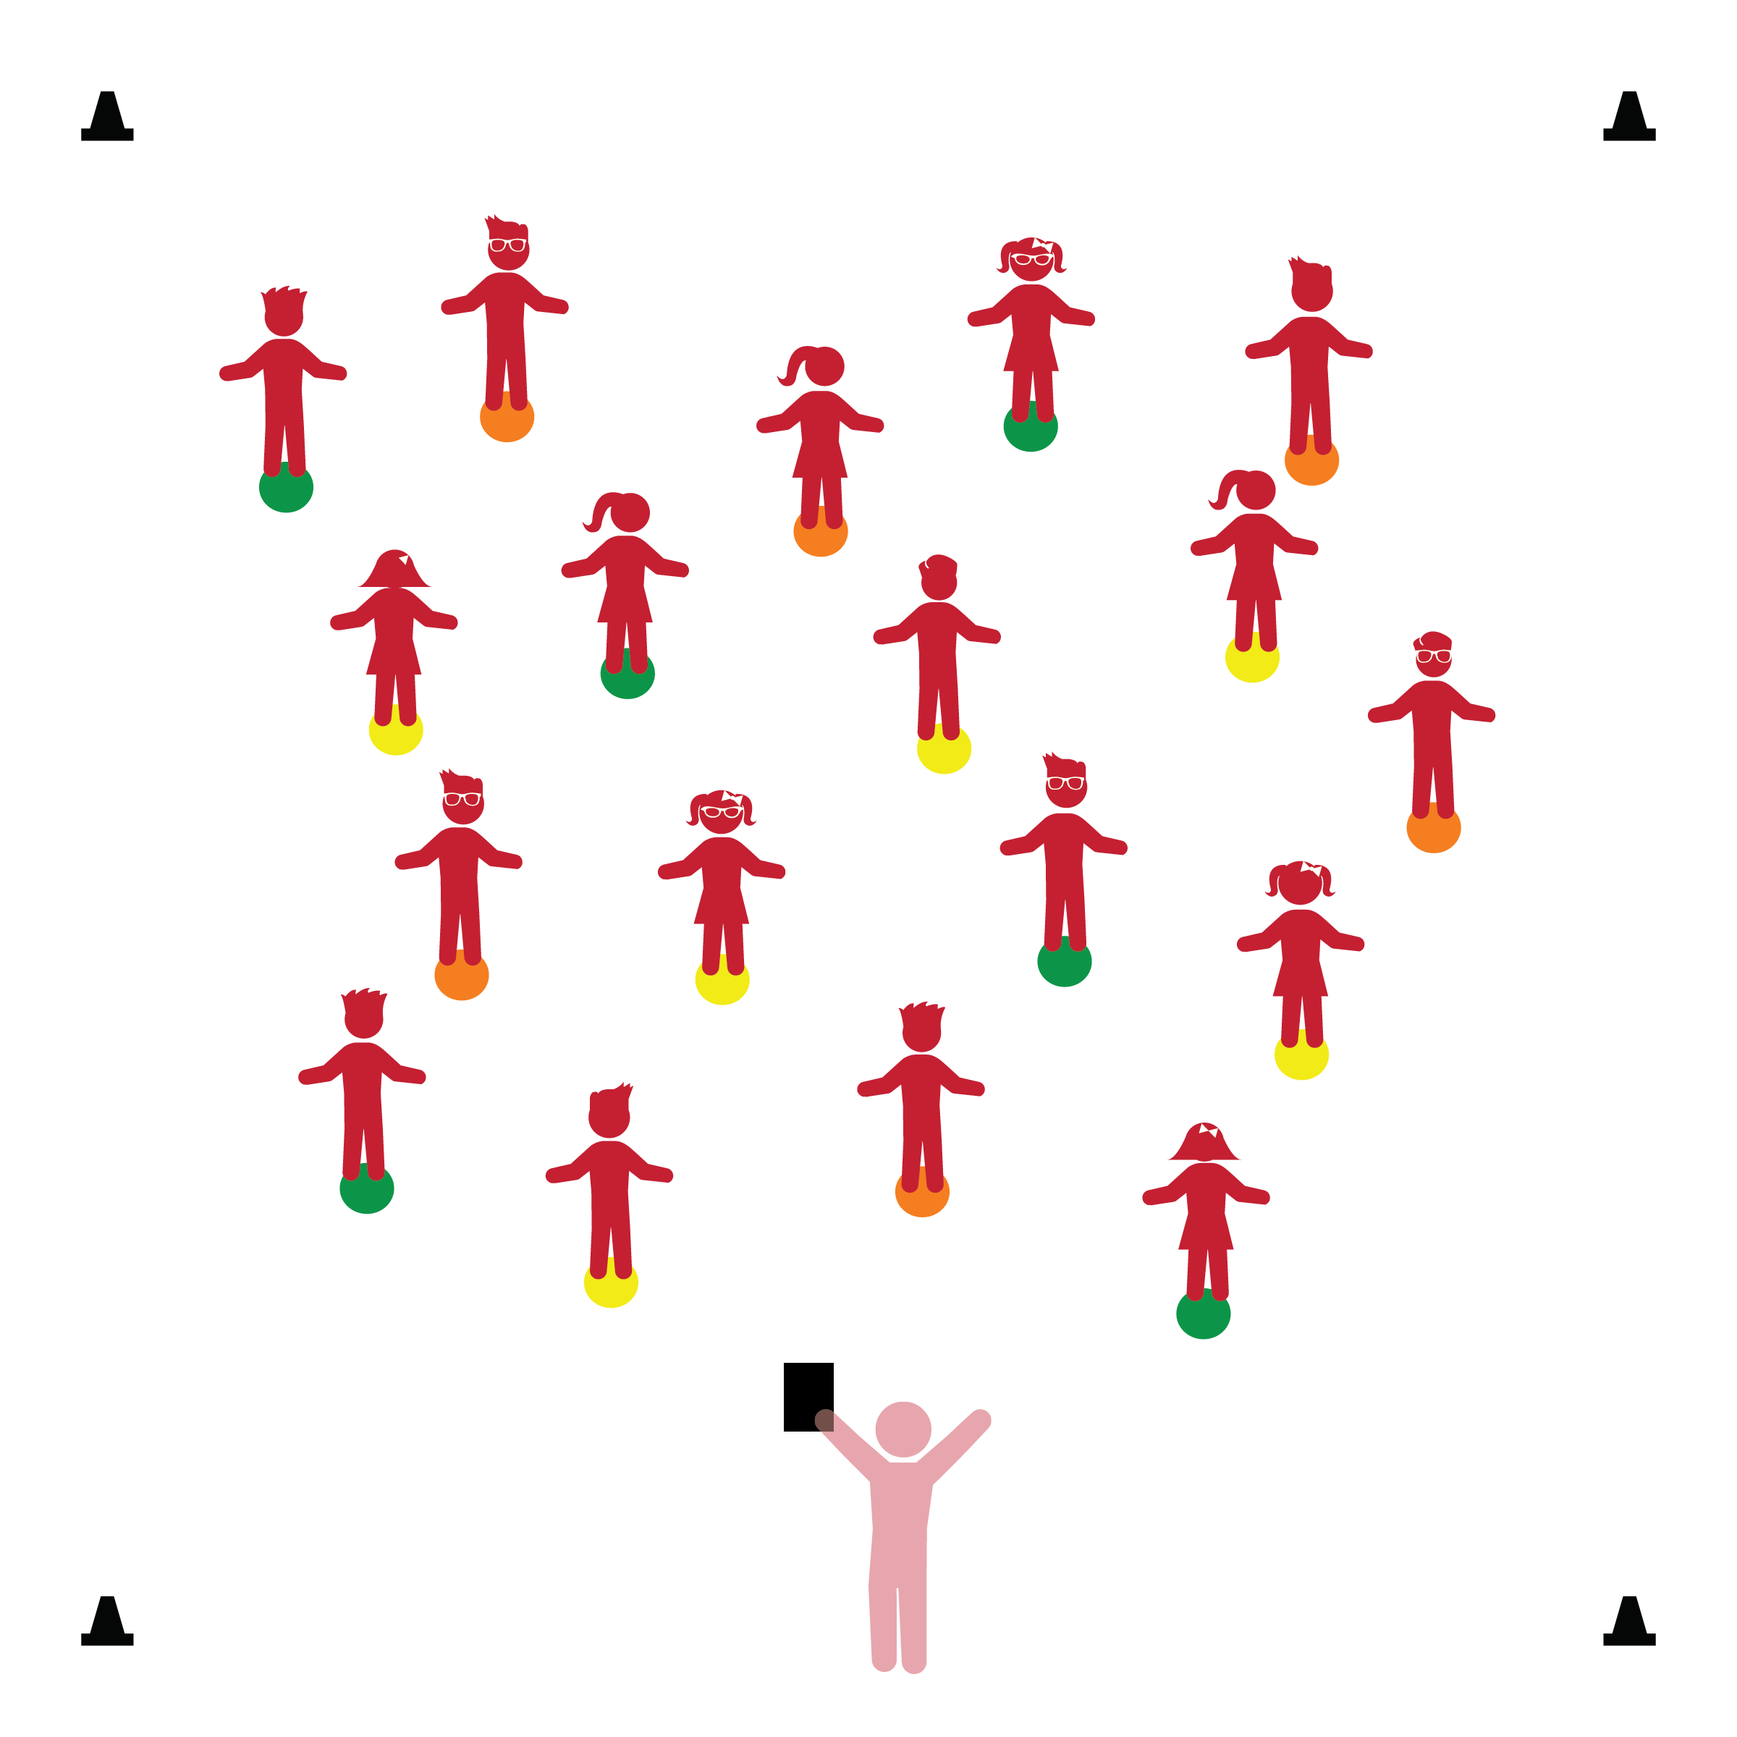­

**Activity Procedures:**

1. Today we’re going to practice our 4 Physical Activity Rules. (Review rule poster.) Let’s focus on Active Ears by listening for start and stop signals.
2. This activity is called, “Gotcha!” The object of this activity is to start and stop moving when you hear the signals so that I don’t yell, “Gotcha!”
3. When I say the word, “Go!” you will safely walk around the activity area. Be careful not to step on any spots. When you hear the word, “Freeze!” stop right where you are and freeze your body. If I see any students moving after I say, “Freeze” I’ll say, “Gotcha!”
4. When I say, “Go Home!” you’ll walk safely back to your Home Base and we’ll start again.
5. Next, we’ll use music as a start and stop signal. When you hear the music, begin walking. When the music stops, freeze your body.
6. Now, let’s play again. This time when you hear, “Freeze!” freeze your body in a balance challenge position (e.g., on 1 foot, on tip toes).

**Universal Design Modification:**

* Use visual signals for start and stop (e.g., colored signs – green/red, raised hand, etc.)
* **Perceptual Development:** Uses perceptual information in directing own actions. Moves body in relation to objects.
* **Gross Motor Development:** Demonstrates balance in large-muscle movement.
* **Safety:** Demonstrates knowledge of personal safety practices and routines.

**Things You Need:**

* 1 spot marker per student
* 4 cones to create activity area boundaries
* Physical Activity Rules Poster
* Music and music player
* Green/red colored signs (optional)

**Set-Up:**

1. Create an activity area using cones or another visible object as boundaries.
2. Scatter spot markers throughout the activity area as home bases for each student.
3. Each student is standing on a home base (spot marker).
4. Be sure spacing between students is safe.

* I will follow all physical activity rules.
* I will control my body by starting and stopping with the signals.
* I will talk about why it’s important to start and stop with the teacher’s signals.