­­

**IMAGINARY FENCE**

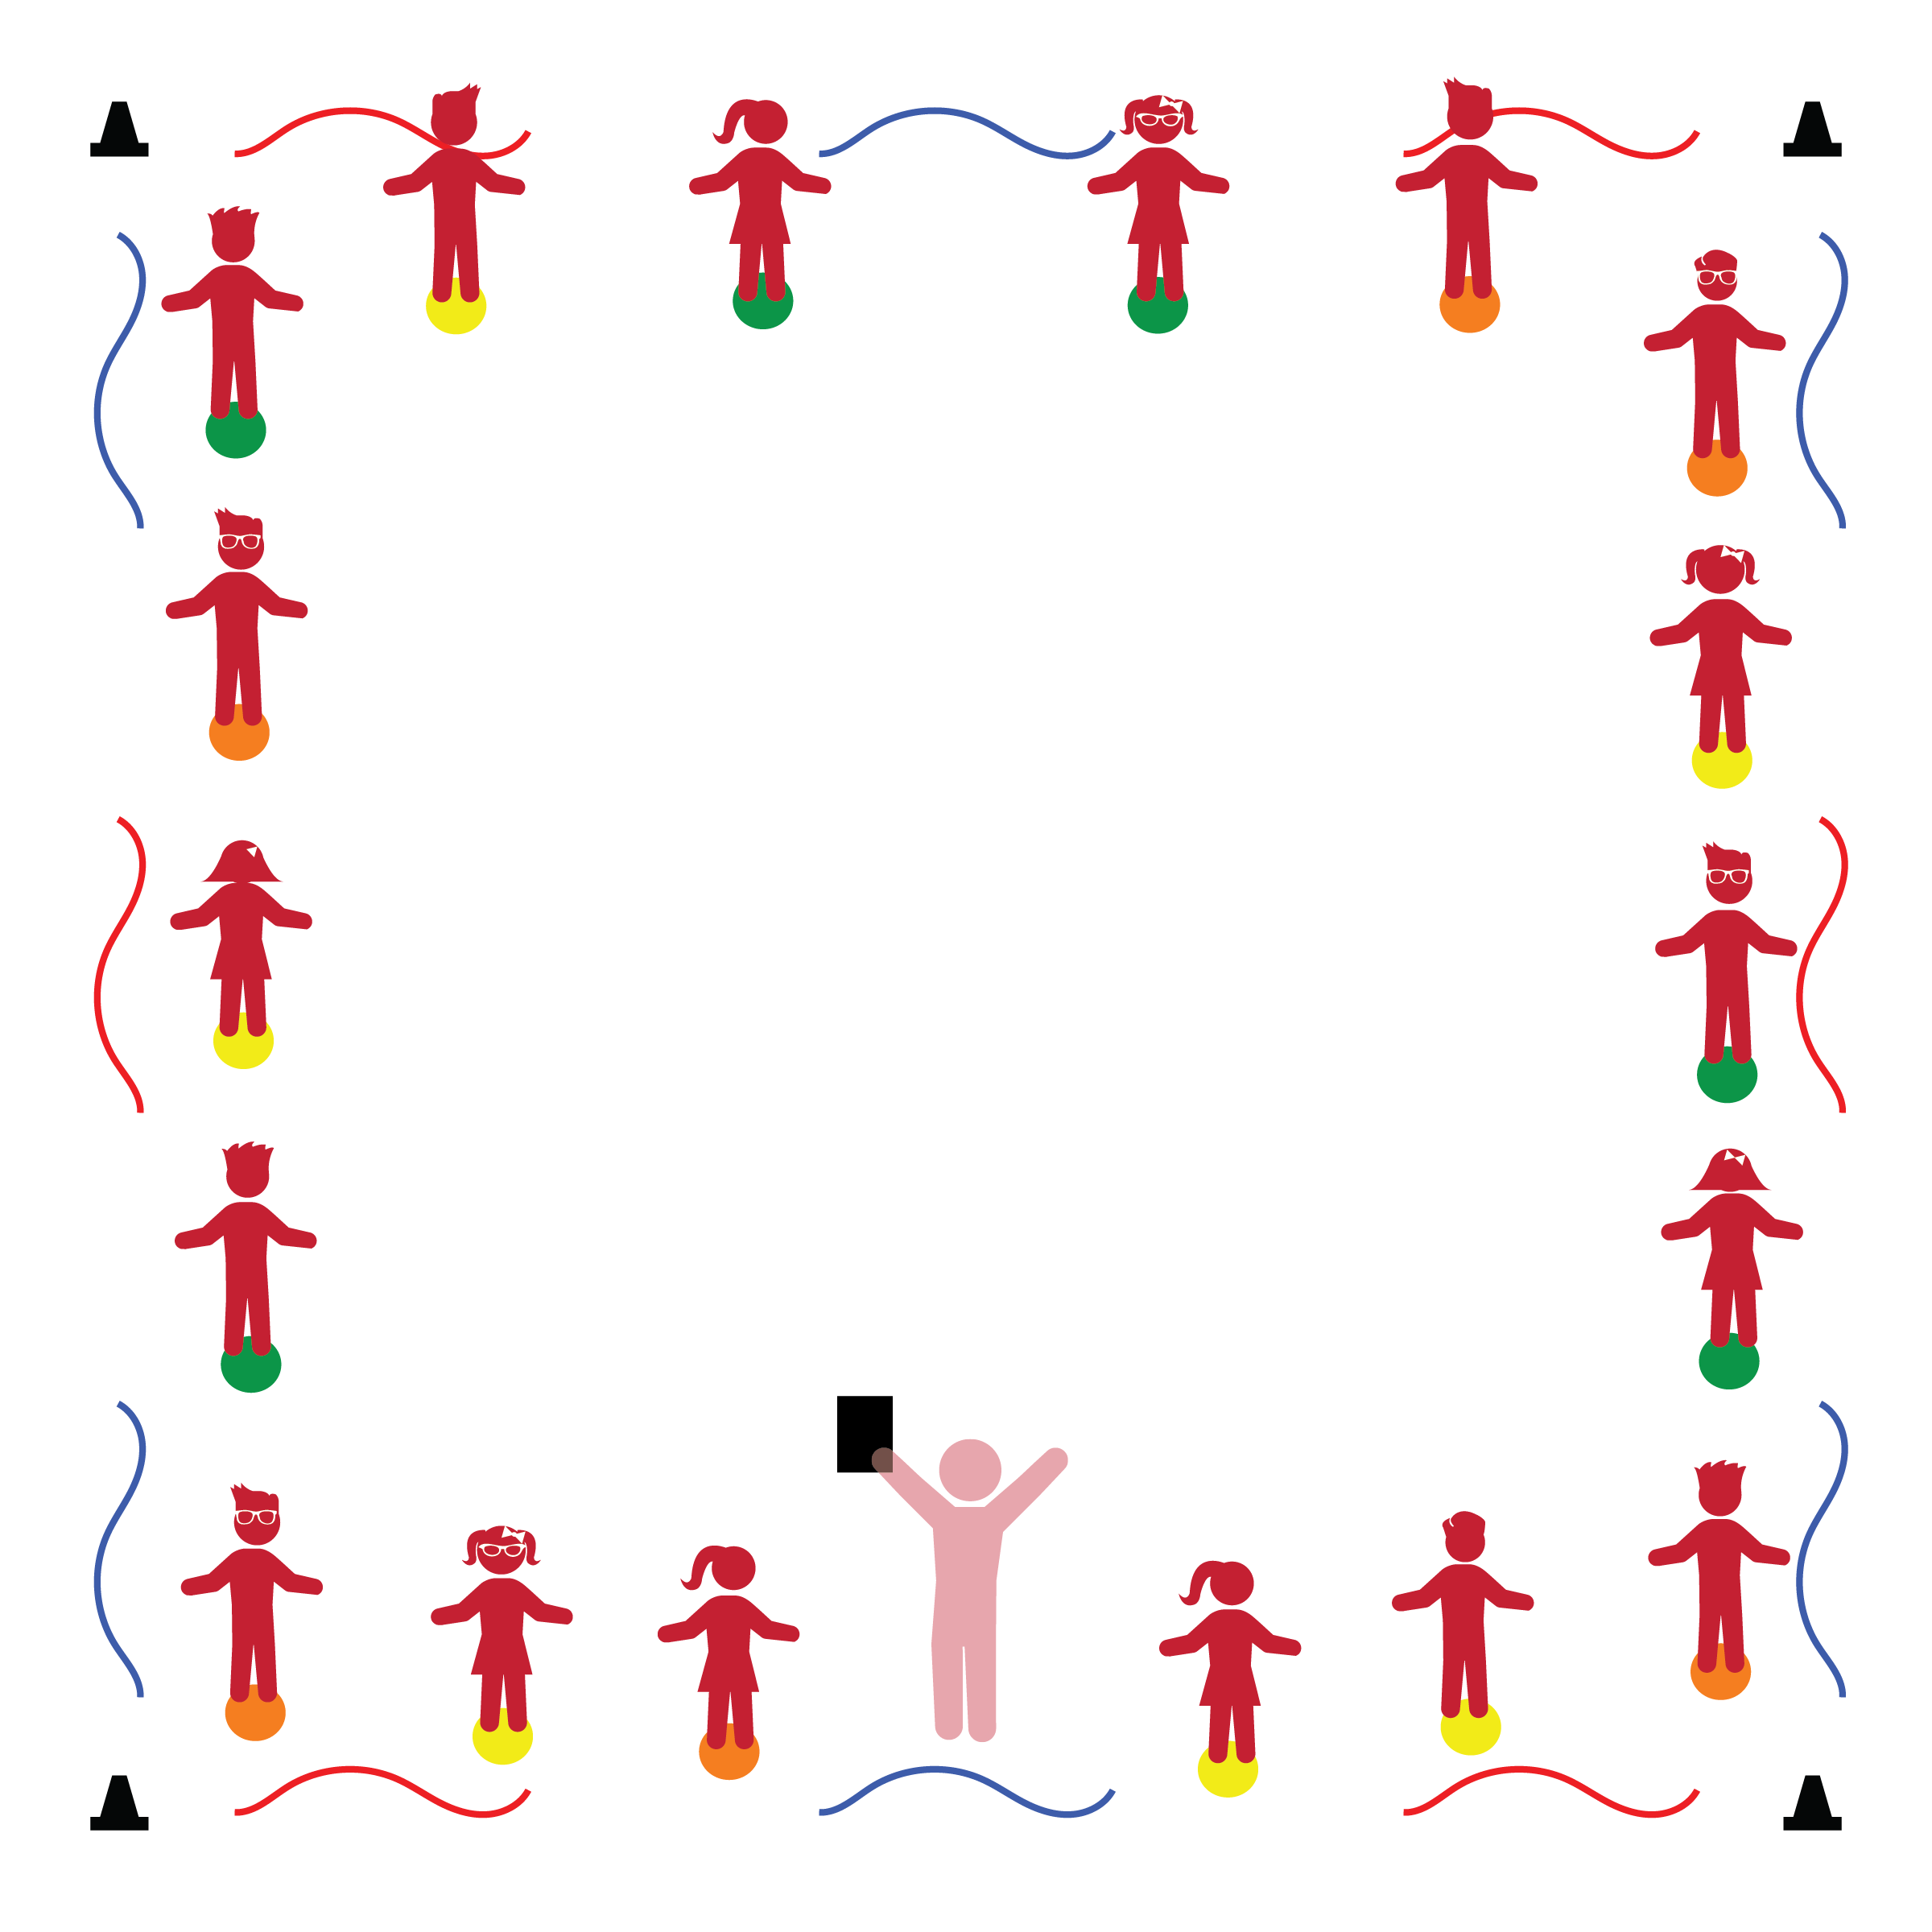­

* **Behavioral:** Demonstrates control of actions and behaviors.
* **Creativity:** Demonstrates imagination in play.
* **Gross Motor Development:** Demonstrates balance in large-muscle movement.
* **Safety:** Demonstrates knowledge of personal safety practices and routines.

**Activity Procedures:**

1. In this activity we’re going to continue practicing our 4 Physical Activity Rules. Now let’s focus on Active Eyes by watching for area boundaries.
2. This activity is called Imaginary Fence. The object of the activity is to move safely inside of our activity boundaries. An example of a boundary is a fence. Some people use fences to keep animals in a yard.
3. When I say, “GO!” (or the music starts), you can move off of your spots and travel through open space in our activity area. When I say, “Freeze!” (or the music stops), freeze your body in the shape of the animal that you want to keep safely inside our fence.
4. Next, on the start signal, you’ll move like that animal inside of our fence. On the stop signal, freeze your body and pretend that the animal is sleeping.

**Universal Design Modifications:**

* Start the activity with one animal movement. For example, a horse. Let students safely explore space while creatively moving like a horse. As student progress, prompt them to gallop like a horse with a focus on galloping cues (1 lead foot step, feet together, lead foot step, feet together).
* Repeat the above progression with other locomotor skills.

**Things You Need:**

* 1 spot marker per student
* 4 cones to create boundaries
* 4+ ropes to create imaginary fences
* Music and music player

**Set-Up:**

1. Create an activity area using cones or another visible object as boundaries.
2. Place ropes in-between cones as boundary “fences.”
3. Place home base spot markers just inside the fence boundaries, with enough distance for movement in personal space.

* I will follow all physical activity rules.
* I can control my body by staying inside the boundaries.
* I understand the importance of staying inside the boundaries.