­­

**SHARING CIRCLE**

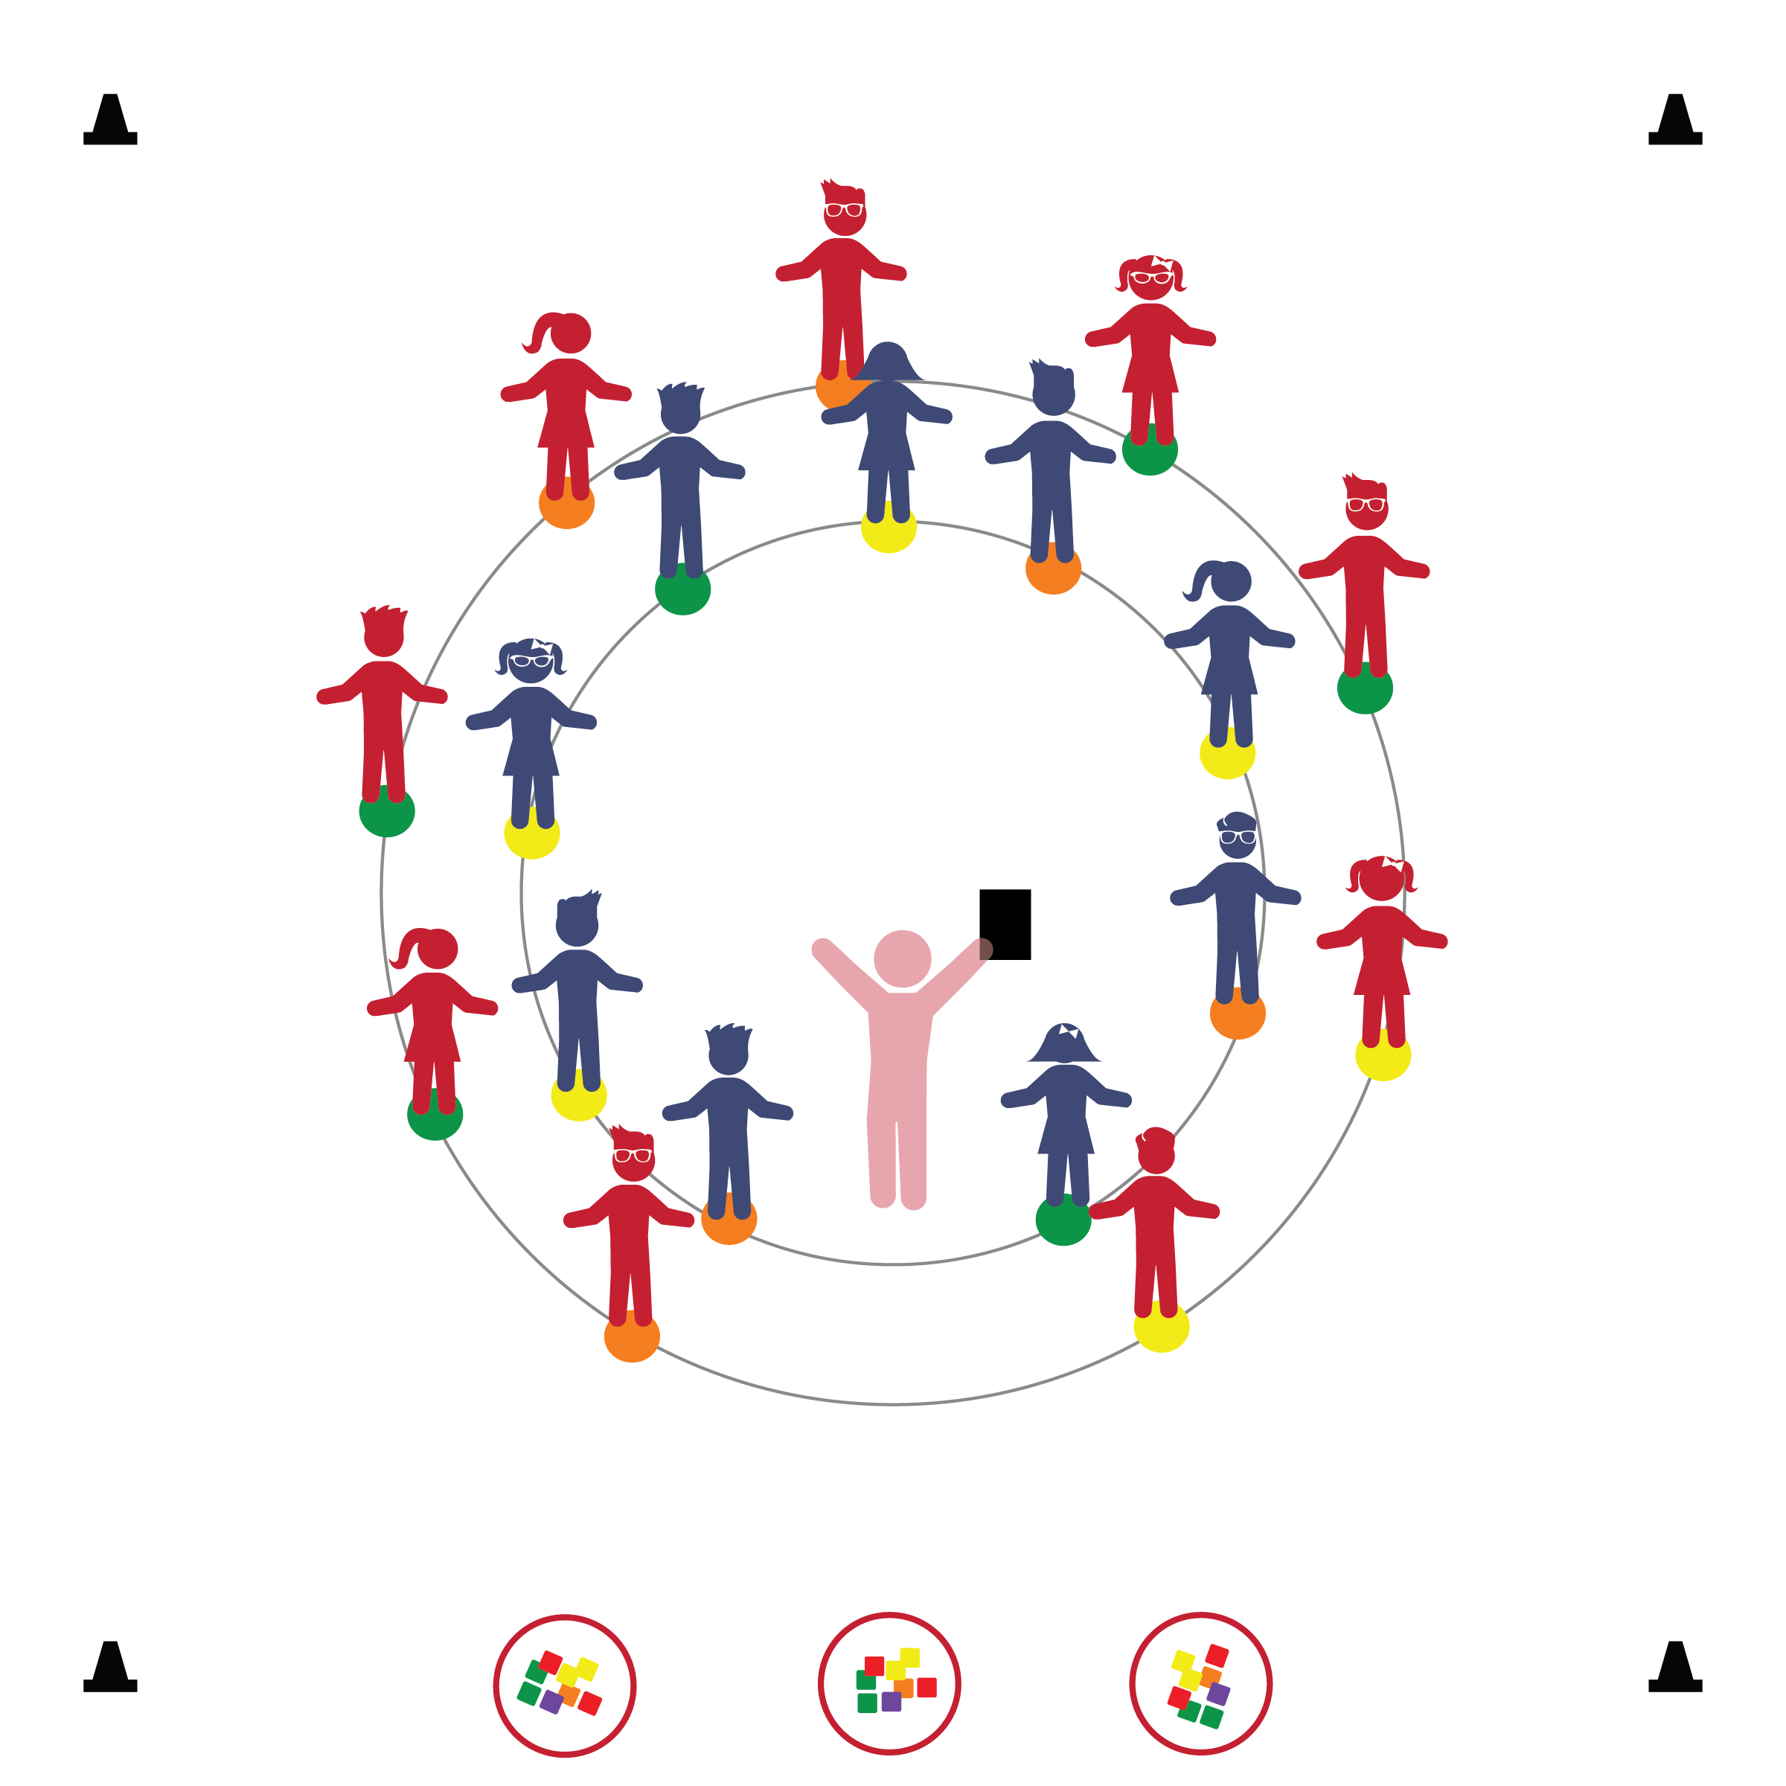­

**Things You Need:**

* 1 spot marker per student
* 1 bean bag or scarf per 2 students
* 3 Hoops for organizing equipment

**Set-Up:**

1. Spot markers are arranged in 2 concentric circles.
2. Bean bags are placed in 2 (or more) piles on the sideline of the activity area.
3. Arrange students, standing on spots, and facing one another.

**Activity Procedures:**

1. The second physical activity rule is “Helpful Hands.” Today we’re going to practice helpful hands with an activity called Sharing Circle. Everyone will share words and equipment with a partner.
2. When I say, “GO!” the partner in the outside circle will talk first. Look your partner in the eye and describe what a juicy orange looks like and tastes like. Listening partners, look your partner in the eye, listen without interrupting. When I say, “Freeze!” stop talking and stand tall, ready to listen. (Repeat with partner on the inside circle describing a crunchy carrot.)
3. Next we’re going to gather some equipment to share. When I say, “GO!” all students on the inside circle will walk to pick up a bean bag, and then return to the spot markers with the bean bag.
4. Pretend your bean bag is a very friendly puppy. When I say, “GO!” tell your partner what your puppy looks like and what her/his favorite game is. When I say, “Freeze!” stop talking and stand tall, ready to listen. It’s time to share the bean bag with your partner, giving them a chance to describe their imaginary puppy. (Repeat with partner on the inside circle. Continue the activity with a variety of topics and imaginary objects.)
5. It’s time put our equipment away. When I say, “GO!” all students on the outside circle will walk to put the bean bag away, and then return to the spot makers.

**Universal Design Modifications:**

* If students are not ready to gather equipment on their own, take a few minutes to hand out/collect bean bags.
* Complete the activity without any equipment. Allow students to practice taking turns in conversation.
* Change partners by rotating students on the outside circle one spot to the right or left.
* **Social/Emotional:**  Takes turns in conversations and interactions with other children.
* **Behavioral:** Maintains engagement in interactions with familiar children.
* **Creativity:** Demonstrates imagination in interaction with others.

* I will follow all physical activity rules.
* I will take turns with my partner.
* I will demonstrate Helpful Hands by gathering and using equipment correctly.