­­

**LINE UP PRACTICE**

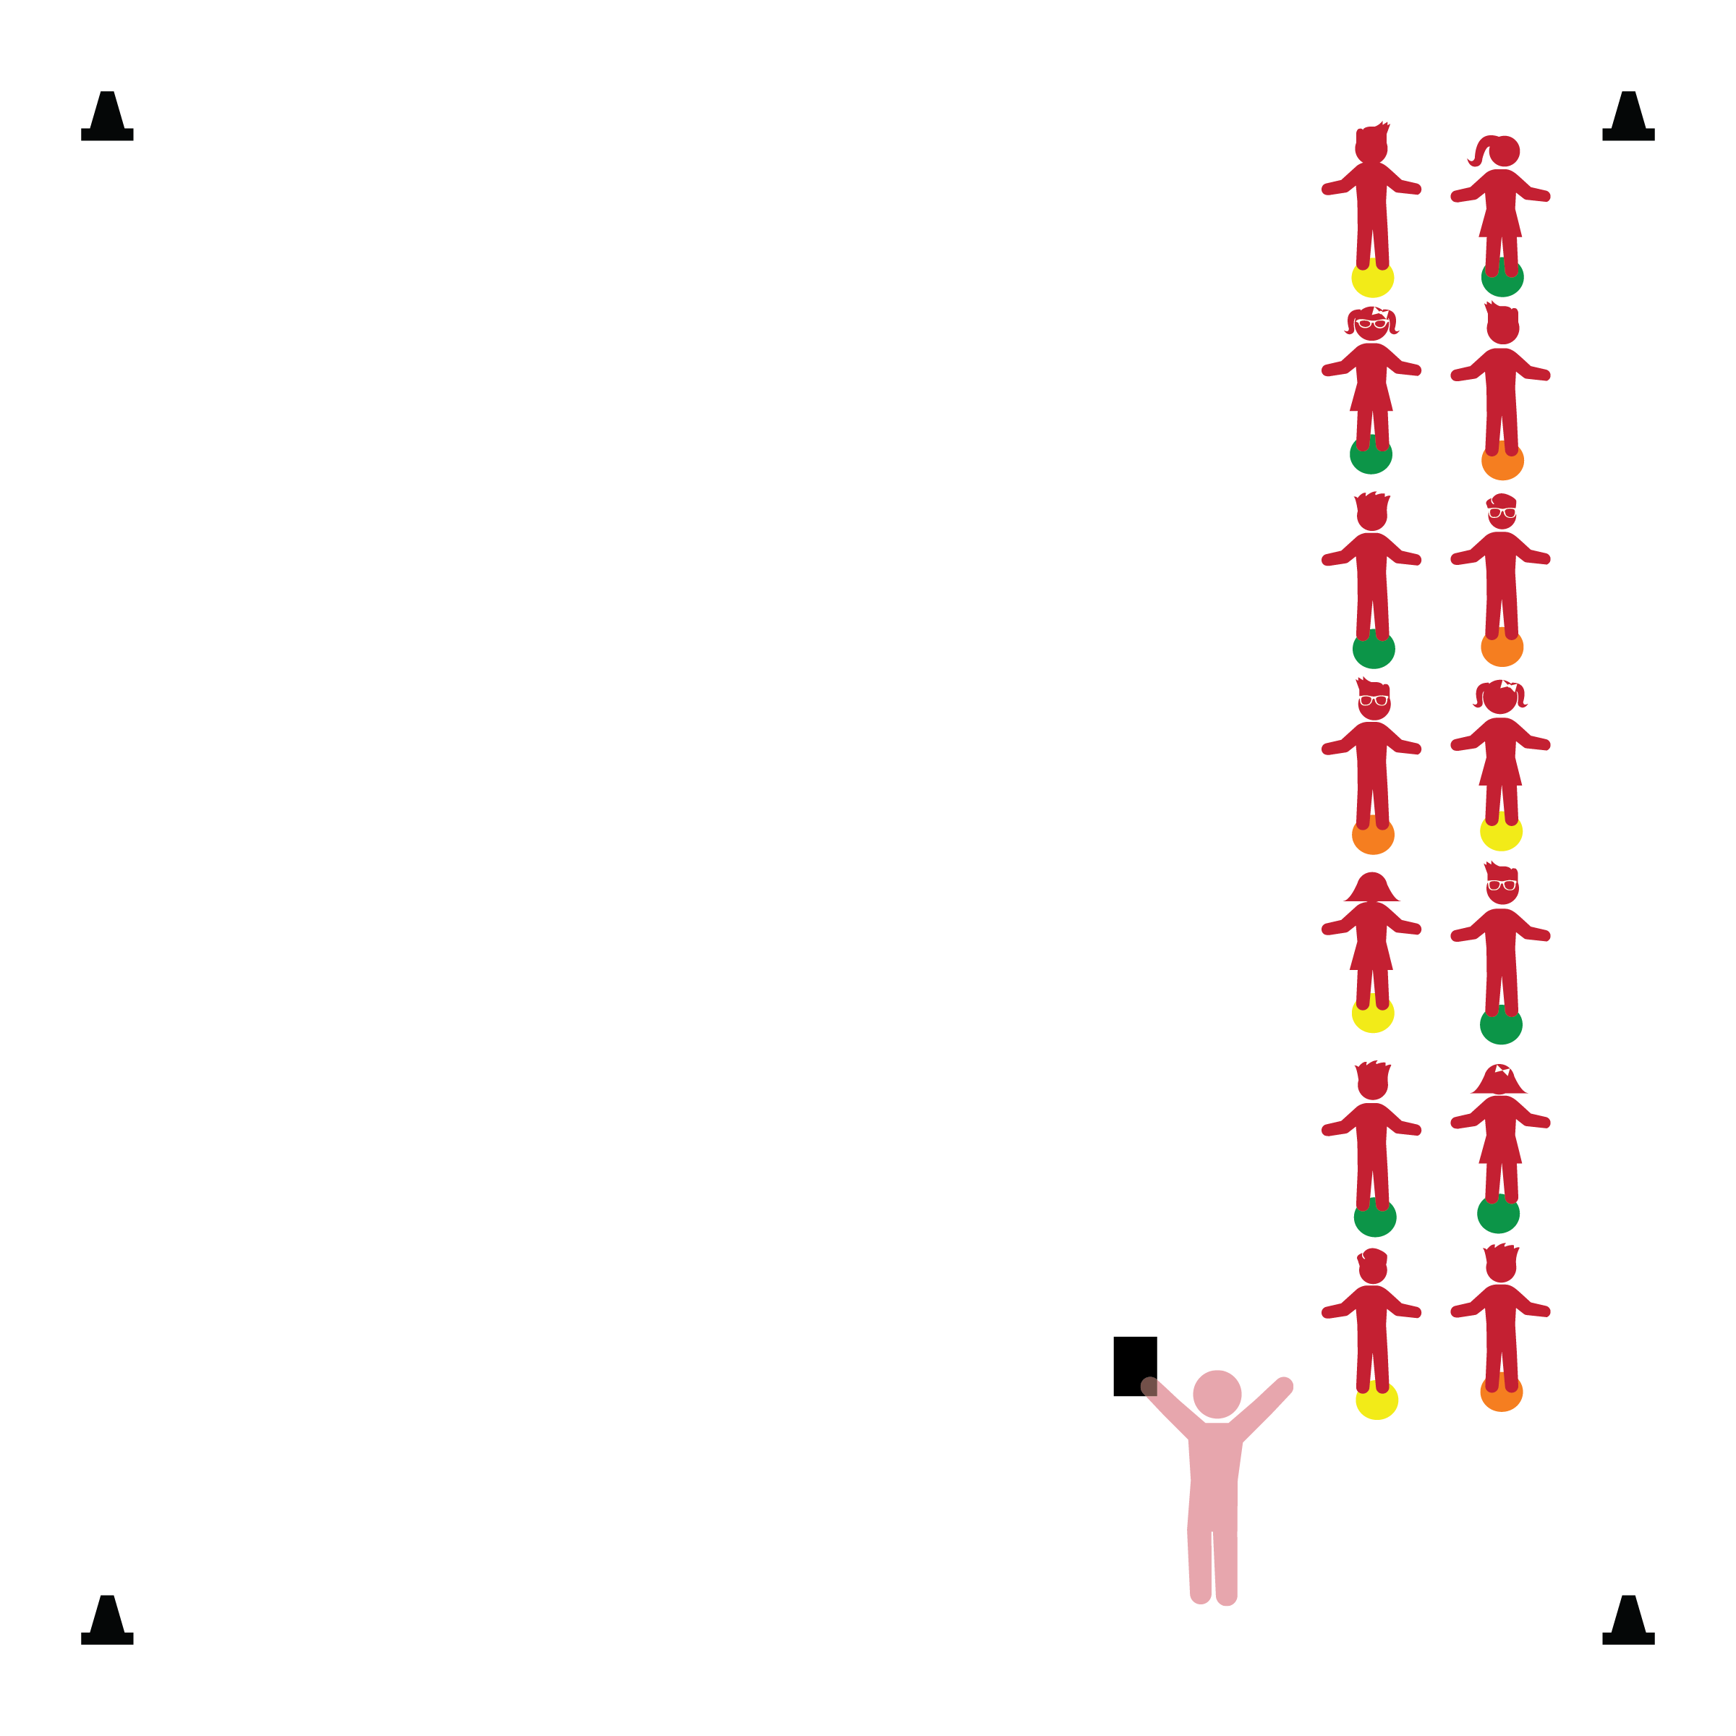­

**Activity Procedures:**

1. We’re now going to practice Following Directions (our 3rd Physical Activity Rule) by moving in the activity area boundaries, and then lining up safely and quietly.
2. Look at your Home Base spot and remember what color it is.
3. When the music starts playing, walk safely in the activity area with active eyes and ears. When the music stops, freeze and listen for instructions. I will call a group of students to quietly line up on the spot markers. (Teacher calls students wearing blue, red, green, etc. until all are lined up.)
4. Let’s play again. This time march in the activity area making large circles using curved pathways. (Repeat the activity several times prompting students to move in a variety of pathways with different locomotor skills.)
5. Next, practice walking in lines throughout the activity area. Guide the students using straight, curved, and zig-zag pathways.

**Universal Design Modifications:**

* Teacher/adult walks hand-in-hand with students having difficulty in line.
* Use a variety of start/stop signals.

**Things You Need:**

* 1 spot marker per student
* 4 cones to create activity area boundaries
* Music and music player

**Set-Up:**

1. Create line(s) with spot makers. (Use the same line formation that you’d used for walking in hallways. E.g., 2 parallel lines, 1 straight line, etc.)
2. Students standing on spot markers in line formation.

* **Behavioral:** Responds to signals when transitioning from one activity to another.
* **Perceptual Development:** Uses perceptual information in directing own actions. Moves body in relation to objects and other people.
* **Safety:** Demonstrates knowledge of personal safety practices and routines.

* I will follow all physical activity rules.
* I will line up quietly by following teacher instructions.
* I will control my body and move safely while staying in the class line.