­­

**EVERYONE CLEANS UP**

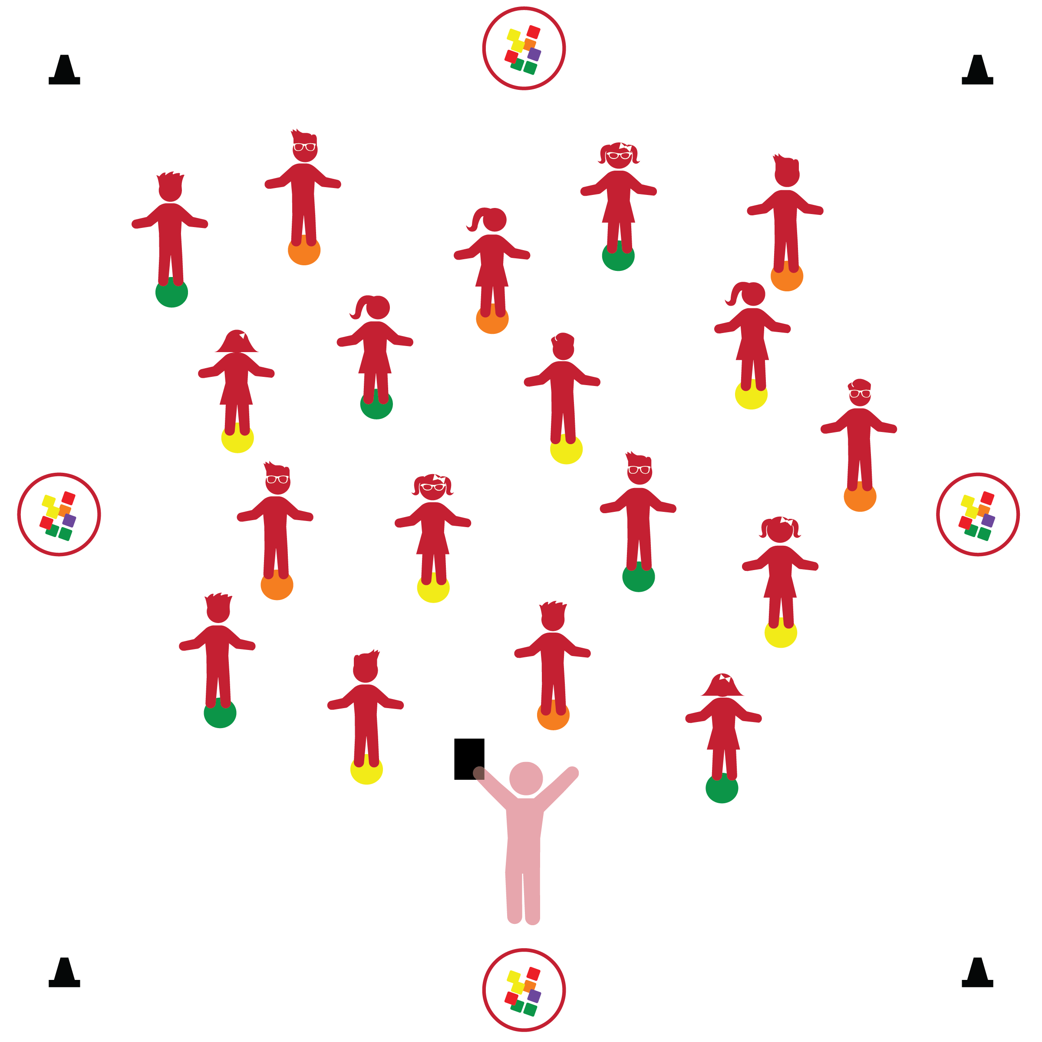­

**Things You Need:**

* 1 spot marker per student
* 1 bean bag per student
* 4 cones to create boundaries
* 4 hoops for organizing bean bags

**Set-Up:**

1. Scatter spot markers within the boundaries of the activity area.
2. Divide bean bags evenly and place in 4 hoops outside of the activity area boundaries.
3. Each students stands at a Home Base (spot marker).

* I will follow all physical activity rules.
* I will gather and return equipment by following teacher instructions.

**Activity Procedures:**

1. Our 4th Physical Activity Rule is, “Move Safely.” Keeping our activity area clean will help us move safely.
2. All of our equipment will be stored just outside of our activity area boundaries. Today we have bean bags inside of hoops to keep them organized. By keeping the equipment organized outside of the boundaries we can move safely inside the activity area without stepping on messy equipment. Let’s try! When I say, “GO!” jump off your stop and see how many spots you can jump on and off (2-foot takeoff and landing). When I say, “Freeze!” stand tall, ready to listen. “GO!”
3. “Freeze!” When I say, “GO!” walk quietly (like little mice) back to your spots.
4. Next, we’ll practice getting equipment. When I call the color that matches your spot color, you’ll walk to the nearest hoop, collect a bean bag, and then return to your spot. Practice balancing the bean bag on your shoulder while you wait for others to collect their bean bag. (Continue calling colors until every student has a bean bag.
5. Before you eat food, or after you use the bathroom, what do you need to remember to do? That’s right – wash your hands. Let’s pretend the bean bag is soap and your spot is a sink. Show me how you would wash your hands.
6. Great! Now let’s practice putting the equipment back where it belongs. When I call the color that matches your spot color, walk to the nearest hoop, put your bean bag away, and then return to your spot. (Continue calling colors until all bean bags are put away. Repeat this activity often to reinforce equipment procedures).

**Universal Design Modifications:**

* Provide adult helpers to students who continually demonstrate difficulty with this task.
* **Health:** Demonstrates personal hygiene and self-care skills.
* **Behavioral:** Demonstrates control of actions and behaviors.
* **Safety:** Demonstrates knowledge of personal safety practices and routines.