­­

**BEAN BAG HOME BASE**

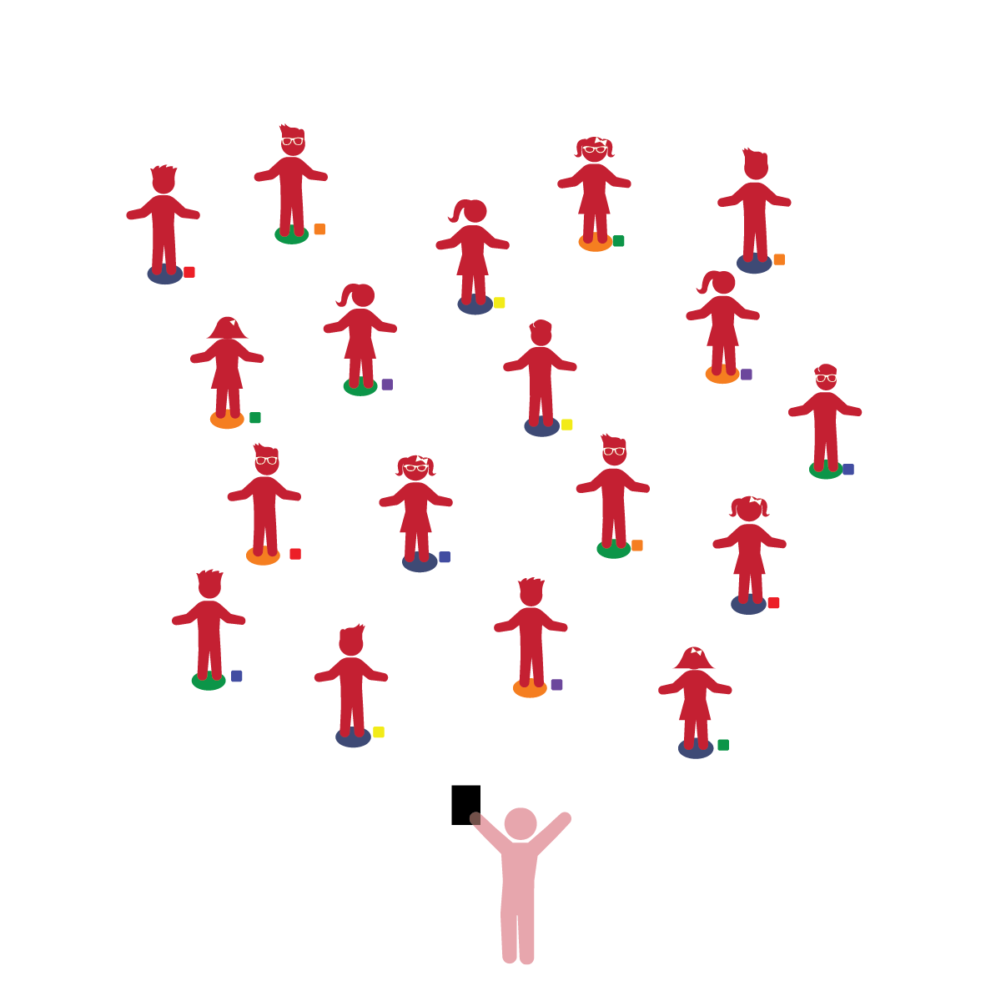­

**Things You Need:**

* 1 bean bag per student
* 1 spot marker per student
* Cones to create boundaries

**Set-Up:**

1. Each student on a Home Base with a bean bag and personal space.
2. Students place their bean bags on the floor at their feet.
3. Be sure spacing between students is safe.

* **Gross Motor Development:** Coordinates movements and actions for a purpose. Walks and runs, adjusting speed or direction depending on the situation. Demonstrates awareness of own body and other people’s space during interactions.
* **Safety:** Identifies and follows basic safety rules with adult guidance and support.

* I will control my body and move safely in general space.
* I will follow my teacher’s instructions and listen for start and stop signals.

**Activity Procedures:**

1. The purpose of this activity is to review Home Base procedures while teaching students to move safely in general space.
2. Before beginning, tell students to remember their bean bag’s color and spot marker location on the floor. This is each student’s Home Base.
3. When teacher says “GO,” students begin walking anywhere throughout general space, staying within the area boundaries. (Say “GO!” or play music as a start signal.)
4. After 15-30 seconds, say “FREEZE” (or pause music). Prompt students to walk back to their Home Base. Repeat this activity, providing students multiple opportunities to practice following directions and signals.
5. Spend a minute talking about what made this process safe/unsafe (i.e. active eyes/ears, remembering your home base, etc.).  Repeat this level using various ways to move (e.g., tip toe, crawling, etc.).

**Universal Design Modifications:**

* Remove one child’s bean bag. This student is called the *Bean Bag Bouncer* and will look for a new Home Base in the next round. Restart the activity and prompt all students to move throughout general space. On the stop signal, students return safely to their Home Bases. The Bean Bag Bouncer can quickly go to any bean bag. The student that lost her/his Home Base becomes the new Bean Bag Bouncer.
* All students can move to any Home Base on the stop signal. They don’t have to move back to their previous home bases.