­­

**MOVE LIKE THIS**

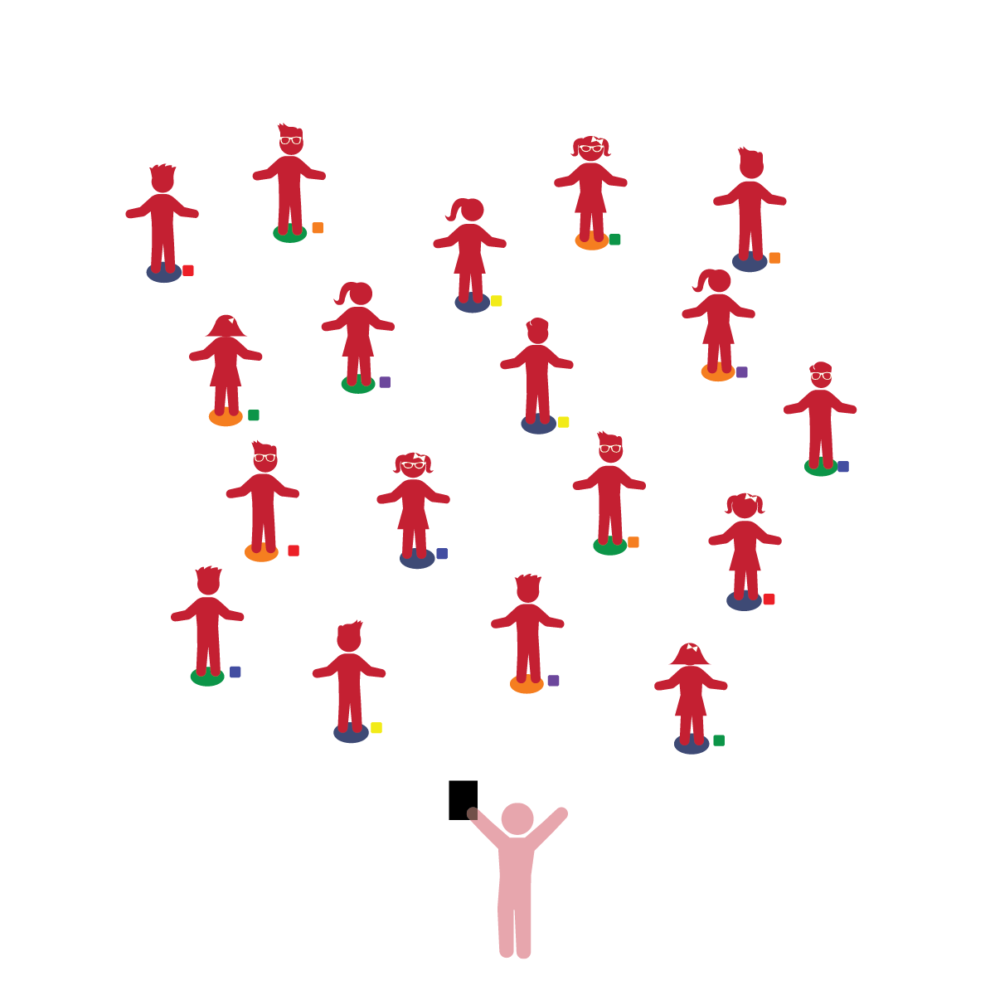­

**Things You Need:**

* 1 bean bag per student
* 1 spot marker per student
* Cones to create boundaries

**Set-Up:**

1. Each student on a Home Base with a bean bag and personal space.
2. Students place their bean bags on the floor at their feet.
3. Be sure spacing between students is safe.

**Review:** In the previous lesson, students were taught the concept of moving in space and returning to their Home Base when asked to do so.

**Activity Procedures:**

1. The purpose of this activity is to teach students how to move safely in space using various locomotor movements.  Begin by having students walk safely in the designated activity space.  Provide signals to start and to stop/freeze, and then prompt students to walk back to their Home Base.
2. Now, repeat the activity while calling out different “speed limits’ and movements. For example, “slow marching.”
3. Start with slower/easier movements. When students are ready, use faster, more advanced locomotor movements (jumping, running, etc.).  Prompt students to return to their Home Bases as needed.

**Universal Design Modifications:**

* Provide more than 1 locomotor skill choice. Students can choose the skill they feel comfortable performing.
* For smaller spaces/large groups, call out 1 or 2 home base colors at a time.  Only students standing at a spot marker of the color called can move to perform the movement skill.
* I will control my body and move safely in general space.
* I will practice moving in space using different movement skills.
* **Gross Motor Development:** Coordinates movements and actions for a purpose. Walks and runs, adjusting speed or direction depending on the situation. Explores environments using motor skills. Performs activities that combine and coordinate large muscle movements.
* **Perceptual Development:** Combines information gained through the senses to understand objects, experiences, and interactions.
* **Safety:** Identifies and follows basic safety rules with adult guidance and support.