­­

**BEAN BAG BODY PARTS**

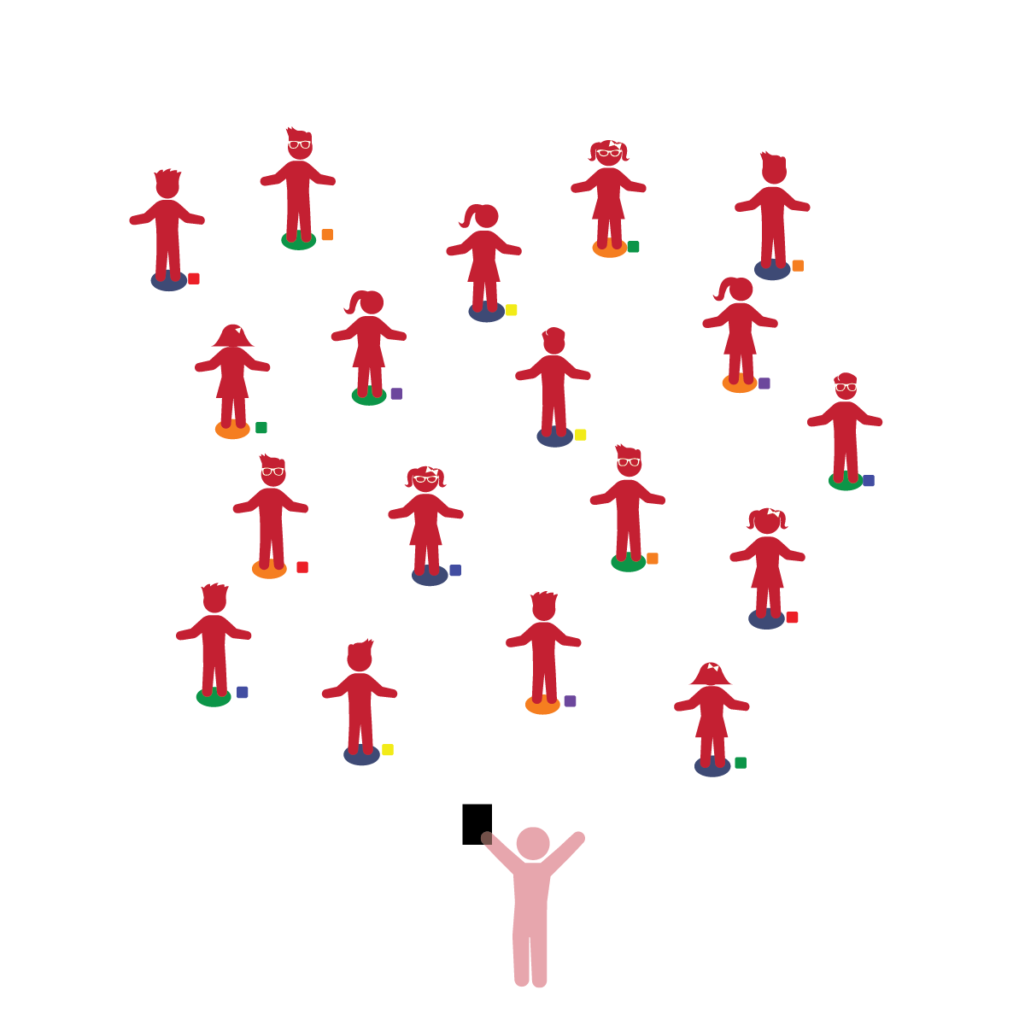­

**Things You Need:**

* 1 bean bag per student
* 1 spot marker per student
* Cones to create boundaries

**Set-Up:**

1. Each student on a Home Base with a bean bag and personal space.
2. Students place their bean bags on the floor at their feet.
3. Be sure spacing between students is safe.

**Review:** In previous lessons, students moved in space and returned to Home Base. In this activity students will move only in personal space (around their home base).

* **Identity and Belonging:** Shows confidence in increasing abilities. Shows others what they can do.
* **Language and Communication:** Acts on descriptions provided by others about people and objects. Demonstrates interest and understanding when participating in language activities or games.
* I will listen to and follow teacher instructions.
* I will try my best.

**Activity Procedures:**

1. The purpose of this activity is to provide a self-testing exercise to help students understand the movement of body parts in relation to objects.
2. Begin by calling out a body part (e.g. elbow, hand, knee, etc.).  Each time a body part is called, students touch that body part to the bean bag, which is lying on the spot marker. Emphasize controlled, safe movements.
3. Next, ask the students to review body parts that have already been covered. Prompt them touch those body parts to the bean bag laying on the floor while saying the name of the body part aloud.
4. Finally, tell the students that you’re going to walk around the class and watch to see if they use the correct body part while also moving safely. Tell the students that you want them to show you what they can do. Take time to watch and praise each student while calling a variety of body parts.

**Universal Design Modifications:**

* Use an object larger than a bean bag, such as a pillow or carpet square.
* Instead of placing the bean bag on the floor, students balance the bean bag on various body parts.