­­

**BEAN BAG BALANCE**

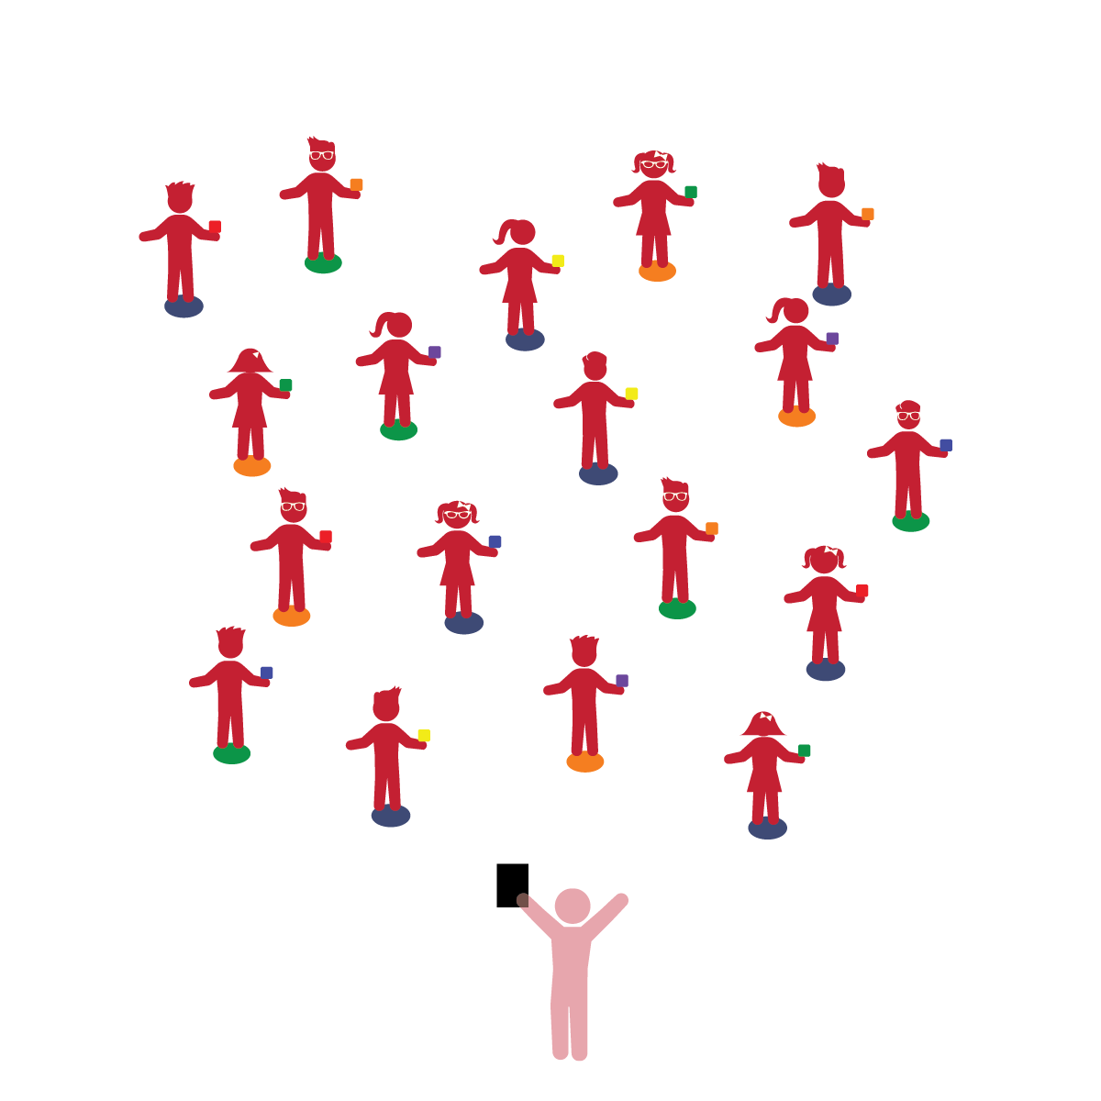­

**Things You Need:**

* 1 bean bag per student
* 1 spot marker per student
* Cones to create boundaries

**Set-Up:**

1. Each student on a Home Base with a bean bag and personal space.
2. Students place their bean bags on the floor at their feet.
3. Be sure spacing between students is safe.

**Review:** In a previous lesson, students moved independently in personal space around their Home Base. This activity builds upon that structure while adding the challenge of balancing an object.

**Activity Procedures:**

1. The purpose of this activity is to provide students an opportunity to explore balance using a bean bag.
2. Students will listen to teacher prompts and balance bean bags on different body parts.
3. Body part suggestions: head, shoulder, elbow, wrist, hand, foot.
4. Next, challenge students to move safely in personal space (twist, bend, extend, etc.) while keeping the bean bag balanced on different body parts.
5. Advance with students balancing a beanbag and walking around a floor spot.

**Universal Design Modifications:**

* Allow students to help an adult balance objects. For example, students place a bean bag on an adult’s shoulder, knee, etc.
* Students balance bean bags on other objects, such as a cone, chair, bench, etc.
* Allow students to be self-directed and choose body parts and movements.
* **Perception:** Combines information gained through the senses to understand objects, experiences, and interactions.
* **Gross Motor:** Demonstrates balance in large-muscle movement. Demonstrates awareness of own body and other people’s space during interactions.
* **Fine Motor:** Uses coordinated movements to complete complex tasks.

* I will follow directions and move safely.
* I will use my arms, legs, and other body parts to keep my balance.