­­

**HOME PLATE FRUIT FINDER**

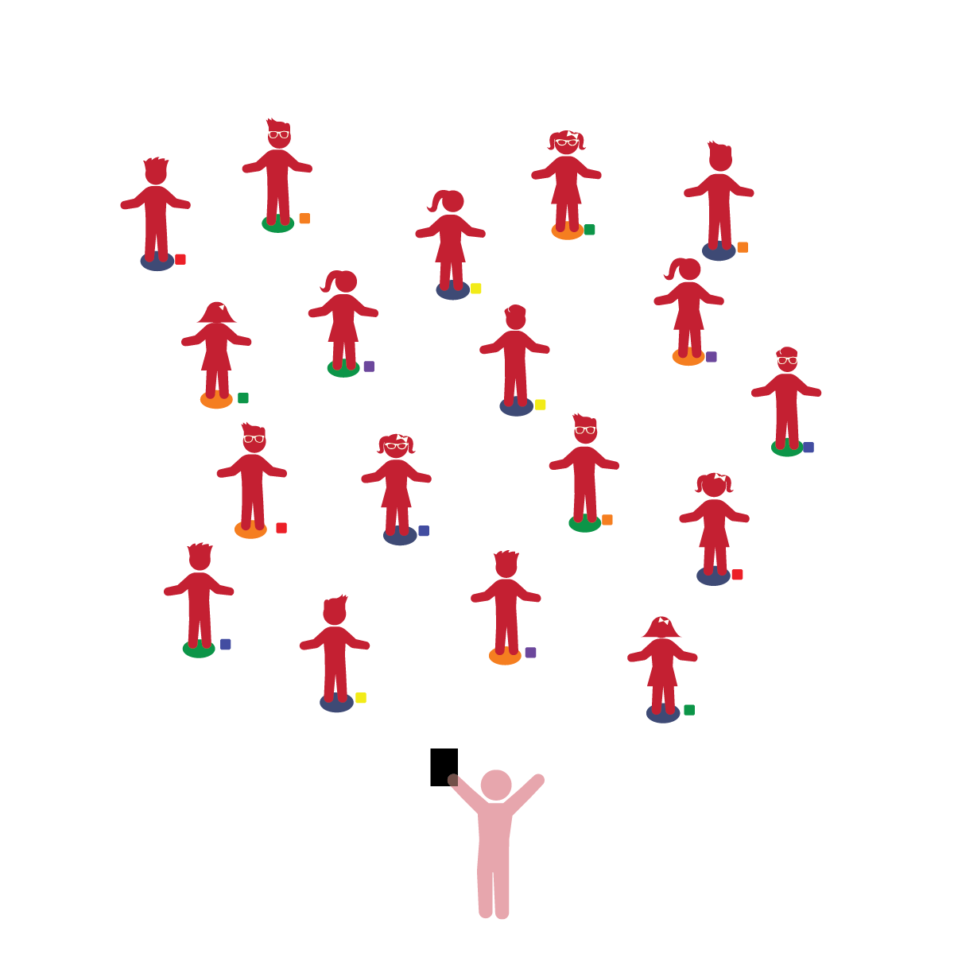­

**Things You Need:**

* 1 bean bag per student
* 1 spot marker per student
* Cones to create boundaries

**Set-Up:**

1. Each student on a Home Base with a bean bag and personal space.
2. Students place their bean bags on the floor at their feet.
3. Be sure spacing between students is safe.

**Review:** In previous lessons, students were taught the concept of moving in space and returning to their Home Base when asked to do so.

**Activity Procedures:**

1. The purpose of this activity is to review movements and concepts taught in previous activities while helping students identify a variety of fruits and vegetables. Begin by having students walk safely in the designated activity space. Provide signals to start and to stop/freeze, and then prompt students to walk back to their Home Base. When students return to their home base, tell them to call out a fruit or vegetable that is the same color as their bean bag. Start by offering suggestions for each color.
2. Now, repeat the activity while calling out different locomotor movements.
3. Challenge students to look and point at a classmate’s bean bag and call out a fruit or vegetable that matches the color of that bean bag.

**Universal Design Modifications:**

* When students return to their Home Base, teacher moves to a single bean bag and allows the entire class to identify fruits/vegetables from that single bean bag color.
* *See previous modifications from earlier activity plans.*
* **Gross Motor Development:** Coordinates movements and actions for a purpose. Walks and runs, adjusting speed or direction depending on the situation. Explores environments using motor skills. Performs activities that combine and coordinate large-muscle movements.
* **Nutrition:** Identifies a variety of healthy foods.
* I will control my body and move safely in general space.
* I will practice moving in space using different locomotor skills.
* I will identify different fruits and vegetables that are good for my body.