­­

**BEAN BAG EGGS**

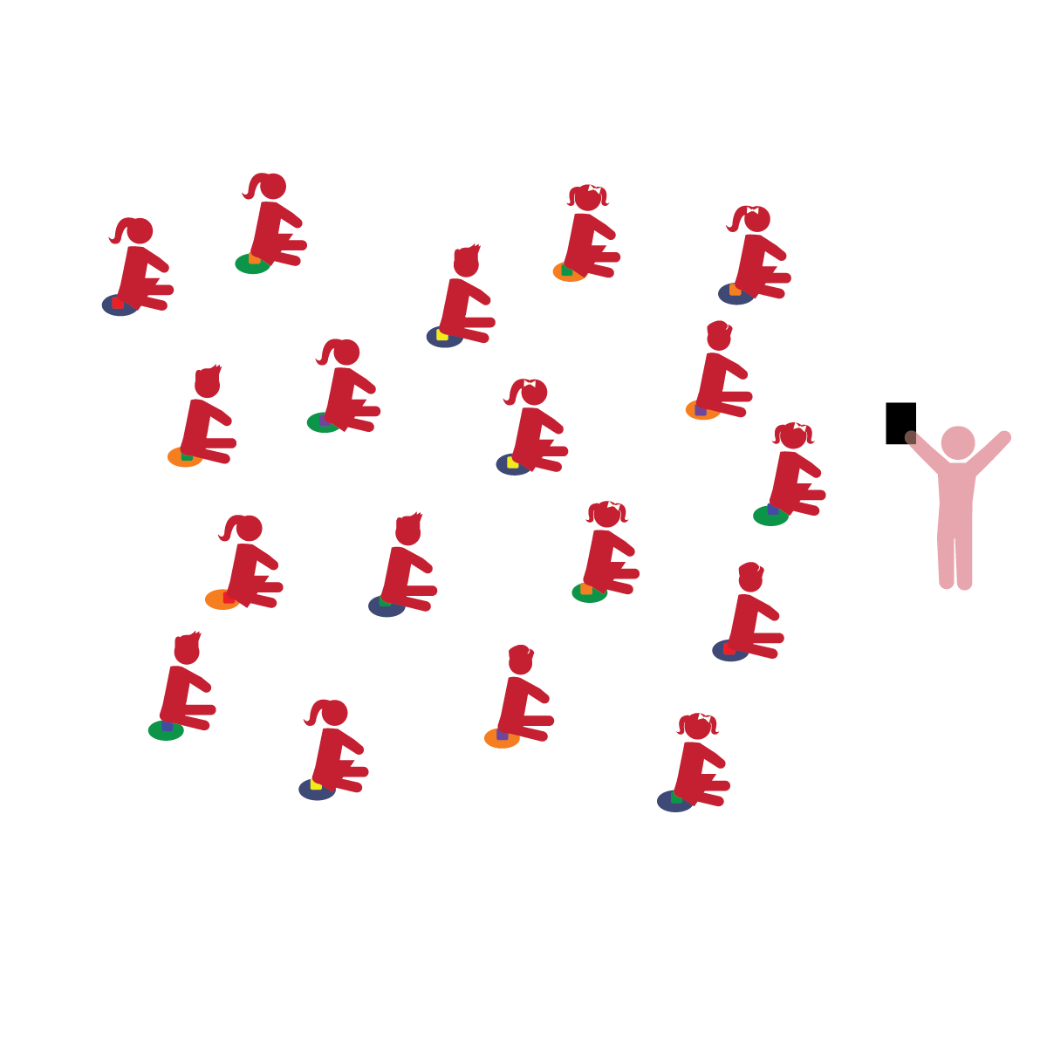­

**Things You Need:**

* 1 bean bag per student
* 1 spot marker per student

**Set-Up:**

1. Each student with a bean bag, sitting on a Home Base.
2. Be sure spacing between students is safe.

* **Emotional and Behavioral Self-Regulation:** Appropriately handles and uses materials and equipment during activities. Manages behavior according to expectations.
* **Gross Motor:** Demonstrates control and coordination of large muscles to perform an activity.

**Activity Procedures:**

1. The purpose of this activity is to provide students practice with the manipulative skill of tossing and catching.
2. Tell students that the bean bag is an egg and it is their job to protect it from cracking.  Prompt them to sit on the eggs (like a bird does).
3. Demonstrate and prompt students to place hands together in good catching form.  Using an imaginary ball, tell students to self-toss and catch.
4. Ask students what color their imaginary ball is and remind them to watch the imaginary ball as they toss it into the air and catch it in their hands.
5. Now, have students place their bean bag (egg) in their hands.  Ask students if the color of their imaginary ball is the same as, or different from, their bean bag egg.
6. From a seated position, students make a nest with their hands and gently toss and catch the bean bag, straight up and down. They are pretending it is an egg. Teach/demonstrate how to “give with it,” or catch “quietly with soft hands, making no sound.”
7. Allow students to creatively “play” with the bean bag and explore other movements at their Home Base.

**Universal Design Modifications:**

* Use balloons or juggling scarves if bean bags are too difficult to track and catch.
* Allow students to drop the “egg” back-and-forth, from one hand to the other.
* I will follow directions and work safely with the equipment.
* I will toss and catch my bean bag (imaginary egg) using soft hands to catch quietly.