­­

**Hoop Race**

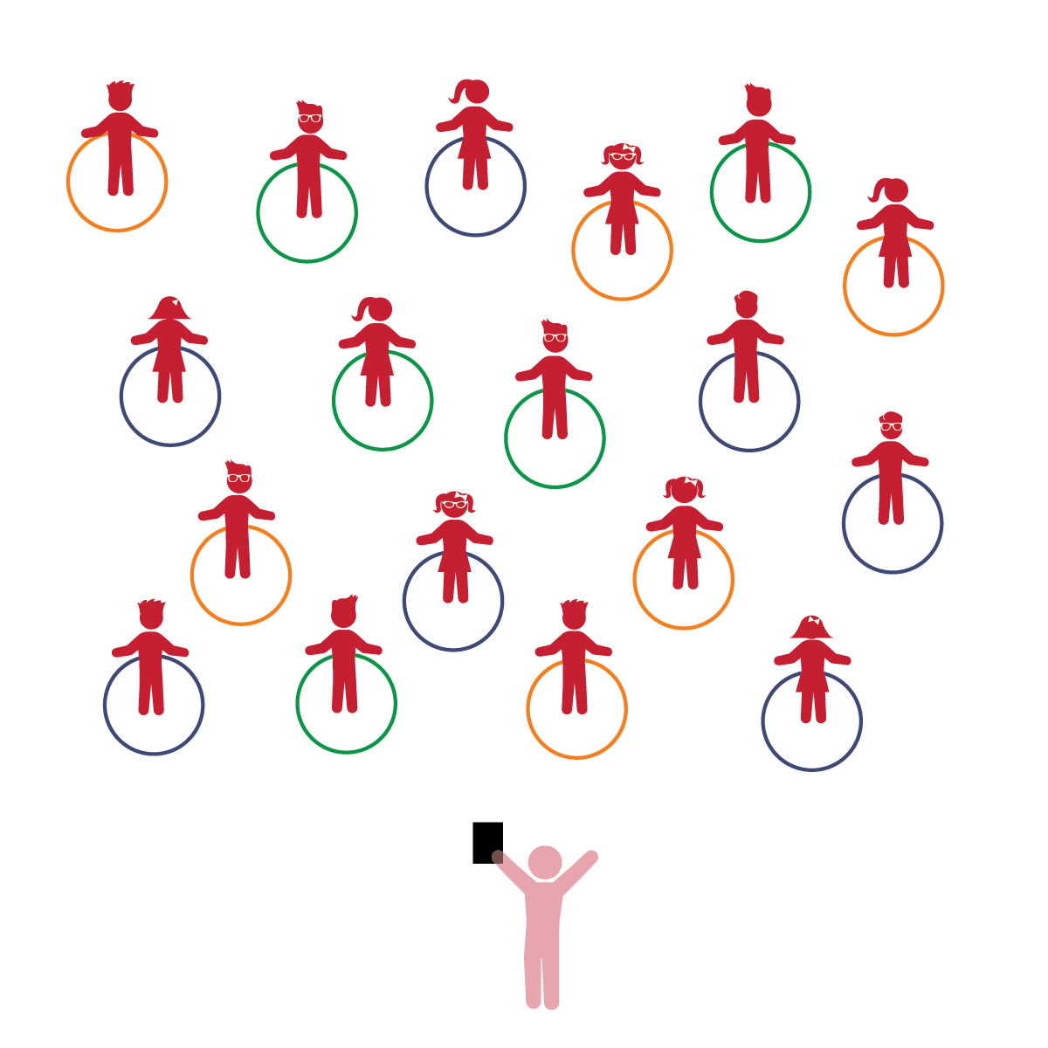­

* **Gross Motor Development:** Demonstrates control, strength, and coordination of large muscles.
* **Emotional and Behavioral Self-Regulation:** Follows classroom rules and routines with increasing independence.
* **Counting and Cardinality:** Knows numbers’ names and the count sequence. Counts verbally to 10 by 1s.

**Things You Need:**

* 1 hoop per student
* Cones to create boundaries

**Set-Up:**

1. Each student on a Home Base with a hoop and personal space.
2. Students place their hoops on the floor at their feet.
3. Be sure spacing between students is safe for activity.

**Activity Procedures:**

1. The purpose of this activity is to allow students to practice various locomotor movements and tasks. Begin with students sitting inside their hoops.
2. Today we’re going to play a game called *Hoop Race.* Before we start, look around and take note of your personal space. Your hoop will act as your personal Home Base.
3. First, let’s practice counting from 1 to 10 together as a class.
4. When I say “GO,” stand up and start walking safely around your hoop. Count each lap that you complete. When you have completed 10 laps, sit inside your hoop while we wait for the whole class to finish.
5. Switch directions and repeat.
6. Repeat, prompting students to try some of these tasks: Walk backwards around the hoop; Walk sideways around the hoop; Jump in a twisting motion inside the hoop; Mirror a movement the teacher leads; Race the teacher by running around the hoop 3 times and then straddle in/out; Try different movements to cross over the hoop.

**Universal Design Modifications:**

* Instead of counting, have students say the alphabet as they perform various tasks.
* Match tasks to the students’ abilities (i.e., if students are not able to walk backward safely, skip this task).
* I will demonstrate strength and stamina while moving my body safely in general space.
* I will follow classroom rules as best I can and demonstrate them when asked.
* I will practice counting to ten.