­­

**Move Crazy**

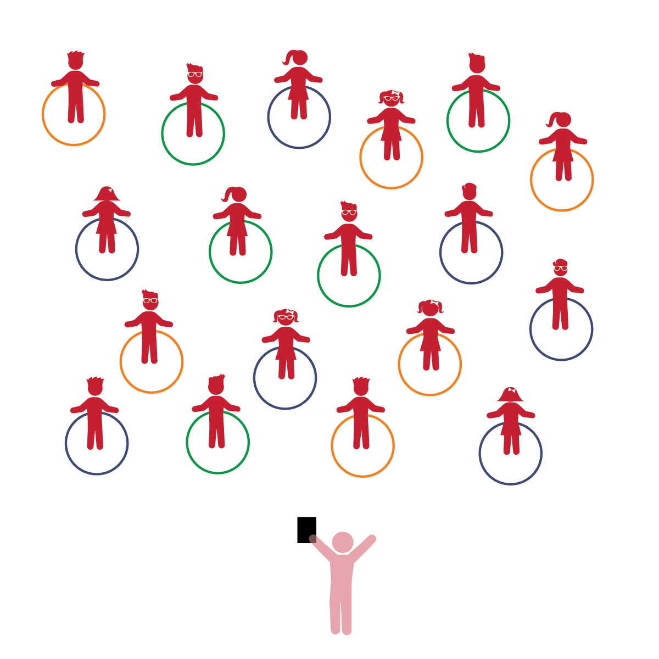­

**Activity Procedures:**

1. The purpose of this activity is to practice body positioning using different movement concepts.
2. Today we’re going to play a game called *Move Crazy.* Before we start, look around and take note of your personal space. Your hoop will act as your personal Home Base.
3. When I call out a level like low level, medium level, or high level, hold your hoop at that level. Teachers, demonstrate the levels before beginning.
4. Next, guide students to move into a narrow body position on the hoop, then ask them to move into a wide body position off the hoop. Then ask them to make a narrow position at a low level, and then a wide position at a high level. Add other concepts such as over, under, side, above, below, behind, front, etc.
5. Finish with a simple fun game of “Simon Says” to review the concepts.

**Universal Design Modifications:**

* Keep the challenges simple and fun for younger students.
* Demonstrate the movements as you call them out to help students understand the concepts you are teaching.
* **Emotional and Behavioral Self-Regulation:** Appropriately handles classroom materials.
* **Gross Motor:** Uses perceptual information to guide motions and interactions with objects and other people.

**Things You Need:**

* 1 hoop per student
* Cones to create boundaries

**Set-Up:**

1. Each student on a Home Base with a hoop and personal space.
2. Students place their hoops on the floor at their feet.
3. Be sure spacing between students is safe for activity.

* I will handle the equipment appropriately during the activity.
* I will move my body using various movement concepts (e.g., low, medium, and high).