­­

**Bodies of Water**

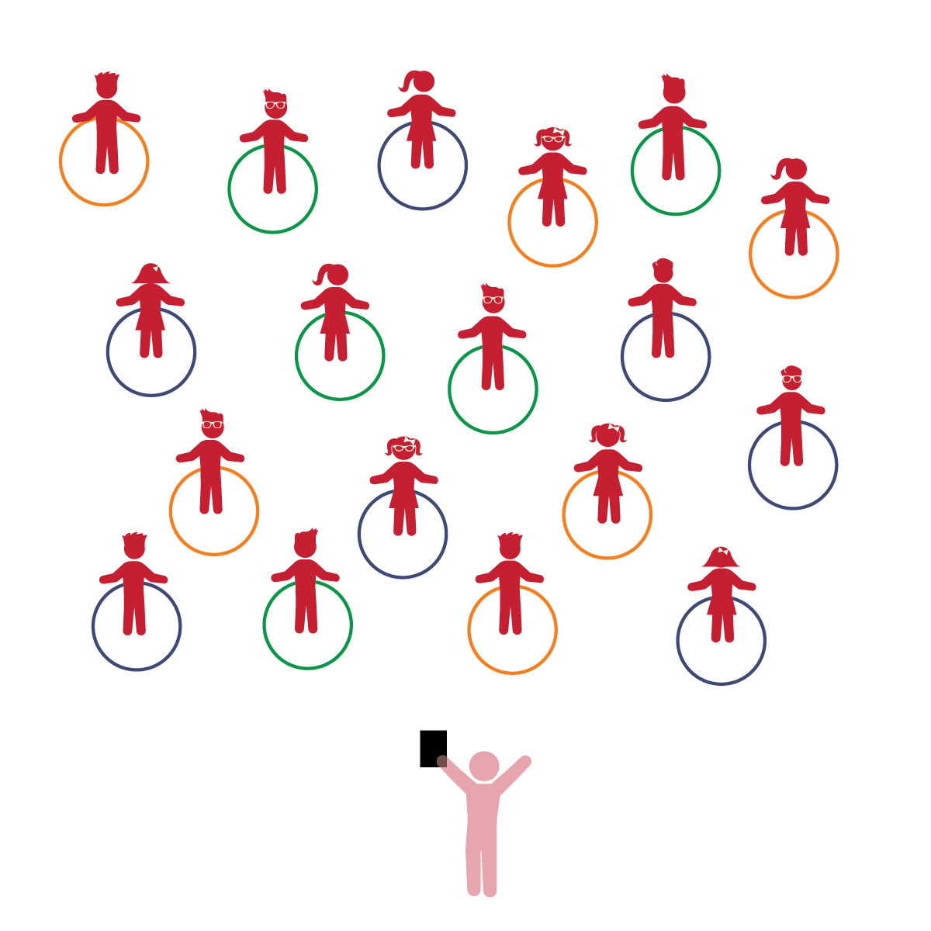­

**Activity Procedures:**

1. The purpose of this activity is to learn about water safety.
2. Explain the concept and importance of being safe around water. Discuss the different places students might encounter water (bath, pool, ponds, rivers, etc.).
3. We’re going to play a game called *Bodies of Water.* The hoops represent water, and these small bodies of water are ponds. When I say “GO,” march around without touching or falling into the ponds. Continue until you hear the stop signal.
4. Next put hoops in groups of 3-4 to form “lakes.” Have students walk on their toes in a straight pathway.
5. Now make a chain of 5-6 hoops to form “rivers.” Ask students to walk on their heels using a curved pathway.
6. Make 1-2 large groupings of hoops to form “oceans.” Have students use a bear walk in a zig-zag pathway.
7. Finally, discuss different types of plants and animals that live in or near the various bodies of water that they learned about. Compare and contrast.

**Universal Design Modifications:**

* Have students walk normally or perform less complex movement variations.
* Have students hold hands with a friend who can remind them to avoid the water while moving in space.
* **Health, Safety & Nutrition:** Demonstrates knowledge of personal safety practices and routines.
* **Gross Motor:** Demonstrates control, strength, and coordination of large muscles.
* **Scientific Inquiry:** Engages in scientific talk.

**Things You Need:**

* 1 hoop per student
* Cones to create boundaries

**Set-Up:**

1. Hoops placed on the floor in a scattered formation.
2. Students spread out in general space.

* I will identify and avoid danger in order to learn about the importance of water safety.
* I will demonstrate strength and stamina while moving my body safely in general space.
* I will use scientific words about bodies of water and wildlife.