­­

**Colored Igloos**

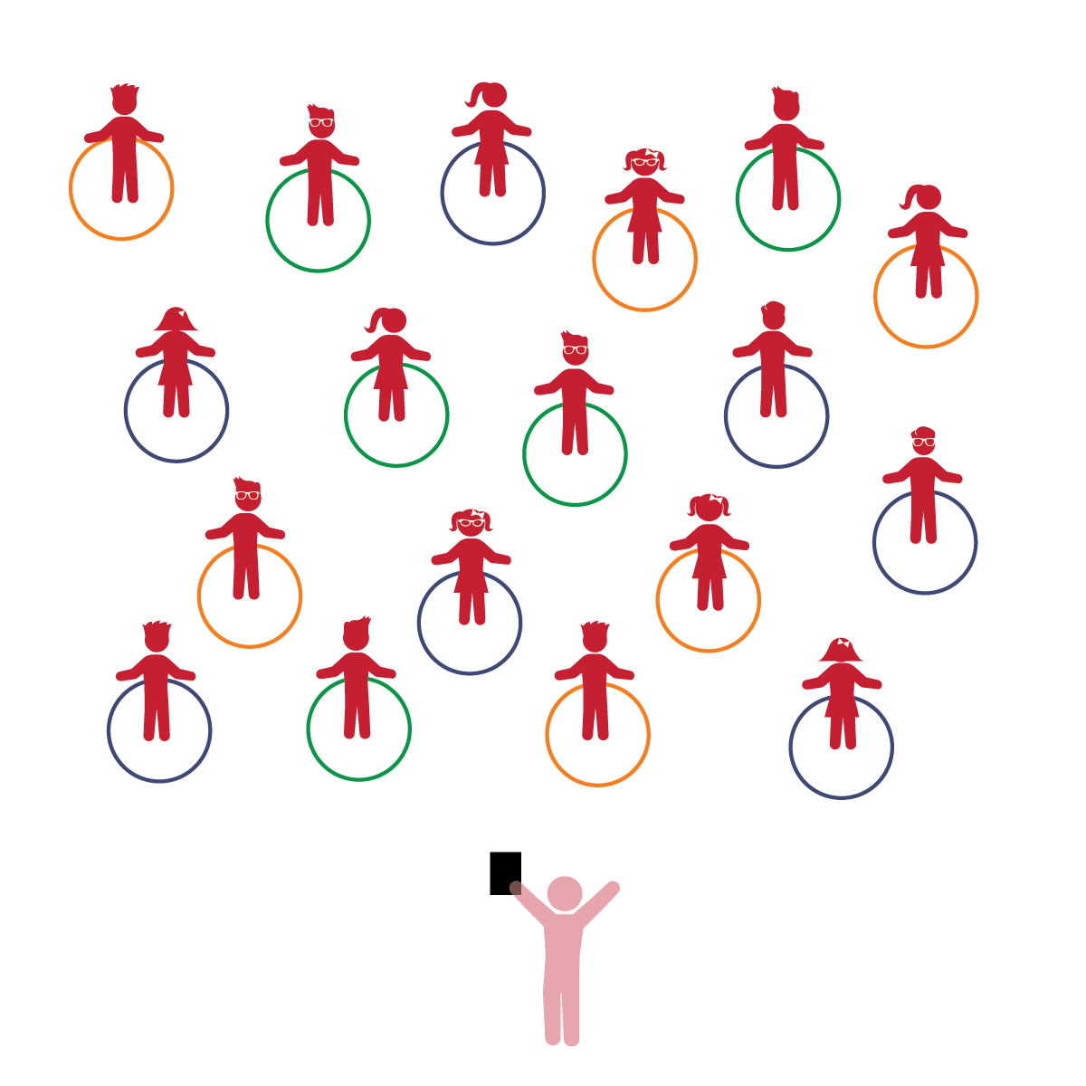­

**Things You Need:**

* 1 hoop per student
* Music and music player
* Cones to create boundaries

**Set-Up:**

1. Each student on a Home Base with a hoop and personal space.
2. Students place their hoops on the floor at their feet.
3. Be sure spacing between students is safe for activity.

**Activity Procedures:**

1. The purpose of this activity is to practice sharing.
2. Today we’re going to play a game called *Colored Igloos.* Today, we are Eskimos and our hoops are igloos. Before we start, look around and take note of your personal space. Your igloo will act as your personal Home Base.
3. As a class, discuss the concept of sharing. Ask students to describe examples of sharing. Explain and demonstrate the importance of sharing along with the correct way to ask someone to share, and how to react to someone asking to share. Remind students that we also have to share the same space. If they move too fast or do not control their body, someone could get hurt.
4. The floor is icy! When you hear the music start, begin to move slowly and safely around the igloos. I will call out a few different colors (2-3). Move safely to stand inside an igloo that is one of the colors I called.
5. Repeat using different movements and calling different colors.
6. Challenge: once students have moved to colored igloos, point to different hoops and ask how many Eskimos are in each. See if they can grasp the quantity without counting.

**Universal Design Modifications:**

* Call more colors (4-5) so that there are less students in each hoop (igloo).
* Have an adult stand near the igloos to ensure students are sharing the space appropriately.
* **Relationships with Other Children:** Engages in cooperative play with other children.
* **Counting and Cardinality:** Recognizes the number of objects in a small set.

* I will cooperate, share, and engage in joint play with my classmates.
* I will recognize, without counting, small quantities (up to 5 objects).