­­

**Balancing Body Parts**

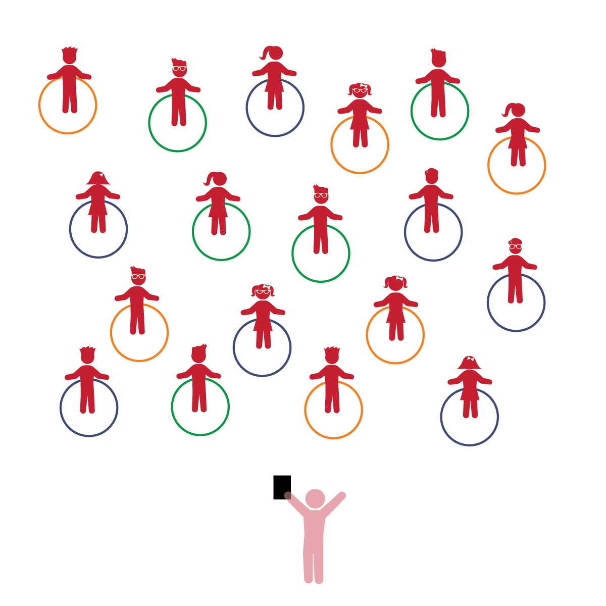­

**Things You Need:**

* 1 hoop per student
* Cones to create boundaries

**Set-Up:**

1. Each student on a Home Base with a hoop and personal space.
2. Students place their hoops on the floor at their feet.
3. Be sure spacing between students is safe for activity.

* **Vocabulary:** Understands and uses a wide variety of words for a variety of purposes.
* **Relationships with Other Children:** Engages in and maintains positive interactions and relationships with other children.

**Activity Procedures:**

1. The purpose of the activity is to recognize the names of different body parts. Students begin the activity standing beside a hoop ready to learn.
2. Today we’re going to play a game called *Balancing Body Parts.* Before we start, look around and take note of your personal space. Your hoop will act as your personal Home Base.
3. When I call out a body part, place that body part inside the hoop.
4. Next, add a color to the body parts called. Students must place their appropriate body part inside a hoop of that color, sharing them with others.
5. Have students return to their Home Base. Allow them to select and identify a body part to place in the hoop.

**Universal Design Modifications:**

* Play the activity as a class using one big circle.
* Use pictures or demonstrations to help students identify different body parts.
* I will use scientific words related to parts of the body.
* I will play kindly and safely with my classmates.