­­

**1,2,3 Lift Off**

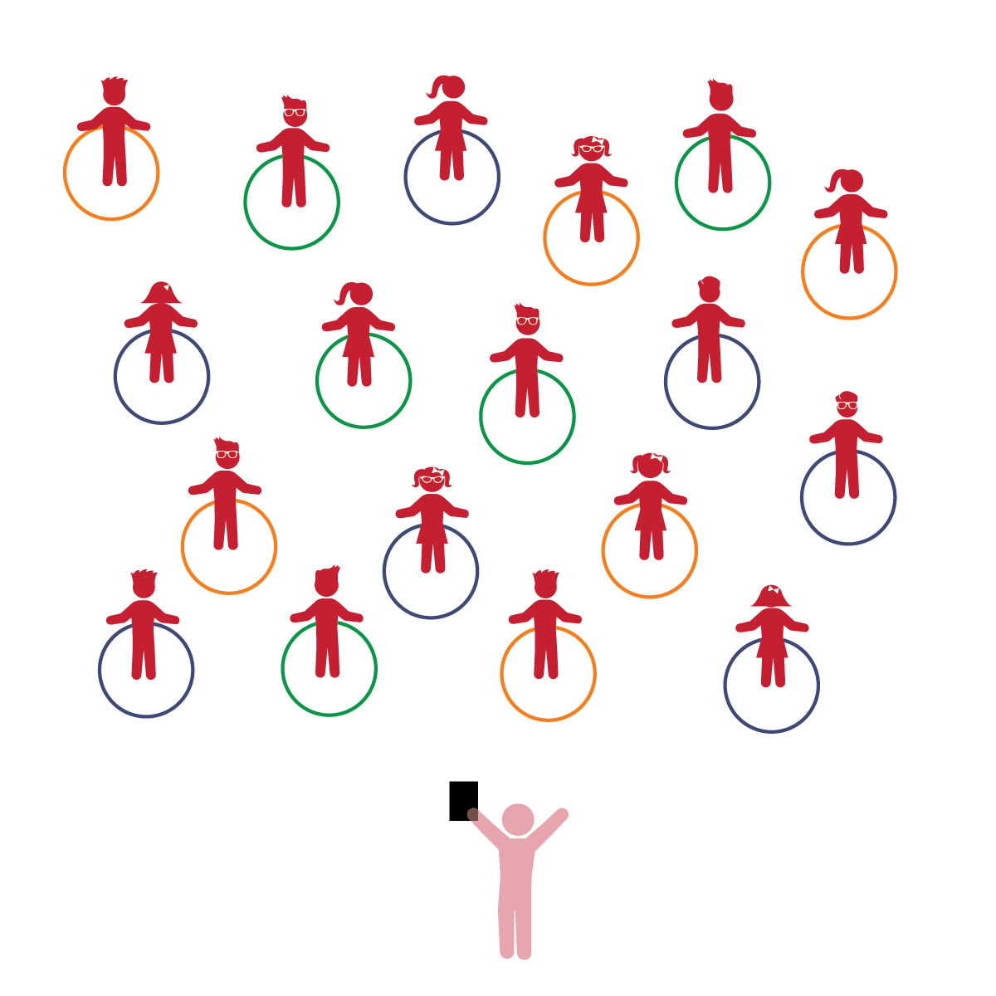­

**Activity Procedures:**

1. The purpose of the activity is to learn the difference between wide and narrow body positions.
2. Today we’re going to play a game called *1, 2, 3, Lift Off.* Before we start, look around and take note of your personal space. Your hoop will act as your personal Home Base.
3. Have students to practice a wide body position, and then a narrow body position. Next, have them make these positions tall & small.
4. Have students hold the hoops over their head so that they are standing under the hoop in a wide body position. Students drop their hoops and quickly make a narrow body position so that the hoop to drops to the ground without touching any part of their body.
5. Repeat the activity. As a class, choose a number and count to that number before dropping the hoop.
6. Next, call out pairs of words (i.e. top/cup; bat/bake; fun/run!). When students hear two words that rhyme, they drop their hoop.

**Universal Design Modifications:**

* Hold hoop at waist level to practice a wide/narrow position using only legs.
* Adults can assist by holding the hoop over students’ heads and ensuring the student makes a narrow body position before the hoop is dropped.

**Things You Need:**

* 1 hoop per student
* Cones to create boundaries

**Set-Up:**

1. Each student on a Home Base with a hoop and personal space.
2. Students place their hoops on the floor at their feet.
3. Be sure spacing between students is safe for activity.

* **Phonological Awareness:** Demonstrates awareness that spoken language is comprised of smaller segments of sound.
* **Gross Motor:** Uses perceptual information to guide motions and interactions with objects and other people.
* **Counting and Cardinality:** Knows number names and the count sequence.
* I will rhyme one or more words to the original word provided.
* I will place myself in relation to objects by making narrow and wide body positions.