­­

**GET IN SHAPE**

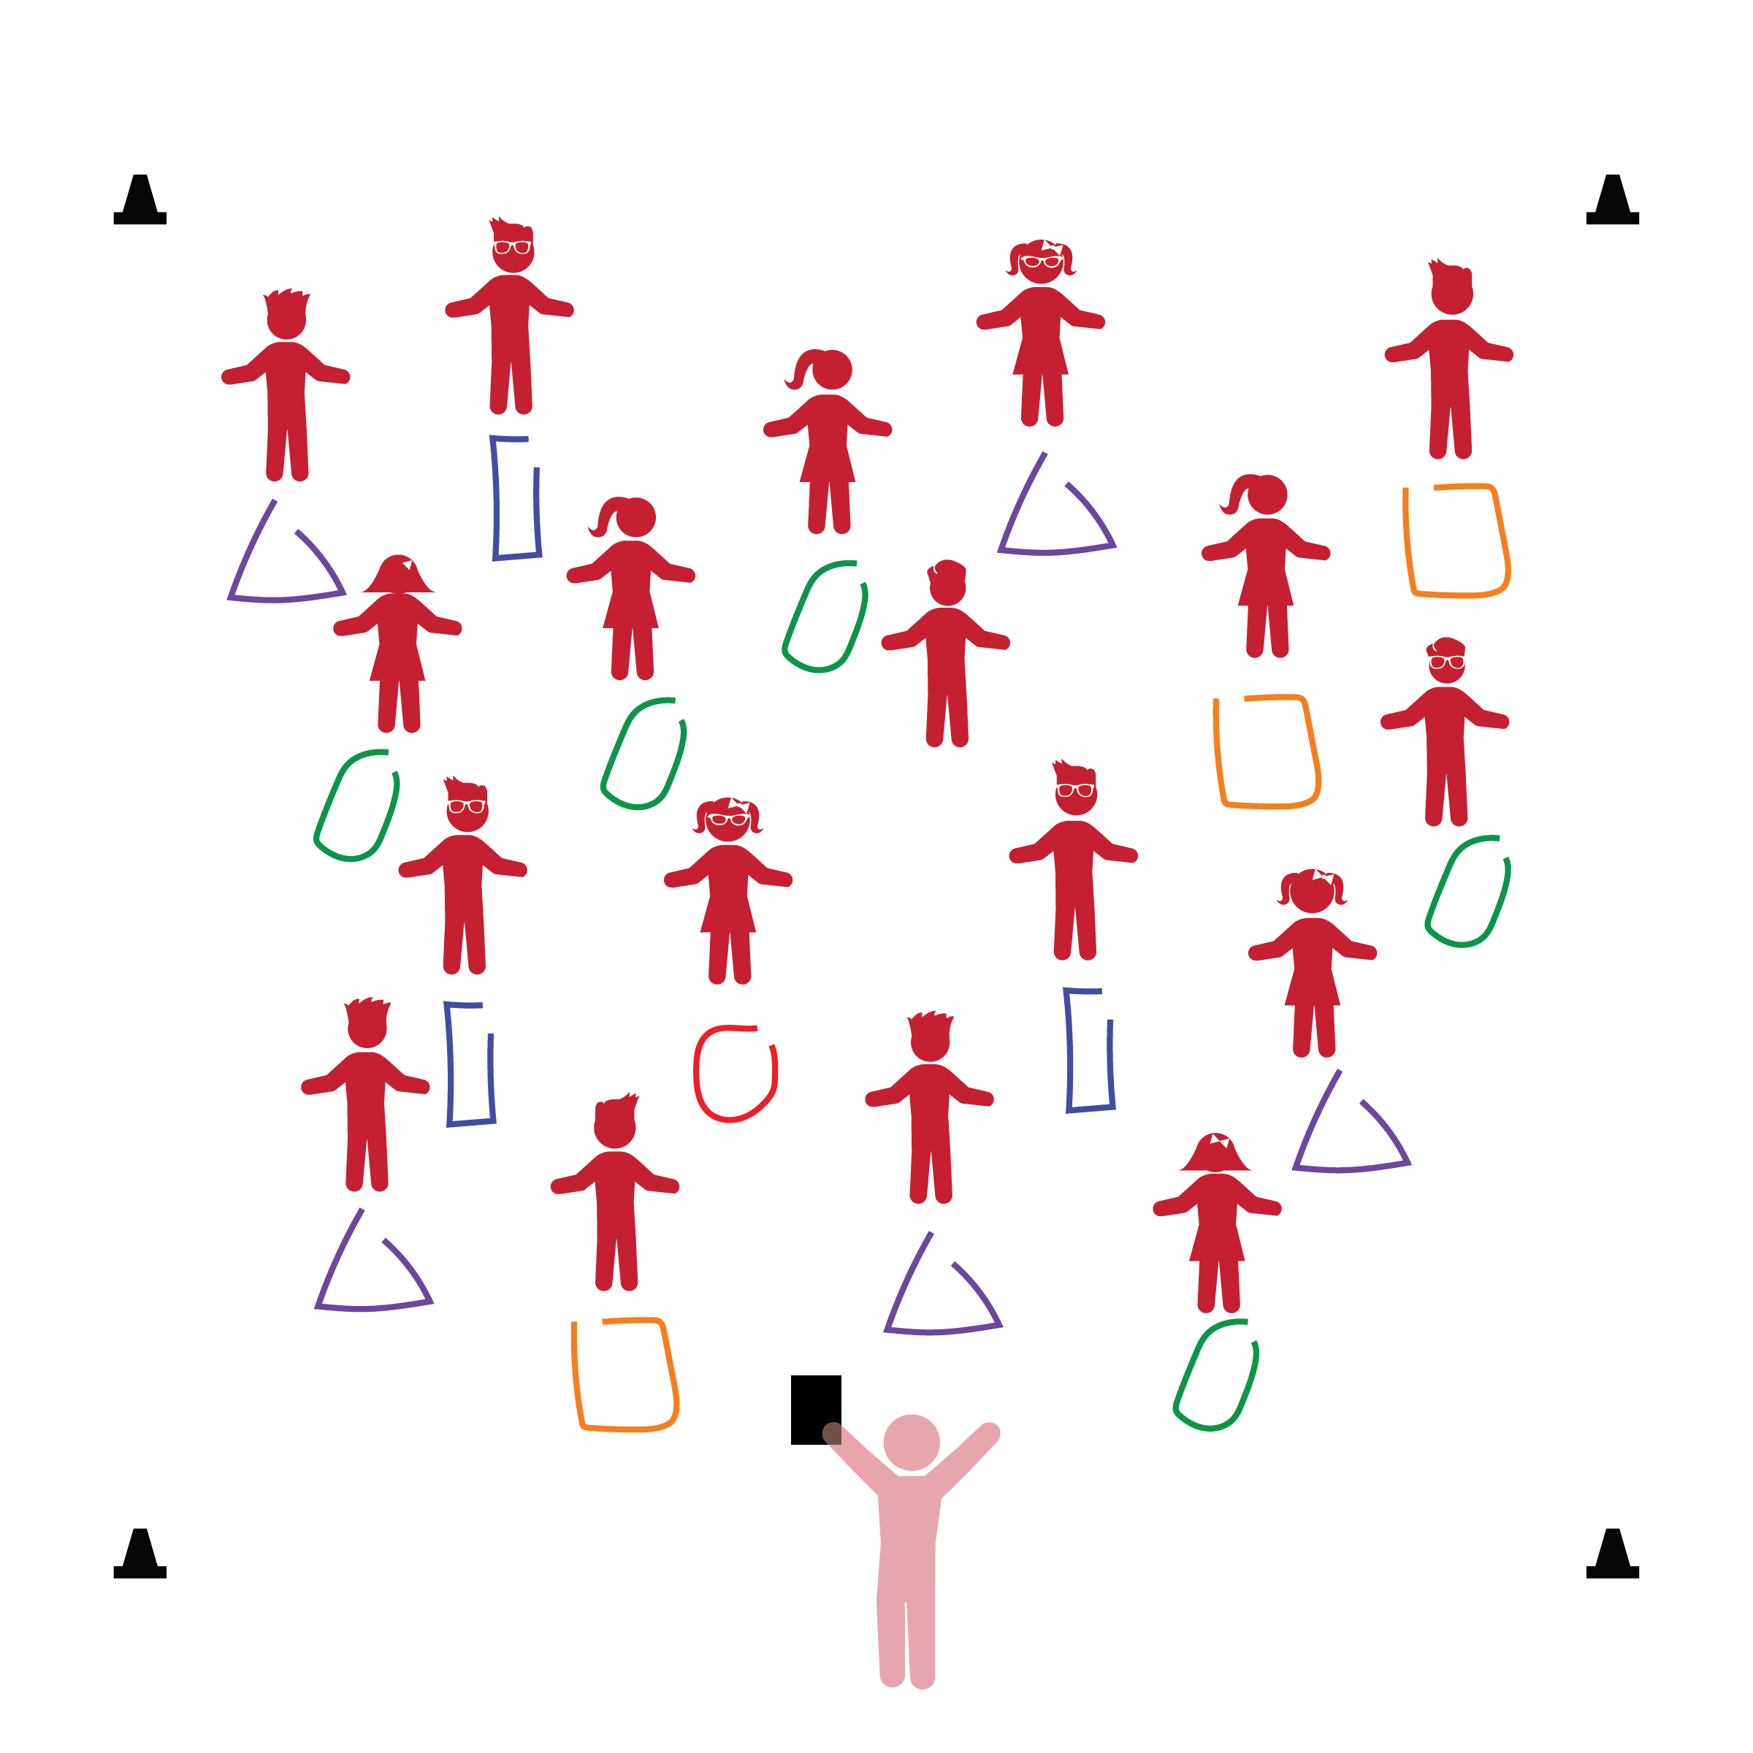­

**Things You Need:**

* 1 rope per student
* Cones to create boundaries

**Set-Up:**

1. Each student on a Home Base with a rope and personal space.
2. Students place their ropes on the floor at their feet.
3. Be sure spacing between students is safe for activity.

* **Approaches to Learning:** Demonstrates initiative and independence. Demonstrates a willingness and capability to work independently.
* **Cognition:** Uses spatial awareness to understand objects and their movement in space.
* **Perception:** Coordinates perceptual information and motor actions to participate in play.

* I will work at a low level and keep my rope on the floor when I’m making shapes.
* I will follow my teacher’s instructions and listen for start and stop signals.

**Activity Procedures:**

1. The purpose of this activity is to allow students to manipulate their ropes on the floor while reinforcing the movement concept of levels. They will be working at a low level during this activity.
2. Before beginning, tell students to look at and take note of their personal space as well as their rope’s color. In this lesson, ropes will act as each student’s Home Base.
3. When teacher says “GO,” students begin to make any shape of their choosing. They can make several different shapes. Allow them to experiment with the rope in safe ways.
4. Say “FREEZE” so that students stop touching their ropes and stand behind them. Spend a minute talking about the different shapes that students made. Also take this time to cover any safety issues that may have come up. Repeat the activity, but this time, describe a shape for the students to create (e.g., create a shape with 4 equal sides [a square]).

**Universal Design Modifications:**

* Use different sized ropes, string, or yarn.
* Provide an adult to assist children who may have difficulty manipulating the rope with their hands.