­­

**“A” IS FOR ACTIVITY**

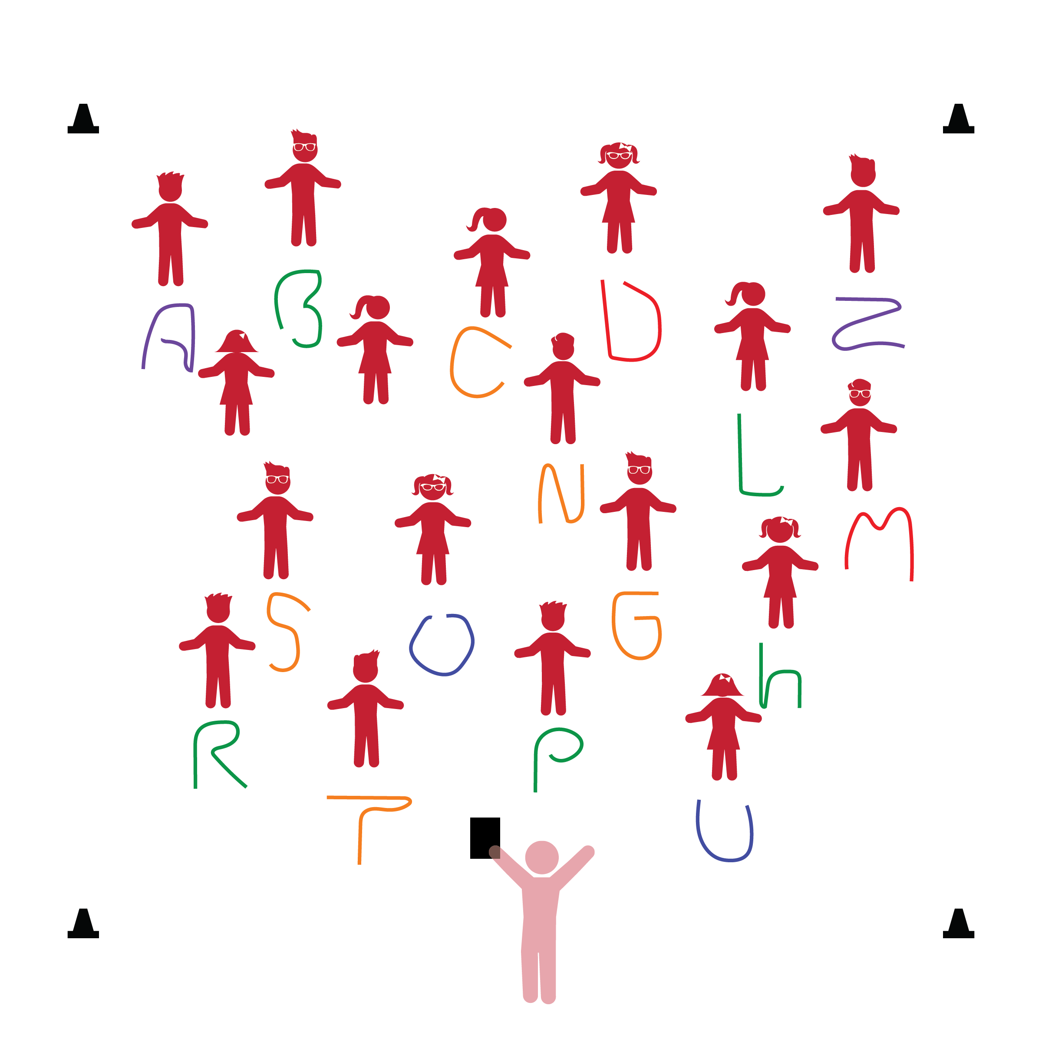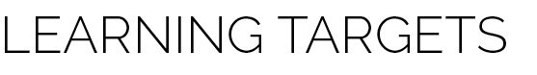­

**Activity Procedures:**

1. The purpose of this activity is to allow students to express themselves while manipulating their ropes on the floor. Again, reinforce that they will be working at a low level during this activity.
2. Before beginning, tell students to look at and take note of their personal space as well as their rope’s color. In this lesson, ropes will act as each student’s Home Base.
3. When teacher says “GO,” students begin to make any letter of their choosing. They can make as many letters as they’d like in the time that you provide.
4. Say “FREEZE” so that students stop touching their ropes and stand behind them. Spend a minute talking about the different letters that students have made. Also take this time to cover any safety issues that may have come up.
5. Repeat the activity, but this time, call a letter for the students to make. Challenge students by making letter sounds for them to identify.

**Universal Design Modifications:**

* Use different sized ropes, string, or yarn.
* Provide an adult to assist children who may have difficulty manipulating the rope with their hands.
* **Identity and Belonging:** Contributes own ideas, skills, and abilities to activities and experiences with adults and other children.
* **Emergent Literacy:** Recognizes and uses some letters or numbers, such as letters in one’s own name.

**Things You Need:**

* 1 rope per student
* Cones to create boundaries

**Set-Up:**

1. Each student on a Home Base with a rope and personal space.
2. Students place their ropes on the floor at their feet.
3. Be sure spacing between students is safe for activity.

* I will show the teacher my ideas by using the rope to make letter shapes that I know.
* I will try my best and follow all directions.