­­

**KNOW WHERE**

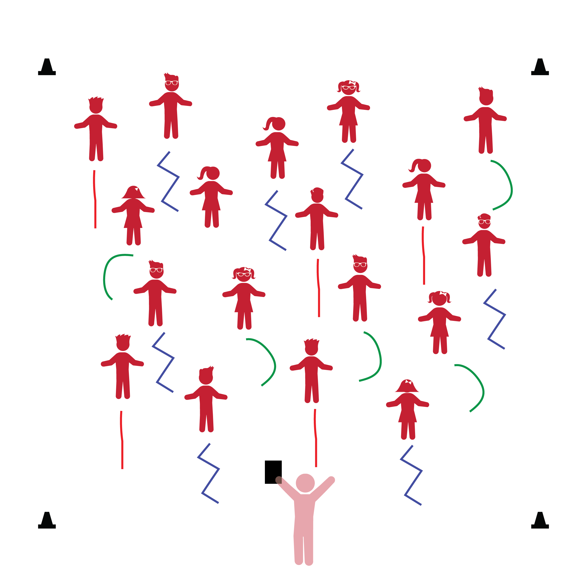­

**Activity Procedures:**

1. The purpose of this activity is to provide students an opportunity to balance in a challenging and dynamic environment. You can also emphasize an understanding of movement pathways.
2. Before beginning, remind students that the ropes will act as each student’s Home Base.
3. When teacher says “GO,” students begin to make a pathway with their rope—curved, straight, or zigzag.
4. Say “FREEZE” so that students stop touching their ropes and stand behind them. Next, prompt students to walk on their rope along the pathway they’ve created. Repeat this activity with students creating a variety of pathways.
5. If students are socially mature enough to work in pairs, group them and then challenge them to create pathways for their partners to walk on. Allow all pairs to switch roles and take turns.

**Universal Design Modifications:**

* Create a variety of pathway patterns with floor tape, allowing students to travel on the tape rather than the ropes.
* Demonstrate the pathway patterns for all students to view and imitate.
* **Gross Motor:** Demonstrates balance in large-muscle movement. Demonstrates awareness of own body and other people’s space during interactions.
* **Geometer and Spatial Sense:** Explores the positions of objects in space.

**Things You Need:**

* 1 rope per student
* Cones to create boundaries

**Set-Up:**

1. Each student on a Home Base with a rope and personal space.
2. Students place their ropes on the floor at their feet.
3. Be sure spacing between students is safe for activity.

* I will follow directions and move safely.
* I will use my arms, legs, and other body parts to keep my balance.