­­

**YIKES…SNAKES!**

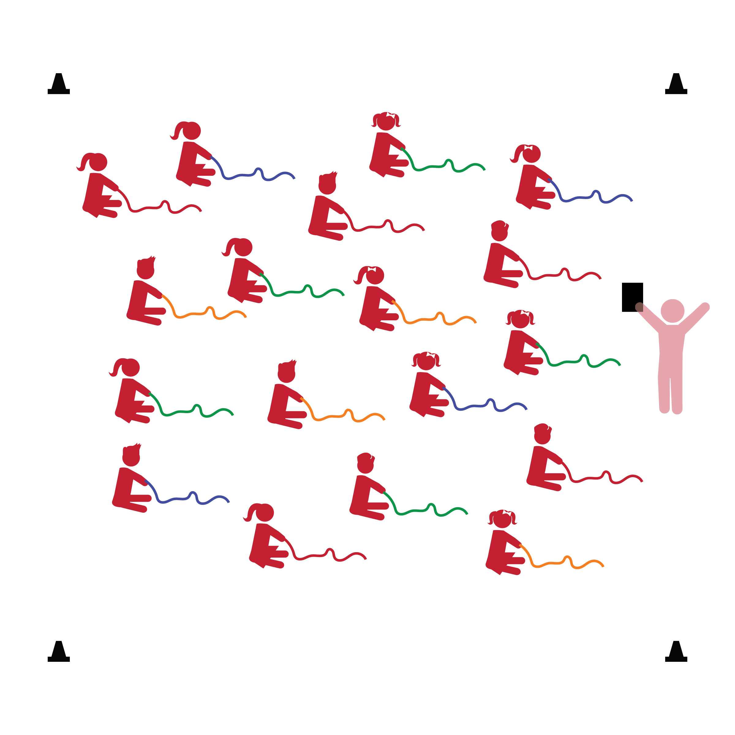­

**Activity Procedures:**

1. The purpose of this activity is to provide students with an engaging way to manipulate the rope with their hands.
2. Before beginning, tell students to look at and take note of their personal space as well as their rope’s color. In this lesson, ropes will act as each student’s Home Base.
3. When teacher says “GO,” students take hold of the rope at one end and begin dragging/wiggling the rope on the ground in front of them. Be sure the movements start slow and small. Stop the activity if you see students using the rope in a way that could be dangerous.
4. As a class, count to 20 out loud and then say “FREEZE” so that students stop touching their ropes and sit behind them. Spend a minute talking about safety with an emphasis on using the rope appropriately.
5. Repeat the activity while saying the alphabet.
6. If students are socially mature enough to work in pairs, group them such that one student becomes the “snake charmer” and the other becomes the “snake trap.” The snake charmer wiggles the rope slowly and the snake trap tries to catch the snake on the floor using an open hand (palms down, don’t grab). Switch roles.

**Universal Design Modifications:**

* Pair students with an adult who acts as the “snake charmer” in order to slow the rope’s movement and make it less challenging.
* Give “snake traps” a large mitten, paddle, or other object to make it easier to catch the snake.
* **Gross Motor Development:** Uses perceptual information to guide motions and interactions with objects and other people.
* **Fine Motor Development:** Demonstrates increasing control and coordination of small muscles.

**Things You Need:**

* 1 rope per student
* Cones to create boundaries

**Set-Up:**

1. Each student on a Home Base with a rope and personal space.
2. Students place their ropes on the floor at their feet.
3. Be sure spacing between students is safe for activity.

* I will control my body and move the rope safely in personal space.
* I will use an open hand as I work to catch the snake on the floor.