­­

**WHAT’S ON YOUR PLATE**

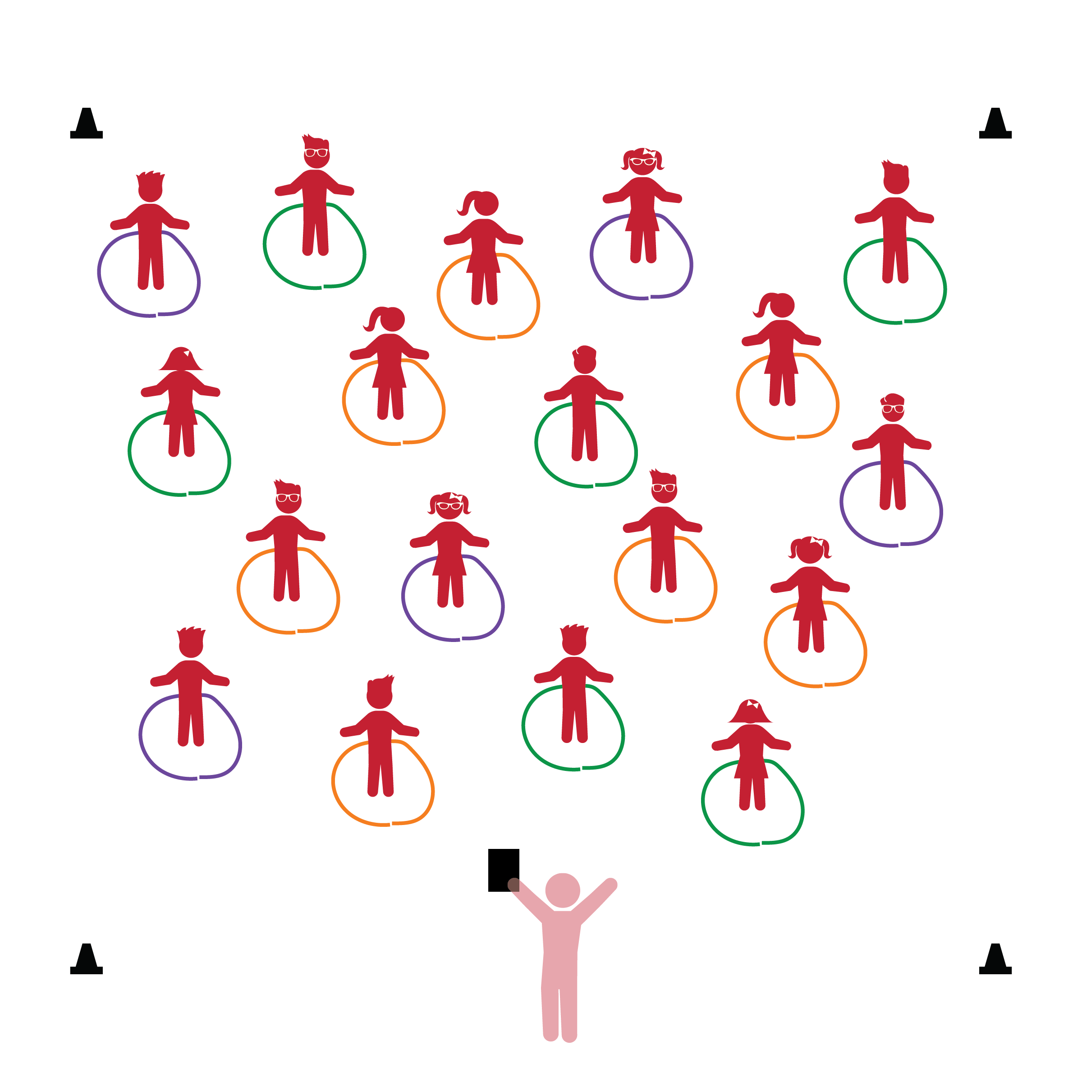­

**Things You Need:**

* 1 rope per student
* Cones to create boundaries

**Set-Up:**

1. Each student on a Home Base with a rope and personal space.
2. Each student creates a circle with their rope on the floor at their feet.
3. Be sure spacing between students is safe for activity.

**Activity Procedures:**

1. The purpose of this activity is to reinforce and teach students about healthy food and why it’s important to put healthy food on their plates. Before beginning, remind students that the ropes will act as each student’s Home Base.
2. Start with the students following and repeating what the teacher says and does. “The rope circle is a plate and we’re going to put healthy foods on our plate. I’m going to jump up and down on my plate. Each time I do I’ll call out a healthy food. After I jump and call a food, you’ll jump and call the same food. Get ready. (Jump) Apple! (Jump) Spinach! (Jump) Oranges! (Jump) Peas! Etc.…
3. Repeat the activity with students taking turns calling out their own healthy foods.
4. Next, reinforce the 5 MyPlate food groups (Fruits, Vegetables, Grains, Protein, Dairy). Jump and call a food group. Then, jump and call foods along with the food group they belong to.
5. Challenge students to connect good nutrition with taste (1 of the 5 senses). Identify a food and have the students help you describe how it tastes. Can you explore foods with all of the 5 senses?

**Universal Design Modifications:**

* This activity can be done with hoops and/or spot markers.
* If students have trouble with jumping inside of the circle, allow them to clap, march, or perform a different movement.
* **Gross Motor Development:** Performs activities that combine and coordinate large-muscle movements.
* **Health and Nutrition:** Identifies a variety of healthy foods with an increasing understanding of the ways in which foods help the body grow and be healthy.
* I will control my body and move safely in personal space.
* I will identify different foods that are good for my body.