­­

**LOW, MEDIUM, HIGH…OH MY!**

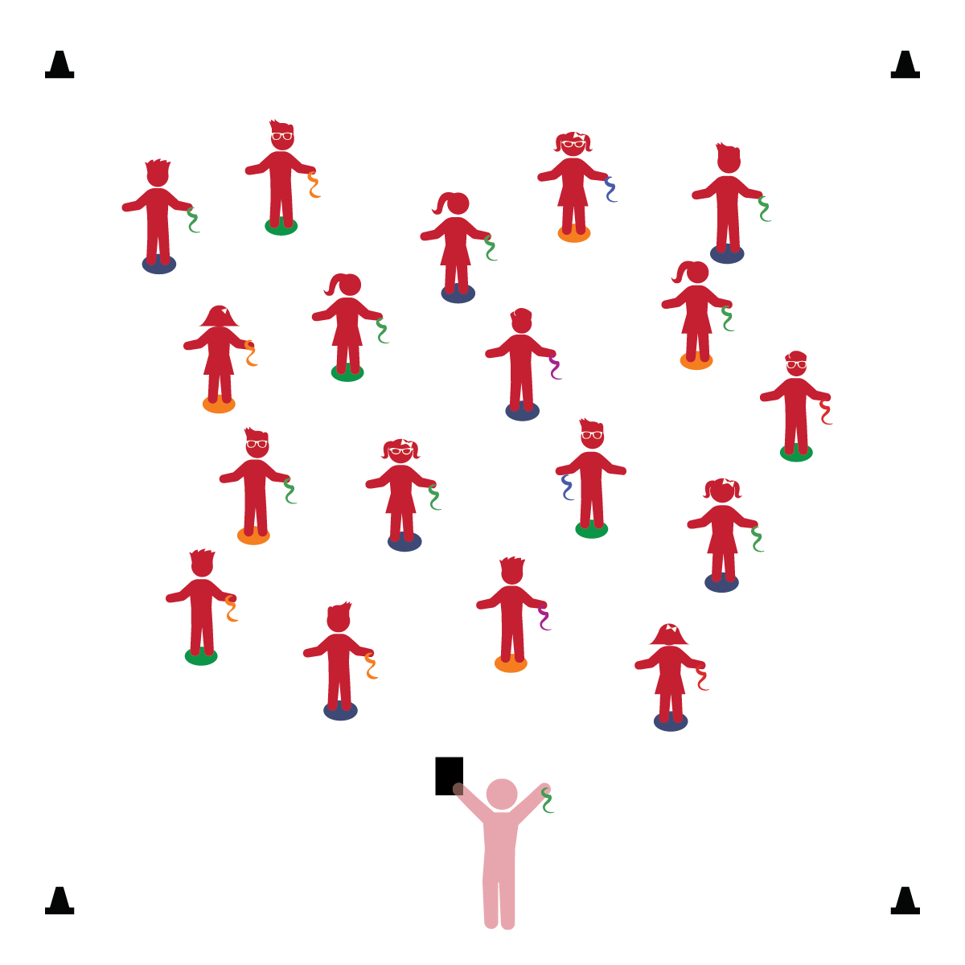­

**Activity Procedures:**

1. The purpose of this activity is to start learning how to move a scarf at different levels.
2. Stand tall on your Home Base with the scarf in 1 hand. When the music starts, you can begin to wave and move the scarf to the music. When the music stops, freeze and stand tall.
3. Great job! Now as the music plays I will call out a different level: high, medium, or low. When you hear the level called out, begin waving you scarf at that level. You can watch me. I’ll be performing with my scarf.
4. Challenge: Teachers, call out an object/animal at each level (e.g., snake, tiger, giraffe). Students wave scarves to match the level of the object.

**Universal Design Modifications:**

* Provide adult assistance for students with developmental and/or movement challenges.
* Allow students to perform the activity in a seated position.
* **Creativity:** Shows willingness to participate in new activities.
* **Gross Motor:** Coordinates movements and actions for a purpose.
* **Fine Motor:** Uses hand-eye coordination to manipulate objects.

**Things You Need:**

* 1 scarf per student
* 1 spot marker per student
* Cones to create boundaries
* Music and music player

**Set-Up:**

1. Each student on a Home Base (spot marker) with a scarf and personal space.
2. Be sure spacing between students is safe.

* I will control my body and move safely in personal space.
* I will follow teacher instructions and wave the scarf at different levels.