­­

**STAND LIKE THIS**

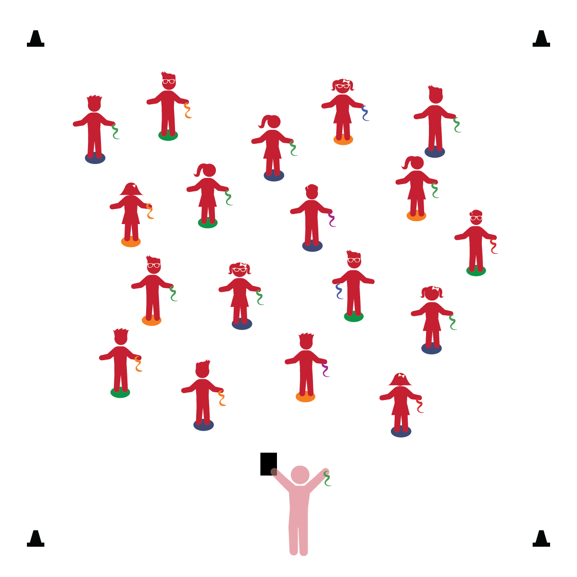­

**Activity Procedures:**

1. It’s time for some balance challenges! Stand tall on your Home Base with the scarf in 1 hand.
2. When I call out a challenge, follow the directions, watch my example, and follow along.
3. Stand with your feet wide apart, arms up, rest the scarf on your elbow.
4. Stand with your feet close together, arms down, rest the scarf on your shoulder.
5. Stand straddling your spot marker with scissor legs, arms to front and back, scarf on your wrist.
6. Stand on 1 foot holding the scarf out wide. Stand on the other foot, scarf in the other hand.
7. Repeat challenges, then create new ones.

**Universal Design Modification:**

* If students have difficulty balancing on different bases of support, allow them to choose one (e.g., feet wide apart) and then move/hold the scarf in a variety of positions.
* **Gross Motor:** Demonstrates balance in large-muscle movements.
* **Self-Regulation:** Follows rules for managing actions and behavior.
* **Cognitive Self-Regulation:** Follows detailed, multi-step directions.

**Things You Need:**

* 1 scarf per student
* 1 spot marker per student
* Cones to create boundaries

**Set-Up:**

1. Each student on a Home Base (spot marker) with a scarf and personal space.
2. Be sure spacing between students is safe.

* I will follow all physical activity rules.
* I will follow directions and perform all of the balance challenges.