­­

**MIRROR ME**

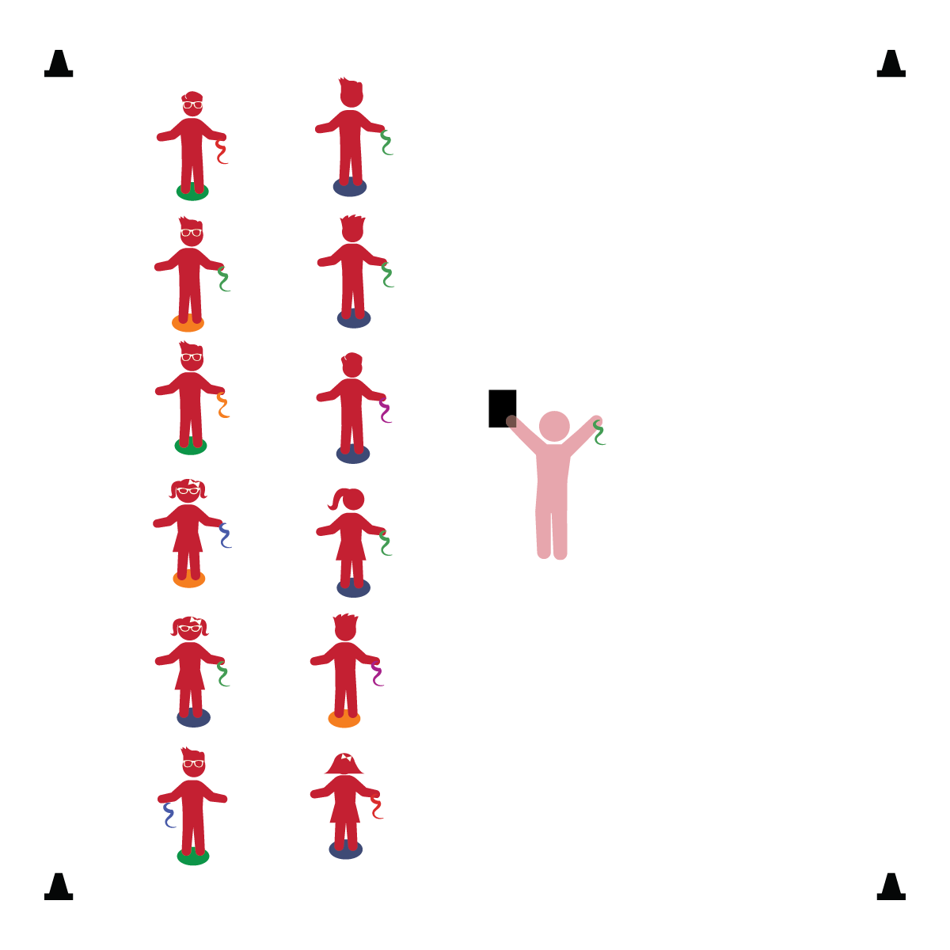­

* **Gross Motor:** Demonstrates awareness of own body and other people’s space during interactions.
* **Fine Motor:** Coordinates hand and eye movements to perform actions.
* **Relationships:** Shows enjoyment of play with other children.
* **Relationships:** Engages in simple cooperative play with other children.

**Activity Procedures:**

1. It’s time to play Mirror Me! Stand tall on your Home Base. When I say, “GO!” I’m going to start to move my scarf very slowly. It’s your job to follow my movements like you are my reflection in a mirror.
2. I’ll gradually start to move my scarf faster. So, pay attention and work hard to mirror my movements.
3. Next, we’ll try to mirror a partner. (Use 2 students to demonstrate.)
4. Turn and face your partner. When I say, “GO!” the partner in Line 1 will start moving her/his scarf very slowly. The partner in Line 2 will mirror her/his movements. (After 30 seconds to 1 minute, change roles.)

**Universal Design Modifications:**

* Instead of working in partners, pick 1 student to be the class leader. All students mirror the class leader’s movements.

**Things You Need:**

* 1 scarf per student
* 1 spot marker per student
* Cones to create boundaries

**Set-Up:**

1. Place spot markers in 2 parallel lines 5 feet apart. Number the lines – Line 1 and Line 2.
2. Each student on a Home Base (spot marker) with a scarf and personal space.
3. Be sure spacing between students is safe.

* I will move safely in personal space.
* I will mirror the teacher’s movements.
* I will work safely with a partner.