­­

**TOSSING CHALLENGES**

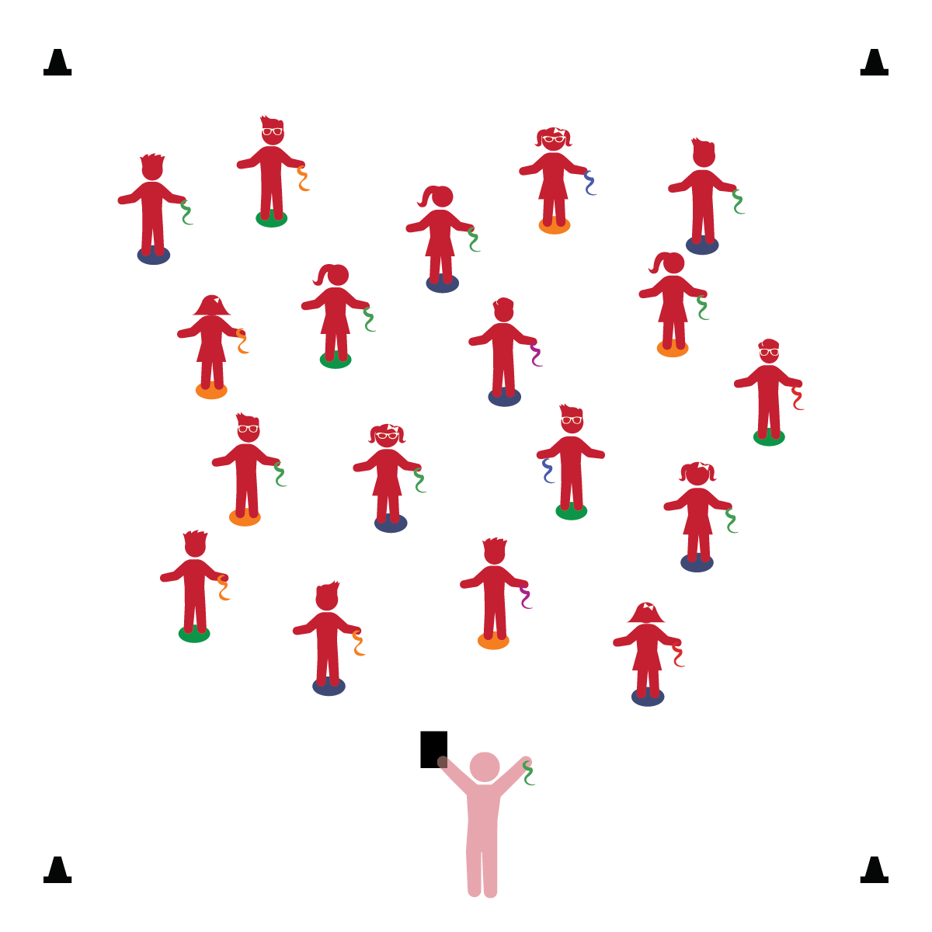­

**Activity Procedures:**

1. It’s time for some tossing challenges! Stand tall on your Home Base with the scarf in 1 hand.
2. When I call out a challenge, follow the directions, watch my example, and follow along. (Allow students to practice each challenge for approximately 30 seconds.)
3. Toss your scarf as high as you can. Toss your scarf down on to your spot marker.
4. Stand next to your spot marker and try to toss your scarf on to the spot. Toss your scarf over your spot.
5. Now, when the music starts, you can try any of the challenges we’ve practiced. You can change from one challenge to another any time you want. You can even make up new challenges that are safe and stay within your personal space.

**Universal Design Modifications:**

* Some children/classes may not be ready to perform challenges independently with the music. Continue practicing challenges as a group until you believe the children are ready to advance.
* I will work in my own personal space.
* I will follow all physical activity rules.
* I will follow directions and will safely toss my scarf.

**Things You Need:**

* 1 scarf per student
* 1 spot marker per student
* Cones to create boundaries
* Music and music player

**Set-Up:**

1. Each student on a Home Base with a scarf and personal space.
2. Be sure spacing between students is safe.

* **Gross Motor:** Coordinates movements and actions for a purpose.
* **Fine Motor:** Uses hands for exploration and play.
* **Self-Regulation:** Manages actions and behavior with increasing independence.