­­

**TAILS**

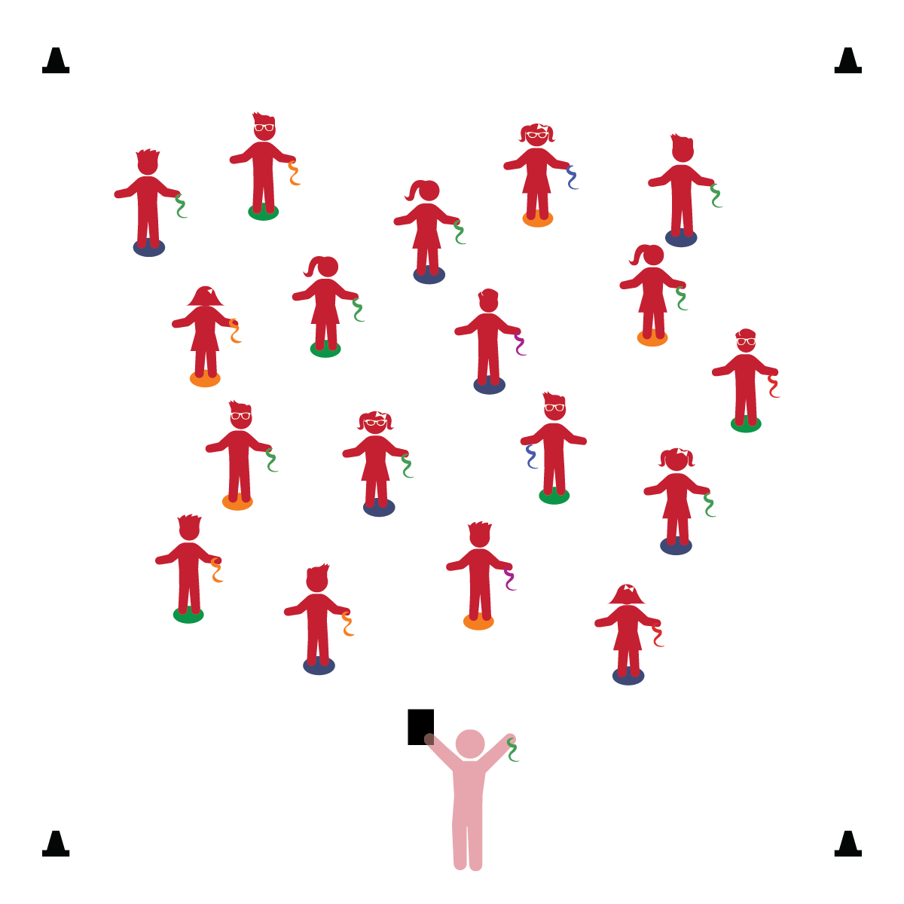­

**Activity Procedures:**

1. It’s time to play a game called Tails! Start by standing tall on your Home Base.
2. Who can name an animal with a tail? (Take time to allow several students to answer.)
3. That’s right! When the music plays we’re going to hold our scarf behind our backs, like a tail, and move like the animal that I call out. (Start with slow animals/movements. Gradually increase speed as students move safely in general space.)
4. When the music stops, freeze and stand tall, ready to learn.
5. Play and repeat this activity for several rounds. As students mature, focus on developing locomotor skills (jump, gallop, slide, etc.).

**Universal Design Modifications:**

* Allow students to move without a scarf, using their imagination to visualize a tail.
* Prompt student to act like animals while staying in personal space.

**Things You Need:**

* 1 scarf per student
* 1 spot marker per student
* Cones to create boundaries
* Music and music player

**Set-Up:**

1. Each student on a Home Base (spot marker) with a scarf and personal space.
2. Be sure spacing between students is safe.

* **Self-Regulation:** Demonstrates awareness of classroom rules.
* **Creativity:** Uses imagination in play.
* **Gross Motor:** Walks and runs, adjusting speed or direction depending on the situation.
* I will follow all physical activity rules.
* I will move safely in general space.
* I will respect the personal space of others.