­­

**SCARF FITNESS**

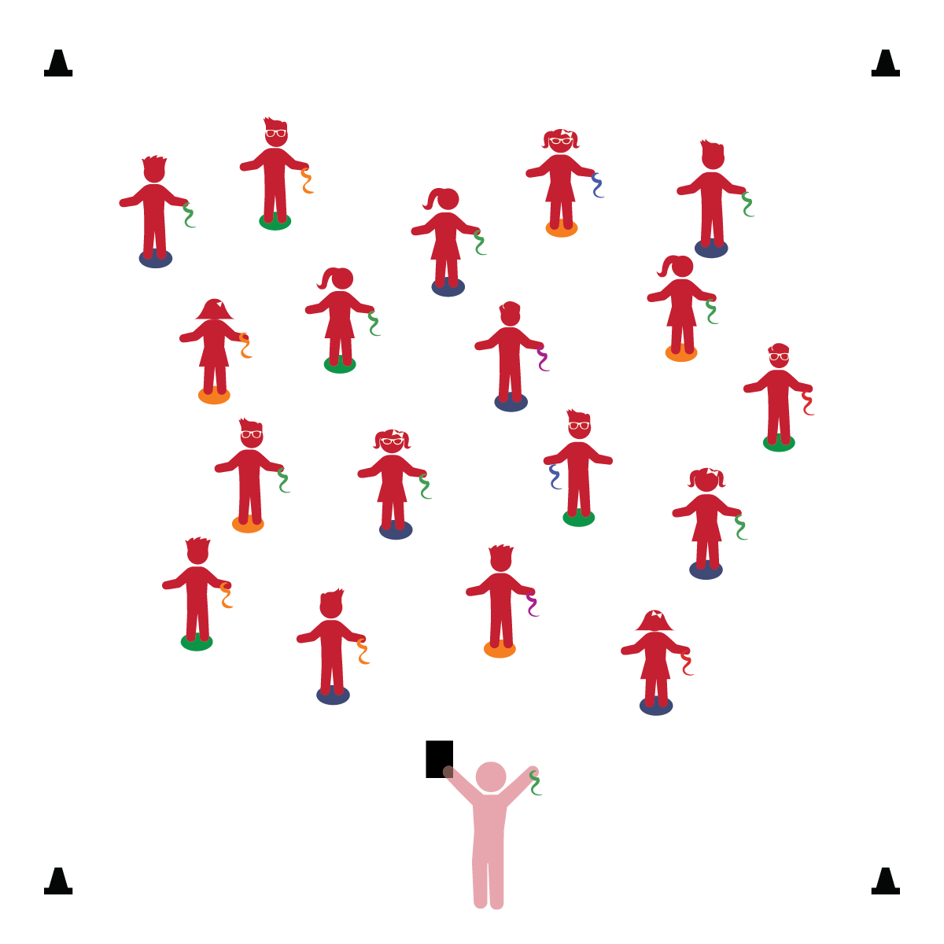­

**Things You Need:**

* 1 scarf per student
* 1 spot marker per student
* Cones to create boundaries
* Music and music player

**Set-Up:**

1. Each student on a Home Base (spot marker) with a scarf and personal space.
2. Be sure spacing between students is safe.

**Activity Procedures:**

1. It’s time to have fun and get some exercise! When you exercise, your heart beats faster. Can you feel your heart beat in your chest?
2. When the music starts, I’m going to demonstrate some exercises with the scarf. You will follow along and do the exercises with me. Let’s see if we can make our hearts beat faster.
3. Hold the scarf and do jumping jacks.
4. Wave the scarf while you jog in place.
5. Pretend the scarf is a weight. Perform dumbbell curls.
6. Hold the scarf and jump side to side – on and off the spot marker.
7. Sit on the spot marker. Lift one leg and pass the scarf around the leg. Repeat with the other leg.
8. On hands and knees. Wave the scarf in front with the right hand. Repeat with the left hand.

**Universal Design Modifications:**

* Choose/create exercise activities that you know your students can perform with success.
* **Health:** Demonstrates healthy behaviors (e.g., daily exercise).
* **Gross Motor:** Demonstrates stamina to participate in physical activity.
* **Self-Regulation:** Demonstrates awareness of classroom rules.

* I will exercise and make my heart beat faster.
* I will follow all physical activity rules.
* I will be active at my Home Base.