­­

**TEAM FITT RPS**



* **Skill:** I will demonstrate fitness activities with proper form and attention to safety.
* **Cognitive:** I will answer questions related to fitness concepts.
* **Fitness:** I will pace my activity so that I work within the targeted Heart Rate Zone.
* **Personal & Social Responsibility:** I will work cooperatively with my teammates.

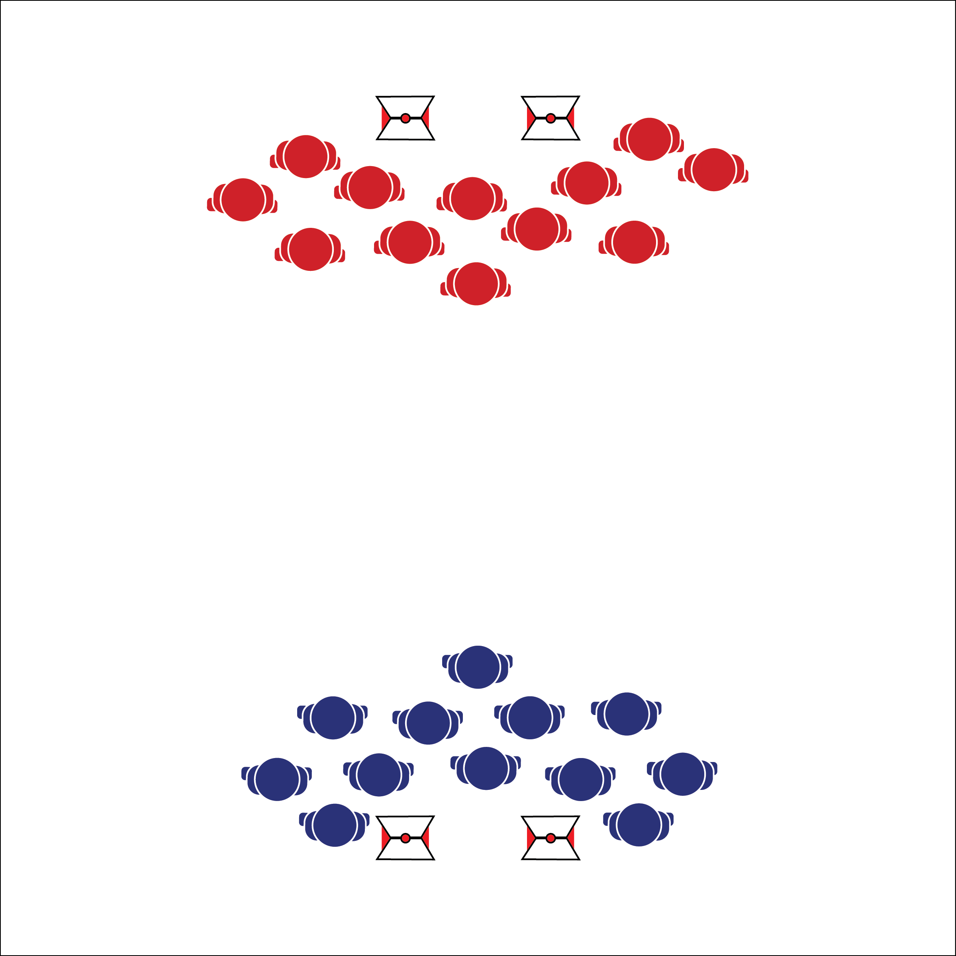

**Activity Procedures:**

1. This fitness activity is called Team FITT RPS. The object of the game is for you and your team to score points by winning Rock, Paper, Scissor matches and then answering fitness-related questions after each round. A round ends when one team wins 5 out of 7 matches.
2. As a team, decide which RPS element you’ll play. On the signal, run together to meet the other team at the center line. On, “Rock, Paper, Scissor, SHOOT!” show your element. (Everyone on a team should show the same element.) If the match is a tie, return to your line and then replay the match with a new element.
3. After each match, everyone must return to their team line and complete 5 reps of the Darebee.com exercise displayed. Change exercises after each round of play.
4. Each team is asked 1 question after each round of matches. The team that wins the round (5 out of 7 matches) earns the 3rd bonus question. Correct answers are worth 5 points.
5. Use the Team RPS Score Card to track your score. Score 1 point per match, 5 points per correctly answered question, and 5 points if your team’s heart rate zone representative finishes a round of play in a target zone.

**Grade Level Progression:**

**L1:** Play as described above.

**L2:** Each team member must be in the target HR zone before moving to the center line for a RPS match.

**Equipment:**

* 4 cones
* 4 task tents
* [Darebee.com PE Cards](http://darebee.com/initiatives/pe-teachers.html)
* Heart rate monitors (HRMs)
* Team RPS Score Card
* Team RPS Question Set

**Set-Up:**

1. Set-up a large activity area using 4 cones and Task Tents.
2. Place Darebee.com PE Cards in task tents, or display the cards using a projector.
3. Create 2 equal teams. Each team starts on an end line. For large groups, create multiple activity areas.
4. Distribute HRMs according to class routine.
5. Designate 1 player per team as a Heart Rate Zone Representative.

* Communicate
* Cooperate
* Pace Your Activity

**TEAM FITT RPS**



FITT, Frequency, Intensity, Time, Type, Heart Rate Monitor, Heart Rate Zone,

Target Heart Rate, Cooperation, Communication, Safety



* **Standard 1 [H3.L1]** Demonstrates competency in one or more specialized skills in health-related fitness activities (L1).
* **Standard 3 [H10.L1&2]** Calculates target heart rate and applies HR information to personal fitness plan (L1); Adjusts pacing to keep heart rate in the target zone, using available technology (e.g., pedometer, heart rate monitor) to self-monitor aerobic intensity (L2).
* **Standard 4 [H3.L1&2]** Uses communication skills and strategies that promote team/group dynamics (L1); Assumes a leadership role (e.g., task or group leader, referee, coach) in a physical activity setting (L2).



* **DOK 1:** What would you include on a list about the FITT Principle?
* **DOK 2:** How does exercise intensity apply to Team FITT RPS?
* **DOK 3:** How would you adapt this activity to make it more intense? How would you make it less intense?
* **DOK 3:** How would you adapt this activity to alter other components of the FITT principle?



**Identify Critical Content:** The FITT Principle is foundational knowledge students need as they work toward creating personalized fitness plans. The questions provided in the Team RPS Question Set will arm students with critical information that they’ll be able to access for future activities and lessons.



* Pair students to provide a guide for students who require assistance.
* Provide fitness activities at various levels of intensity and difficulty. Allow students to choose their level of participation.

## 

* Pace Your Activity
* Focus on Form
* Think Safety First

**Activity Procedures:**

1. Today we’re going to work in our target heart rate zone and unlock fitness puzzle pieces by completing level 1 of a Darebee.com High Intensity Interval Training (HIIT) routine. Monitor your heart rate to make sure you’re working in your target zone.
2. After you’ve completed all the sets for level 1, walk 1 lap around the activity area to cool down and help you heart rate recover.
3. When you’ve finished your cool-down lap, open your puzzle pieces and complete the puzzle. There will be a cognitive challenge for your team to complete using the paper and pencil.
4. On the music, begin your workout.

**Grade Level Progression:**

**L1:** Prompt students to use the information provided on each puzzle to evaluate activities that can be pursued locally in order to improve 1 or more components of fitness.

**L2:** Prompt students to outline ways in which heart rate monitor and activity tracking technology can be used to support a healthy and active lifestyle.

**Equipment:**

* 5 cones with task tents
* 5 Fitness Puzzles
* Paper and pencil for each team
* Heart rate zone chart
* 5 Darebee.com HITT Routine Cards  
  (Links available at OPENPhysEd.org)

**Set-Up:**

1. Place cones around the perimeter of the activity area with space for teams to exercise safely.
2. Place cut Fitness Puzzle pieces, along with paper and pencil in task tents behind each Darebee.com card.
3. Place heart rate zone charts in the back side of each task tent.
4. Create 5 equal teams. Each team at a cone.

**HEALTH-RELATED JIGSAW**

* **Skill:** I will demonstrate fitness activities with proper form and attention to safety.
* **Cognitive:** I will discuss ways to maintain an active lifestyle using available community resources.
* **Fitness:** I will increase my heart rate into a target zone.
* **Personal & Social Responsibility:** I will work cooperatively with my team to complete the jigsaw challenge.

**FITNESS CONCEPT JIGSAW**



Health-Related Fitness, HIIT, Intensity, Target Heart Rate Zone, Exercise Form, Pace, Safety



* **Standard 1. [H3.L1 & L2]** Demonstrates competency in one or more specialized skills in health-related fitness activities (L1); Demonstrates competency in two or more specialized skills in health-related fitness activities (L2).
* **Standard 3. [H2.L2]** Analyzes and applies technology and social media as tools to support a healthy, active lifestyle (L2).
* **Standard 3. [H10.L1 & L2]** Calculates target heart rate and applies HR information to personal fitness plan (L1); Adjusts pacing to keep heart rate in the target zone, using available technology (e.g., pedometer, heart rate monitor) to self-monitor aerobic intensity (L2).



* **DOK 1:** What would you include on a list of local community resources that can help you and your family maintain a healthy and active lifestyle?
* **DOK 2:** Pick 1 resource and tell the class all that you know about it.
* **DOK 3:** How are community resources related to maintaining a healthy and active lifestyle?
* **DOK 4:** What information can we gather to help learn of and understand all the different community resources are available to help us stay physically active?



**Organize students to interact with content:** This activity provides a student-centered and cooperative learning environment in which students collaborate and interact with the lesson concepts. Facilitate this process by encouraging students to communicate and help one another to understand and process key lesson points.



* Modify activity cards and exercises to meet the needs of all students.
* Decrease the intensity of this activity by allowing groups to complete challenges in relay format.

­­

**NUMBER CARD TAG**

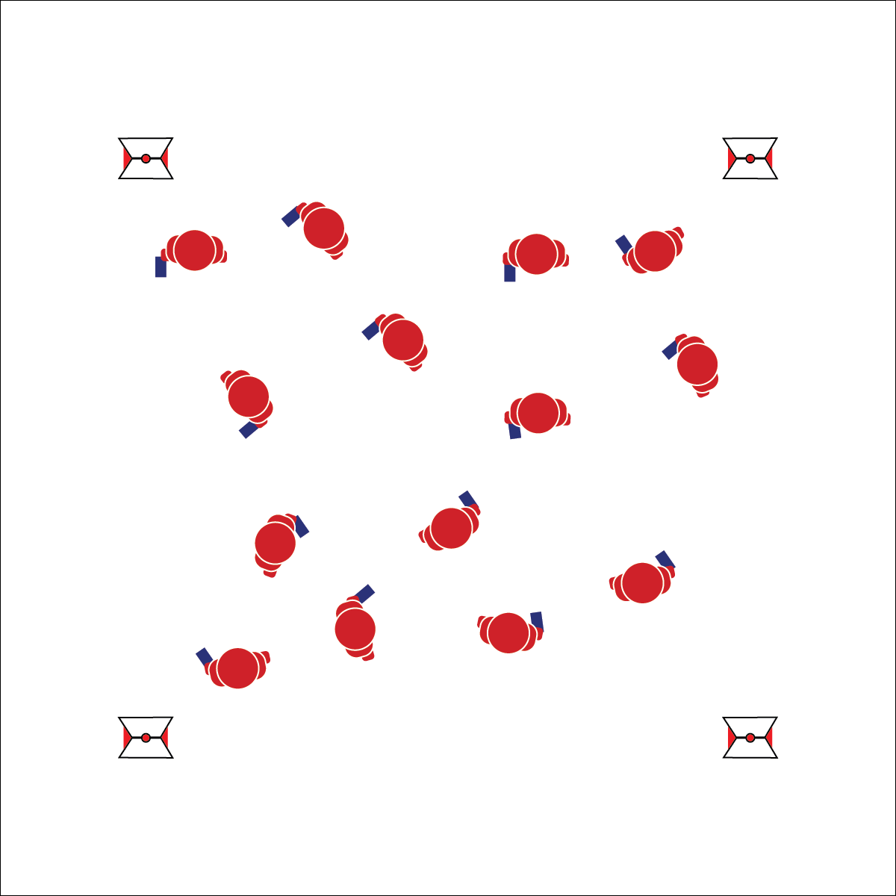

* Safe Tagging
* Maintain Control
* Actively Engage
* **Skill:** I will demonstrate safe tagging and controlled movement.
* **Cognitive:** I will discuss stress management strategies.
* **Fitness:** I will increase my heart rate into a target zone.
* **Personal & Social Responsibility:** I will demonstrate safe behaviors that enhance the class learning environment.

**Equipment:**

* 1 deck of playing cards
* 4 cones with task tents
* Lap Station Cards

**Set-Up:**

1. Create a large activity area using 4 cones as boundaries.
2. Place Lap Station Cards in task tents on cones.
3. Distribute 1 playing card per student. Be sure that 2 to 4 students have cards with matching numbers (but different suits).
4. Scatter students in activity area.

**Activity Procedures:**

1. This activity is called Number Card Tag. We’ll start at a speed-walking pace. The object of the game is for the taggers to tag all students, and for those students fleeing to be the final student tagged.
2. I will call out a card number (e.g., 5, Ace, Queen). That call will be the signal for all players holding a card with that number to become taggers. They will work together to tag as many other students as possible.
3. When tagged, move to the perimeter and walk the circuit of Lap Station Cards. At each station card, read and compete the challenge. Then rate your perceived exertion before walking to the next Lap Station Card.
4. When all but 1 player remains in the tag game, we’ll reset and I will call a new number.
5. *Note: This game can also be played with students returning to the tag game after completing 1 lap station circuit.*

**Grade Level Progression:**

**L1:** Increase the pace of the game when students demonstrate safe tagging and fleeing behaviors.

**L2:** Allow students to create new Lap Station Cards.

**NUMBER CARD TAG**



* Use more or fewer taggers to change the pace and dynamics of the activity.
* Increase or decrease the size of the playing are while also changing the speed at which students can move.



Actively Engage, Stress Management, Healthy Lifestyle, Perceived Exertion



* **Standard 1. [H3.L1 & L2]** Demonstrates competency in one or more specialized skills in health-related fitness activities (L1); Demonstrates competency in two or more specialized skills in health-related fitness activities (L2).
* **Standard 3. [H2.L1 & L2]** Evaluates the validity of claims made by commercial products and programs pertaining to fitness and a healthy, active lifestyle (L1); Analyzes and applies technology and social media as tools to support a healthy, active lifestyle (L2).
* **Standard 3 [H14.L2]** Identifies stress-management strategies (e.g., mental imagery, relaxation techniques, deep breathing, aerobic exercise, meditation) to reduce stress (L2).



* **DOK 1:** What is stress management?
* **DOK 2:** What do you know about different stress-management strategies?
* **DOK 3:** How would you adapt the Lap Station Circuit in order to help our class practice different stress-management strategies?
* **DOK 4:** Stress management is a skillset that takes practice. Let’s develop a practice plan for you to follow at home to improve your stress management skills.



**Help students practice skills, strategies, and processes:** The stress management strategies provided on the Lap Station Cards prompt students to think about and practice relaxation techniques within a dynamic social setting. This is done intentionally in an effort to simulate contexts in which students may find themselves in need of stress management. Although the activity itself should be enjoyable and stress-free, providing this type of practice allows students to develop content fluency in an environment that more closely matches the everyday world of a high school student.

## 

**Equipment:**

* 2 cones per pair of students
* 1 deck of cards per 4 students
* Heart rate zone chart
* Pacer cadence audio
* 1 Pacer Points Score Card per pair
* Heart rate monitors (HRMs)

**Set-Up:**

1. Pair students. Each pair with a score card.
2. For each pair, create one 20-meter pacer lane using 2 cones.
3. Place ½ deck of playing cards behind each cone on one side of the area.
4. Line students behind the opposite cone, 20 meters away.
5. Display the heart rate zone chart.
6. Cue the pacer cadence audio.
7. Distribute HRMs according to class routine.

* **Skill:** I will demonstrate proper pacing while working in my target heart rate zone.
* **Cognitive:** I will discuss the principles of deliberate practice.
* **Fitness:** I will increase my heart rate into a target zone.
* **Personal & Social Responsibility:** I will work cooperatively with my partner to collect as many points as possible.
* Stay Focused
* Be Mindful
* Move Safely

**PARTNER PACER POINTS**

**Activity Procedures:**

1. It’s time to play Partner Pacer Points. The object of the game is to collect as many points as possible by adding up the values of the cards you will collect from the cone opposite you and your partner.
2. When the pacer audio begins (on the 1st beep), Partner 1 will jog to the other cone. She/he will then pick up a card and wait for the next pacer beep. On the 2nd beep, return to the starting cone.
3. On the 3rd beep, Partner 2 will jog to the opposite cone. She/he will collect another card and on the 4th beep will return to the starting cone. Continue in this pattern as the pacer cadence gets faster.
4. If a player does not make it to a cone before the beep, she/he must continue to the cone but must wait until the next beep before moving again.
5. When the pacer audio ends, each pair will walk the perimeter to cool down while adding up their total points from the values of the cards collected. Add each player’s average heart rate during the activity to the total number of points earned.

**Grade Level Progression:**

**L2:** Allow students to analyze their score cards at the start of the next class; prompt them to set a goal, then perform the activity again. Discuss the principles of deliberate practice.

**PARTNER PACER POINTS**



* Use manual signals rather than the pacer cadence in order to decrease the intensity of the activity.
* Students play in teams of 3.
* Decrease the length of the pacer lanes.



* **Standard 3. [H2.L2]** Analyzes and applies technology and social media as tools to support a healthy, active lifestyle (L2).
* **Standard 3. [H10.L1 & L2]** Calculates target heart rate and applies HR information to personal fitness plan (L1); Adjusts pacing to keep heart rate in the target zone, using available technology (e.g., pedometer, heart rate monitor) to self-monitor aerobic intensity (L2).+
* **Standard 4. [H5.L1]** Applies best practices for participating safely in physical activity, exercise, and dance (e.g., injury prevention, proper alignment, use of equipment, implementation of rules) (L1).
* **Standard 5 [H2.L2]** Chooses an appropriate level of challenge to experience success and desire to participate in a self-selected physical activity (L2).



**Help students practice skills, strategies, and processes:** Few students find enjoyment in pacer-style fitness assessments. This activity is designed to make practice for this assessment more enjoyable while also requiring students to think about personal achievement and what it takes to reach goals that go beyond our current abilities. Taking time to develop student understanding of deliberate practice will help young people in all areas of personal development.



Perceived Exertion, Deliberate Practice, Cardiorespiratory Endurance, Cool-Down



* **DOK 1:** What is deliberate practice?
* **DOK 2:** What do you know about the term *stretch goal*?
* **DOK 3:** How can you apply fitness concepts to developing a personal stretch goal?
* **DOK 4:** Identify 2 ways in which you can improve your pacer performance. Develop a stretch goal that you can apply when practicing for the pacer test.

­­

**AEROBIC TIC TAC TOE**

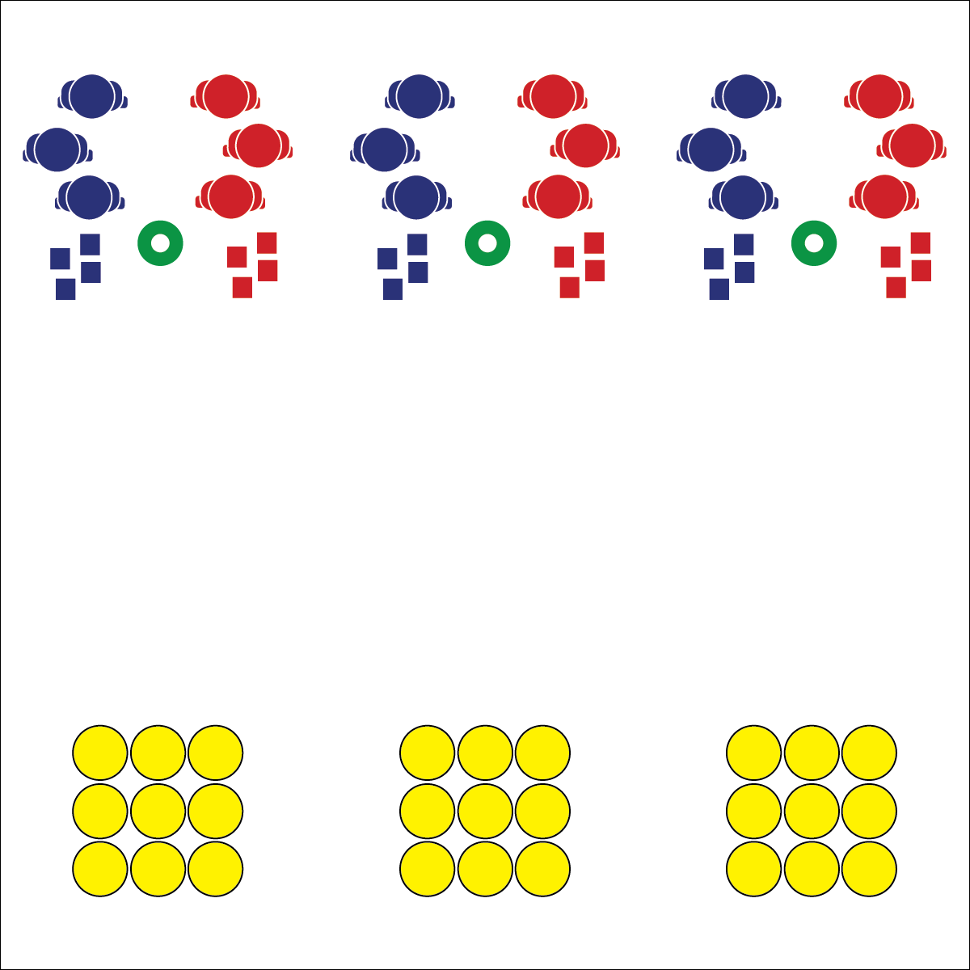

* **Skill:** I will move safely from the starting cone to the game grid.
* **Cognitive:** I will identify and discuss activity-related stress management strategies.
* **Fitness:** I will stay active at a pace that will increase my heart rate into a target zone.
* **Personal & Social Responsibility:** I will use positive communication and encouraging language with my teammates.

**Equipment:**

* 9 spot markers per 2 teams of students
* 4 beanbags of a matching color per team
* 1 low profile cone per 2 teams
* Heart rate zone chart
* Heart rate monitors (HRMs)

**Set-Up:**

1. For each team, place 1 set of 9 spot markers in a 3X3 grid on one end of the activity area.
2. Place 1 low profile cone 10 yards (or more) from the spots as a starting line.
3. Organize 2 teams of 2-4 students at each cone. Each team has a set of 4 bean bags of a matching color, but different than their opponent.
4. Display heart rate zone chart.
5. Distribute HRMs according to class routine.

* Stay Alert While Moving
* Encourage Others
* Have Fun

**Activity Procedures:**

1. Today’s fitness warm-up is called Aerobic Tic-Tac-Toe. The object of the game is for your team use your bean bags to create tic-tac-toe and win the game.
2. On the start signal, the first player on each team will sprint to the game grid and place a bean bag on a spot marker. As soon as the first player returns and gives the second player a high-5, the second player runs with another bean bag and places it strategically on the game grid. Both teams continue in this way until all 8 bean bags are placed on the game grid.
3. After all bean bags are in play, the following players can sprint to the game grid and strategically move 1 bean bag at a time until a team wins, or until you hear the stop signal.
4. If a game is complete before the stop signal sounds, clear the game grid and start a new game.

**Grade Level Progression:**

**L1:** Play the game without HRMs. After teaching HRM usage and heart rate concepts, require students to be in their target zones in order to move to the board and make a strategic play. This will require players waiting in line to remain active.

**L2:** Play the game as a royal court tournament. Teams that win move up, and teams that lose move down. Teams waiting must complete team workouts until the next game grid is available.

**AEROBIC TIC TAC TOE**



* Modify the pace/distance/dimensions of the game to match student abilities.
* Allow students to move to the game grid in pairs. This will allow students requiring assistance to fully participate.



Target Heart Rate, Heart Rate Zone, Pace, Stress Management, Encouragement



* **Standard 3 [H14.L1]** Identifies stress-management strategies (e.g., mental imagery, relaxation techniques, deep breathing, aerobic exercise, meditation) to reduce stress (L1).
* **Standard 3 [H10.L1-L2]** Calculates target heart rate and applies HR information to personal fitness plan (L1); Adjusts pacing to keep heart rate in the target zone, using available technology (e.g., pedometer, heart rate monitor) to self-monitor aerobic intensity (L2).
* **Standard 4 [H3.L1-L2]** Uses communication skills and strategies that promote team/group dynamics (L1); Assumes a leadership role (e.g., task or group leader, referee, coach) in a physical activity setting (L2).



* **DOK** **1:** What is aerobic exercise?
* **DOK 2:** How would you summarize the importance of aerobic exercise as it relates stress management?
* **DOK 3:** How would you describe the physiological response the body has to aerobic exercise as it relates to stress management?
* **DOK 4:** Let’s design a stress management plan that includes a physical activity routine that you enjoy. We’ll identify potentially stressful times (e.g., testing time) in which you could use this plan.



**Help students process content:** Aerobic Tic Tac Toe is an engaging and vigorous physical activity that students enjoy. Oftentimes, it sets a very positive tone for a class and provides an opportunity to talk about positive feelings and the emotional benefits of being physically activity with friends. Use the questions above as a starting point for rich, student-centered discussion. Allow students to talk freely about their experience, transfer their thinking to past activity events, and process the connection between physical activity and good mental and emotional health.

**TABATA INTERVAL STATIONS**

## 

**Equipment:**

* 1 spot marker per student
* 6 cones with task tents (use 6-color set if available)
* Interval Station Cards
* Equipment specific to each station card
* Music with Tabata interval breaks

**Set-Up:**

1. Place cones in a line along one side of the activity area.
2. Place Interval Station Cards in task tents on each cone.
3. Distribute spot markers in a line behind each cone with space for safe movement. Color-coordinate spots with cones if possible.
4. Distribute station equipment at corresponding spots.

* Move Safely
* Rotate Quickly
* Keep Your Pace
* **Skill:** I will adjust exercise intensity in order to work in my target zone.
* **Cognitive:** I will discuss best safety practice in exercise environments.
* **Fitness:** I will increase my heart rate into a target zone.
* **Personal & Social Responsibility:** I will work in self-space with awareness of and respect for others.

**Activity Procedures:**

1. It’s time to try Tabata interval training. This style of HIIT training was adapted from a research study done by Dr. Izumi Tabata from Tokyo, Japan. He studied and found positive effects when individuals completed 8 rounds of 20-second exercise intervals followed by 10-second rest intervals, lasting a total of 4 minutes.
2. To create a 20-minute workout, we’ll complete four separate 4-minute interval cycles with 1 minute of rest in between each cycle.
3. Prepare to begin the exercise designated for your row of spot markers. Start when the music begins. On the signal, stop your exercise and move to the spot to your left. Prepare to start the new exercise and begin on the signal. The station on the far left will move quickly around the circuit to the spots on the far right. After 8 cycles, we’ll rest for 1 full minute.
4. Pace your movement so that you stay in the target heart rate zone.

**Grade Level Progression:**

**L2:** Use several types of activity tracking technology and compare the results of each. Discuss the pros, cons, and accuracy issues of the technology used.



* Change the duration of work and rest intervals.
* Provide modifications at each station, and allow students to work at the level of their choices.



Tabata Interval Training, Perceived Exertion, Personal Challenge, Deliberate Practice



* **Standard 3. [H10.L1 & L2]** Calculates target heart rate and applies HR information to personal fitness plan (L1); Adjusts pacing to keep heart rate in the target zone, using available technology (e.g., pedometer, heart rate monitor) to self-monitor aerobic intensity (L2).
* **Standard 4. [H5.L1]** Applies best practices for participating safely in physical activity, exercise, and dance (e.g., injury prevention, proper alignment, use of equipment, implementation of rules) (L1).



* **DOK 1:** What would you in include on a list about safety in exercise/fitness environments?
* **DOK 2:** How does safety affect the long-term health benefits of exercise?
* **DOK 3:** Can you describe a sequence of safety measures and precautions that one could take in an exercise/fitness environment?
* **DOK 4:** Analyze the consequences of past behavior with respect to safety and exercise. How has that behavior either enhanced or hindered your physical activity experiences? Why?



**Help students elaborate on content:** The debrief question set above requires students to make inferences about the information presented in class as it relates to prior experiences and past behavior. Allow students to explore these inferences through focused discussion, prompting them to give evidence and context to support their thinking.

**TABATA INTERVAL STATIONS**

­­

**PUSH-UP SKI TEAM**



* **Skill:** I will demonstrate proper exercise form and modify exercises as needed.
* **Cognitive:** I will discuss the importance of overload with respect to muscular strength and personal fitness planning.
* **Fitness:** I will increase my heart rate into a target zone.
* **Personal & Social Responsibility:** I will work cooperatively with my partner to collect as many points as possible.

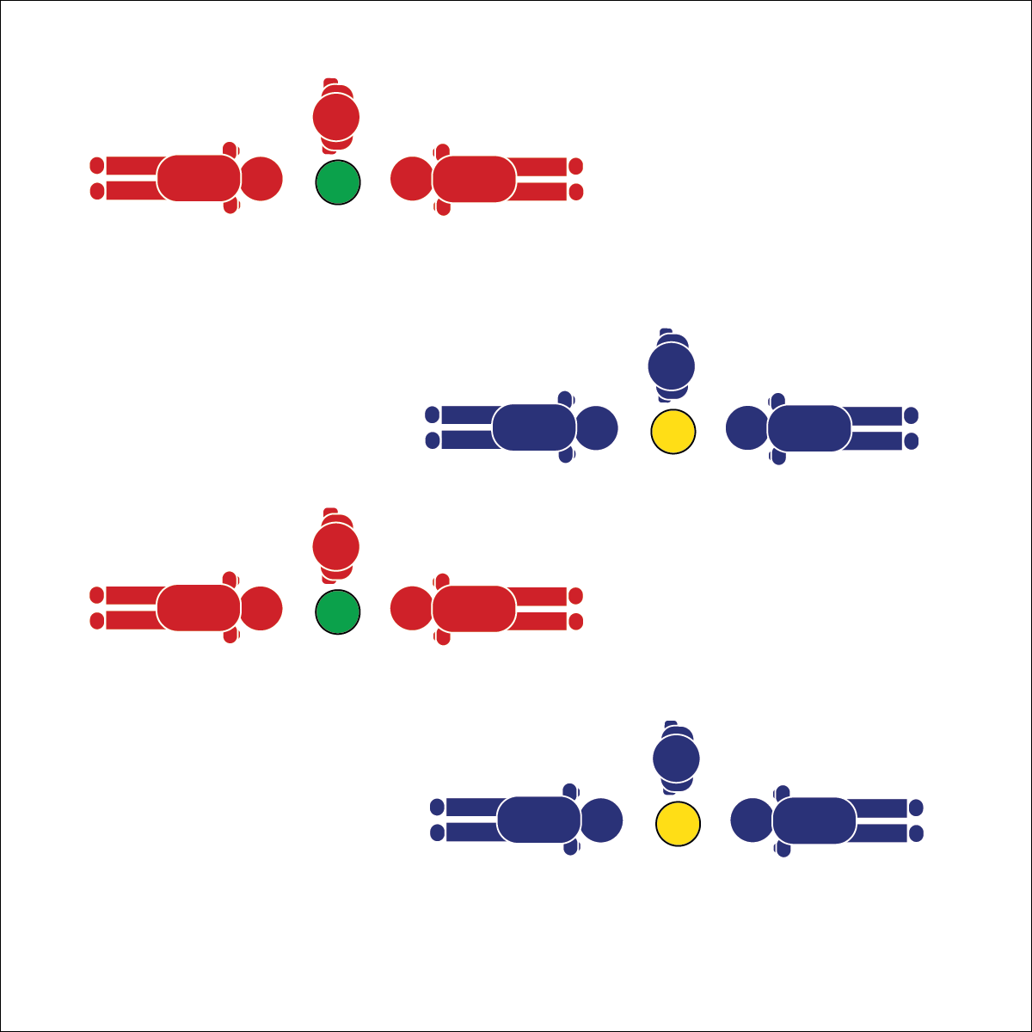

* Work Together
* Pace as a Team
* Modify When Needed

**Equipment:**

* 1 low profile cone per 3 students
* 1 Push-up Ski Team Scorecard per 3 students
* Heart rate zone chart
* Heart rate monitors (HRMs)

**Set-Up:**

1. Scatter spots throughout the activity area with enough room for groups of 3 to move safely.
2. Create teams of 3. Each team at a spot with heart rate monitors and a Push-up Ski Team Scorecard.
3. Display heart rate zone chart.

**Activity Procedures:**

1. Push-up Ski Team is a fitness game designed to develop muscular fitness and cardiorespiratory endurance. You will work in teams of 3 for 1 minute to do as many combined push-ups as possible.
2. Your average heart rate will also be totaled into the score. Keep track of your heart rate data using your heart rate monitor and the Push-up Ski Team Scorecard.
3. Begin with 2 players in push-up position facing each other. (Choose standard or modified push-up position.) The 3rd player is the ski jumper and will stand to one side of the low profile cone that is in the middle of the push-up players.
4. On the signal, the ski jumper will jump over the cone with feet together (2-foot take-off, 2-foot landing). Each time the ski jumper jumps the cone, push-up players do 1 push-up. The team’s ski-jumper must pace her/his jumps so that they push-up players can keep pace with their push-ups.
5. On the stop signal, stand up and rotate positions with a new ski-jumper. We’ll rest for 2 minutes in between rounds while you record your team’s score.
6. Teachers: Prompt students to go from standard push-ups in round 1 to modified push-ups in round 2. Further, some students may have difficulty with standard push-ups. If that’s the case, students can do shoulder taps from plank position. Scorecards encourage students to embrace modification.

**Grade Level Progression:**

**L1:** Utilize a video assessment app to analyze exercise form.

**L2:** Prompt students to adjust pacing during the activity to move from 1 zone to another.

**PUSH-UP SKI TEAM**



* Change the muscular fitness exercise from push-up to another appropriate exercise.
* Allow students to move over or around the cone in a variety of different ways.



Pacing, Teamwork, Muscular Endurance, Muscular Strength, Personal Fitness Plan



* **Standard 3. [H10.L1 & L2]** Calculates target heart rate and applies HR information to personal fitness plan (L1); Adjusts pacing to keep heart rate in the target zone, using available technology (e.g., pedometer, heart rate monitor) to self-monitor aerobic intensity (L2).
* **Standard 4. [H5.L1]** Applies best practices for participating safely in physical activity, exercise, and dance (e.g., injury prevention, proper alignment, use of equipment, implementation of rules) (L1).



* **DOK 1:** What does overload mean with respect to personal fitness?
* **DOK 2:** How would you apply the overload principle in personal fitness planning?
* **DOK 3:** Can you predict the results of a fitness plan that does not include overload?
* **DOK 4:** Using information from the Push-up Ski Team Scorecard, analyze the positive and negative consequences of past strength-building routines. Using that information, develop a muscular fitness plan utilizing the concept of overload.



**Help students revise knowledge:** Students may bring previous knowledge and experiences into physical education that can hinder or even be harmful to the development of a physically active lifestyle. Exercise modifications must be seen as appropriate for everyone, and not a sign of failure or weakness. This activity will challenge students to overload their muscles to the point of fatigue. Monitor student performance carefully and require that exercise modifications be made to ensure that students can continue safely. This will almost certainly require some students to examine and critique their previous understanding of the benefit of exercise modifications.

## 

**Activity Procedures:**

1. It’s time to test our academic language knowledge with a game of Tag Team Scramble. The object of the game is for the fleeing player to avoid being tagged by the tagger. The player waiting to become a tagger will work to complete the puzzle.
2. On the start signal the first player in line will speed-walk into the open space while the second player does 5 jumping jacks. The 3rd player will begin working on the puzzle.
3. When jumping jacks are done, the tagger will speed-walk into the area and try to tag the 1st player. When tagged, the 1st player comes back to the cone and switches with the 3rd player, who then becomes the new tagger. This rotation continues until you hear the stop signal.
4. If a player completes 3 puzzle words before a tag is made, she/he will call out the name of the other players and the team will rotate.
5. If your team completes the puzzle before the game is over, continue playing with the player at the cone doing jumping jacks while waiting.

**Grade Level Progression:**

**L1:** Use a blank Heart Rate Information Guide to help the students practice heart rate computations based on their personal information.

**Equipment:**

* 4 large cones
* 1 low profile cone per team
* 1 Fitness Scramble Puzzle per team

**Set-Up:**

1. Create a large activity area with 4 cones.
2. Place low profile cones on the perimeter of the area to create line-markers for each team.
3. Create teams of 3. Each team behind a low profile cone with a Fitness Scramble Puzzle and a pencil.

**TAG TEAM SCRAMBLE**

* **Skill:** I will demonstrate safe cuts and direction changes in order to flee from the tagger.
* **Cognitive:** I will apply my knowledge of fitness-related academic language in order to solve the scramble puzzles.
* **Fitness:** I will increase my heart rate into a target zone.
* **Personal & Social Responsibility:** I will work hard with a focus on safety.
* Safe Tagging
* Stay Alert
* Rotate Quickly

**TAG TEAM SCRAMBLE**



* Remove the tagging element. Students move into the area to touch as many spot markers or low profile cones as possible, while their teammate completes 3 puzzle words.



Exercise Science, Personal Fitness Plan, Active Lifestyle



* **Standard 2 [H1.L1]** Applies the terminology associated with exercise and participation in selected individual-performance activities, dance, net/wall games, target games, aquatics, and/or outdoor pursuits appropriately (L1).
* **Standard 3. [H10.L1 & L2]** Calculates target heart rate and applies HR information to personal fitness plan (L1); Adjusts pacing to keep heart rate in the target zone, using available technology (e.g., pedometer, heart rate monitor) to self-monitor aerobic intensity (L2).
* **Standard 4. [H5.L1]** Applies best practices for participating safely in physical activity, exercise, and dance (e.g., injury prevention, proper alignment, use of equipment, implementation of rules) (L1).



* **DOK 1:** What is academic language?
* **DOK 2:** How can you use the academic language of fitness to help you become healthy and active for a lifetime?
* **DOK 3:** What facts would you select to support the argument that the academic language of fitness and health is important? Why would you choose those facts?
* **DOK 4:** Using the information learned in physical education class, write a letter to your school board advocating for more quality physical activity opportunities.



**Review content:** This exercise is designed to highlight the cumulative nature of the content learned in this module as well as students’ expanded physical education experience. The importance of a strong vocabulary in all areas of health literacy cannot be overstated. Taking time to review academic language words can help students see the range and depth of what they’ve learned over time.

­­

**CIRCUIT TRAINING**

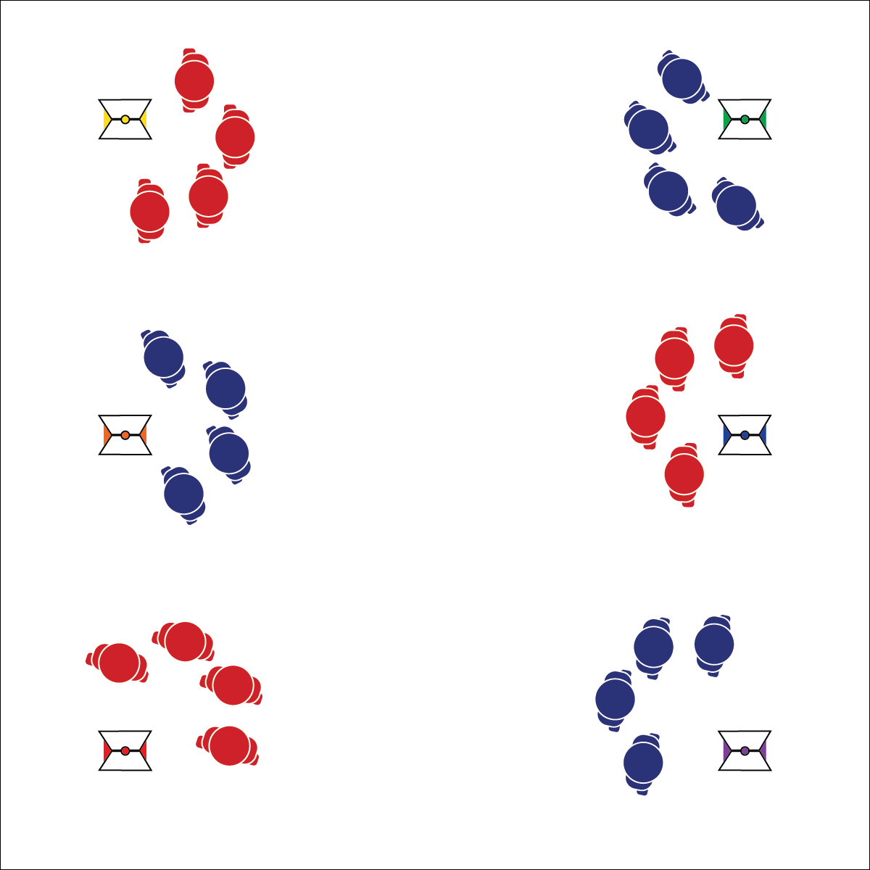

* Focus on Form
* Think Safety
* Work in My Zone
* Encourage Classmates
* **Skill:** I will perform exercises with attention to safety & form.
* **Cognitive:** I will discuss the benefits and challenges of using technology such as heart rate monitors and activity trackers as tools to support an active lifestyle.
* **Fitness:** I will work at a target zone intensity level.
* **Personal & Social Responsibility:** I will use supportive and encouraging language with classmates.

**Equipment:**

* 6 cones (6-color set)
* Task tents
* Station cards
* Fitness equipment to match station cards
* Heart rate monitors (HRMs)

**Set-Up:**

1. Using cones, task tents, station cards, and create a circuit of 6 fitness stations using appropriate station cards. A list of station types/colors are listed in the procedures below.
2. Divide students into 6 equal groups. Send each group to a different station to begin.
3. Distribute HRMs according to class routine.

**Activity Procedures:**

1. Activity Circuit Training is a great way to get a balanced workout with a focus on a variety of fitness components. Today, each group will work through a circuit of fitness stations. Again, your individual target heart rate zone is 60-90% of your maximum heart rate.
2. On the start signal, begin working at your station. After 2 minutes (or another set time), you’ll hear a stop signal letting you know it’s time to rotate. We’ll continue through the circuit, exercising at each station.
3. Focus on good form and safe movement. Be sure to ask if you have any questions about a movement or exercise.
4. Notice that each station is marked with a differently colored cone. Each color represents a component of health- or skill-related fitness. Red is aerobic endurance, orange is muscular fitness, yellow is flexibility, green is skill-related fitness, blue is balance & flexibility, purple is muscular fitness (with equipment).

**Grade Level Progression:**

**L1:** Rotate students as station leaders for their group. Station leaders are responsible for monitoring and providing feedback on exercise form and safety.

**L2:** Rotate an additional student as a station zone leader. Station zone leaders are responsible for pacing and encouraging groupmates to maintain target intensity.

**CIRCUIT TRAINING**



* **Standard 1 [H3.L1-L2]** Demonstrates competency in one or more specialized skills in health-related fitness activities (L1); Demonstrates competency in two or more specialized skills in health-related fitness activities (L2).
* **Standard 3 [H2.L2]** Analyzes and applies technology and social media as tools to support a healthy, active lifestyle (L2).
* **Standard 3 [H10.L1-L2]** Calculates target heart rate and applies HR information to personal fitness plan (L1); Adjusts pacing to keep heart rate in the target zone, using available technology (e.g., pedometer, heart rate monitor) to self-monitor aerobic intensity (L2).



* Complete circuit training workouts without a heart rate component, focusing on exercise form and safety.
* Group students with physical or cognitive limitations with students that are able and willing to assist.
* Provide different activity intensity and/or exercise options, allow students to choose an exercise they can complete safely.



**Help students examine their reasoning:** Many students want the latest technology gadget with little to no evidence that it will improve or enhance their lifestyle. Activity trackers are no different. There’s always a new and improved version just being released. Tiered discussion questions can help students produce and defend their claims and arguments, which in turn can help make their use of fitness technology more thoughtful and purposeful. It will also help to highlight that technology devices on their own are not magical gateways to being healthy and fit.



* **DOK 1:** How would you describe an activity tracker and how is it used in day-to-day life? (Provide the Polar A360 or FitBit as an example.)
* **DOK 2:** How does an activity tracker affect personal habits?
* **DOK 3:** What are the pros and cons of using an activity tracker?
* **DOK 4:** If you were trying to convince someone to buy you an activity tracker, what evidence could you gather to support a persuasive discussion?



Circuit Training, Activity Tracker, Heart Rate Monitor, Active Lifestyle, Support, Encouragement

## 

**Equipment:**

* A variety of fitness equipment
* 1 Creative Mode Fitness Worksheet per group
* 6 Creative Mode Blank Station Cards per group
* Pens or pencils
* Heart rate monitors (HRMs)
* Access to Darebee.com Resources (if possible)

**Set-Up:**

1. Create equipment centers that are neatly organized and easily accessible to students.
2. Divide class into work groups (we suggest groups of 2-4 students)
3. Give each group a Creative Mode Fitness Worksheet and a pen/pencil.
4. Distribute HRMs according to class routine.

* **Skill:** I will perform with proper form all of the exercises included in my Creative Mode Routine.
* **Cognitive:** I will create an exercise routine that is safe and appropriate for all members of my class.
* **Fitness:** I will test my routine to ensure participants will work in their target heart rate zones.
* **Personal & Social Responsibility:** I will analyze the health benefits of the exercises in my Creative Mode Routine.
* Collaborate
* Communicate
* Apply Your Knowledge
* Think Safety

**CREATIVE MODE**

**Activity Procedures:**

1. Now that we’ve experienced Tabata interval stations and circuit training routines, it’s time to work productively as a group to create your own workout.
2. Use the Creative Mode Fitness Worksheet to complete this task. The criteria for your work is listed on the worksheet. Use the equipment provided to experiment and try your routine before you finalize it. Remember, this routine will be performed and evaluated by your classmates. Each workout must move participants into a specified target heart rate zone.
3. If you chose to create a Tabata interval station workout, use the Tabata Interval Station Workout Card to finalize your work. If you chose to create a circuit training routine, use the Creative Mode Station Cards to finalize your work.

**Grade Level Progression:**

**L2:** Students create both Tabata interval stations and circuit training routines with a full analysis of the health benefits of the activities selected.

**CREATIVE MODE**



Creativity, Competence, Personal Fitness, Exercise, Health Benefits, Safety



* **Standard** **1 [H3.L1-L2]** Demonstrates competency in one or more specialized skills in health-related fitness activities (L1); Demonstrates competency in two or more specialized skills in health-related fitness activities (L2).
* **Standard 3 [H9.L1]** Identifies types of strength exercises (isometric, concentric, eccentric) and stretching exercises (static, PNF, dynamic) for personal fitness development (e.g., strength, endurance, range of motion) (L1).
* **Standard 4 [H5.L1]** Applies best practices for participating safely in physical activity, exercise, and dance (e.g., injury prevention, proper alignment, use of equipment, implementation of rules) (L1).
* **Standard 5 [H1.L1]** Analyzes the health benefits of a self-selected physical activity (L1).



* **DOK 1:** How can you recognize exercises that are safe and appropriate for all class members?
* **DOK 2:** How does the type of exercise (FITT) affect its appropriateness in either the Tabata interval or circuit training formats?
* **DOK 3:** How is time (FITT) related to each of these routine formats?
* **DOK 4:** Create an exercise routine for all of your classmates to participate in during an upcoming physical education class.



**Help students process content:** With Creative Mode Routine creation, the physical education classroom shifts toward student-centered learning. Learning groups are required to process and generate conclusions about what they’ve learned in order to produce safe and appropriate exercise routines from which their classmates will benefit. Prompting students to work directly with the content in a real and meaningful way pushes the depth of their understanding further toward cognitive complexity.



* Provide a variety of equipment so that all students can create and experience a routine that is appropriate and challenging.

­­

**SURVIVAL MODE**

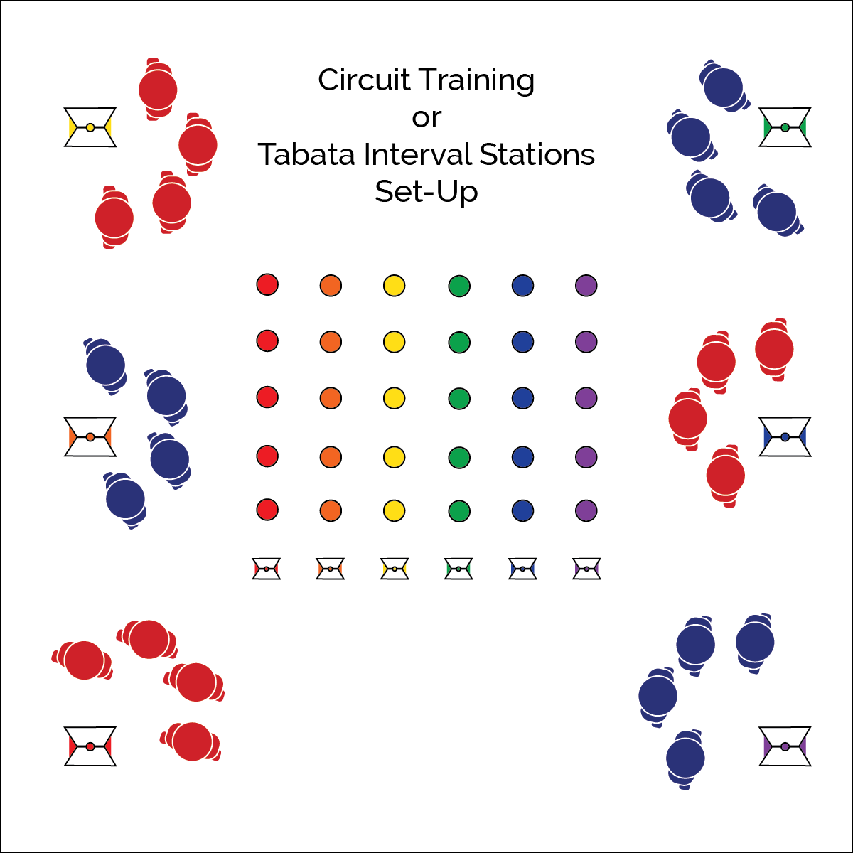

* **Skill:** I will perform with proper form all of the exercises included in the Creative Mode Routines.
* **Cognitive:** I will create a personal Tabata training plan that I can implement at home.
* **Fitness:** I will work in my target heart rate zones.
* **Personal & Social Responsibility:** I will challenge myself during each Creative Mode Routine in an effort to improve my overall fitness.
* Focus on Form
* Pace for Challenge & Success
* Improvement is Success

**Equipment:**

* Student-generated team workout or station cards
* Fitness equipment to match student workouts
* 6 cones (6-color set)
* Task tents
* Perceived Exertion Cards
* Survival Mode Reflection Cards
* Heart rate monitors (HRMs)

**Set-Up:**

1. Create and post schedule of student workouts.
2. Be sure to check student workouts for safety and developmental appropriateness. Suggest modifications when necessary.
3. According to the schedule, allow students time to set up their workout format based on the set-up followed in previous lessons.
4. Distribute HRMs according to class routine.
5. Display Perceived Exertion Cards.

**Activity Procedures:**

1. I’ve looked at and evaluated all of your Creative Mode Workouts and they look amazing!
2. Today we’re going to begin performing the workouts that you’ve created. According to the posted schedule, each group will set up their workout and organize the class to perform the workout.
3. Each workout will be evaluated by 3 main criteria. 1 – Safety and appropriateness; 2 – fitness concepts; 3 – health benefits.
4. At the end of each workout, everyone in the class will log their experience using a Survival Mode Reflection Card.

**Grade Level Progression:**

**L2:** Students complete a personal Tabata training plan with exercise options and a planned schedule that can be implemented away from physical education class.

**SURVIVAL MODE**



Survival, Prevention, Safety, Personal Challenge, Success, Desire



* **DOK 1:** How would you perform a Tabata routine at home?
* **DOK 2:** How would you apply what you’ve learned in physical education class to ensure your Tabata home routines are both safe and effective?
* **DOK 3:** How can you apply the FITT principle to your home Tabata workout plans?
* **DOK 4:** Create a home Tabata routine utilizing skills and concepts previously learned. Include an interpretation of how the routine is an expression of both personal challenge and enjoyment.



* Provide a variety of equipment so that all students can create and experience a routine that is appropriate and challenging.



* **Standard** **1 [H3.L1-L2]** Demonstrates competency in one or more specialized skills in health-related fitness activities (L1); Demonstrates competency in two or more specialized skills in health-related fitness activities (L2).
* **Standard 4 [H5.L1]** Applies best practices for participating safely in physical activity, exercise, and dance (e.g., injury prevention, proper alignment, use of equipment, implementation of rules) (L1).
* **Standard 5 [H1.L1]** Analyzes the health benefits of a self-selected physical activity (L1).
* **Standard 5 [H2.L2]** Chooses an appropriate level of challenge to experience success and desire to participate in a self-selected physical activity (L2).



**Help students record and represent knowledge:** Providing students with an opportunity to create home Tabata routines will allow them the space to represent what they’ve learned and document it in a way that can be meaningful to their personal journey toward a physically active lifestyle. As students begin to think about fitness choices as expressions of personal challenge and accomplishment, encourage their creativity and help them refine their activity choices with consideration for safety and lifetime enjoyment.