­­­

* FITT [Frequency, Intensity, Time, Type]
* Heart Rate Monitor
* Heart Rate Zone
* Target Heart Rate
* Safety

­

* **Skill:** I will demonstrate fitness activities with proper form and attention to safety.
* **Cognitive:** I will answer questions related to fitness concepts.
* **Fitness:** I will pace my activity so that I work within the targeted Heart Rate Zone.
* **Personal & Social Responsibility:** I will work cooperatively with my teammates.
* **Standard 1 [H3.L1]** Demonstrates competency in one or more specialized skills in health-related fitness activities (L1).
* **Standard 3 [H10.L1&2]** Calculates target heart rate and applies HR information to personal fitness plan (L1); Adjusts pacing to keep heart rate in the target zone, using available technology (e.g., pedometer, heart rate monitor) to self-monitor aerobic intensity (L2).
* Team RPS Score Card
* Health-Related Jigsaw Cognitive Challenges

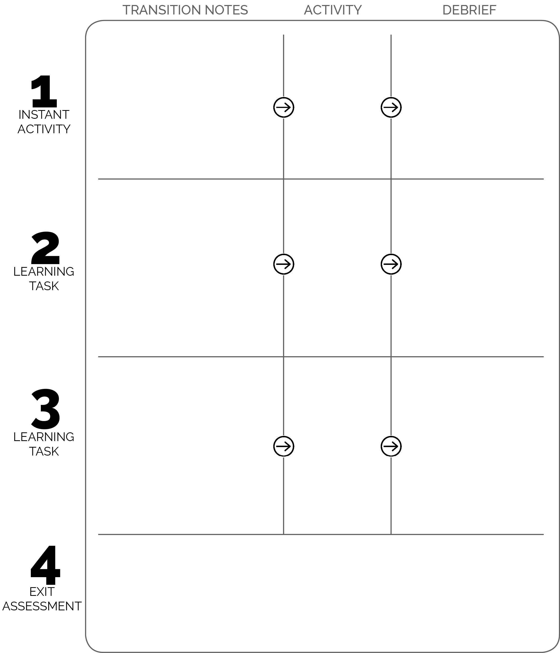

**DOK 1:** What would you include on a list about the FITT Principle?

**DOK 2:** How does exercise intensity apply to Team FITT RPS?

**DOK 3:** How would you adapt this activity to make it more intense? Less intense?

Students complete and turn in their Cognitive Challenge lists as an exit slip.

Students walk a cool-down lap and then gather as a group. Discuss their responses to the Cognitive Challenge.

Cool-Down Lap and Puzzle Completion

Complete and discuss the cognitive challenges provided on the puzzle.

**DOK 1**: What would you include on a list of local community resources that can help you maintain a healthy lifestyle?

**DOK 2:** Pick 1 resource and tell the class all that you know about it.

Fitness Concept Jigsaw

Students break into groups and prepare to participate in the Fitness Concept Jigsaw activity.

Team FITT RPS

Students enter the activity area to see a discussion prompt: Tell a partner all that you know about the FITT Principle. When the majority of students arrive, begin the Team FITT RPS Activity.