­­

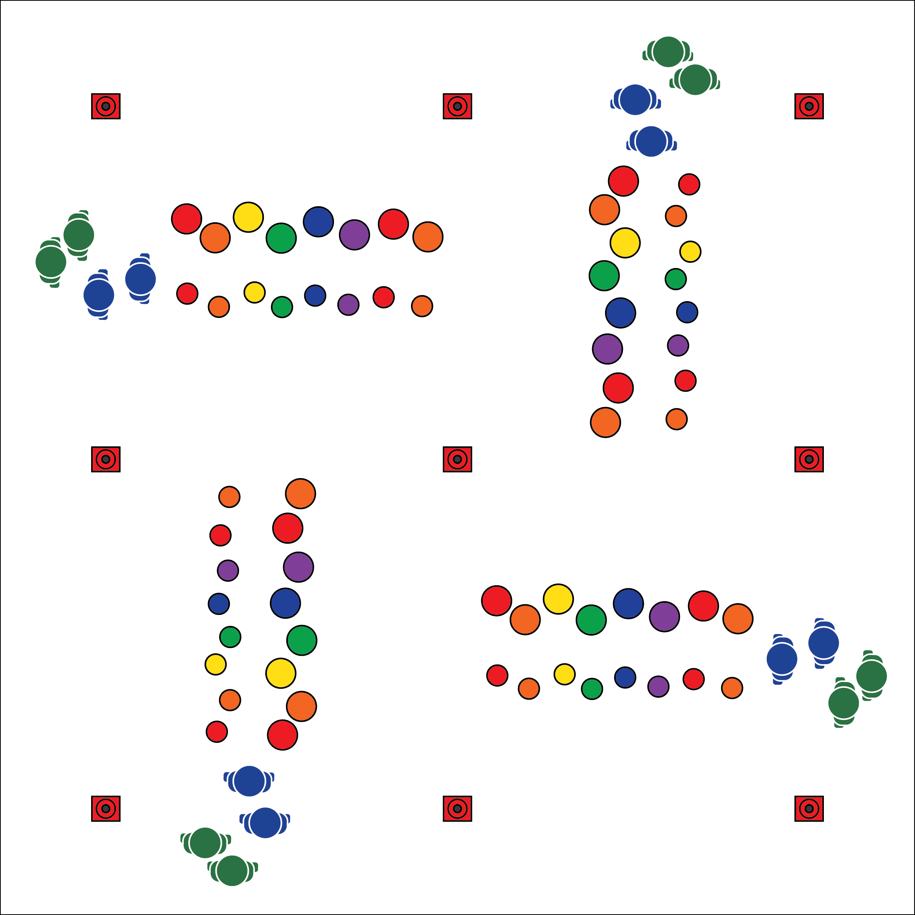

**Equipment:**

* 50 (or more) 5-inch spot markers per 15 students
* 50 (or more) 10-inch spot markers per 15 students
* Cones to mark area boundaries
* 1 blindfold per 4 students
* 3 long jump ropes per 4 students

**Set-Up:**

1. Create a grid with 4 to 6 activity areas (depending on number of students).
2. Use spot markers to create 2 close parallel lines across each area: 1 line of smaller spots for hands, another line of larger spots for feet. (Use floor tape or painter's tape if you don’t have enough spot markers.)
3. Create groups of 2 to 6 students. 1 group per activity area.

* **Skill:** I will demonstrate coordination while applying movement skills.
* **Cognitive:** I will discuss the role of communication in cooperative activities.
* **Fitness:** I will actively engage with classmates in Urban Plane Climbing.
* **Personal & Social Responsibility:** I will demonstrate focus by working with classmates to successfully complete the Birth of Sky challenges.
* Use Positive Communication
* Demonstrate Teamwork
* Be Respectful to Others

**BIRTH OF SKY**

**Activity Procedures:**

1. Activity This is the Birth of Sky Challenge. It will be our mode of transportation to each of the other OPEN 8 Adventure Challenges. You’ll flex and extend your muscles as you climb across the gym, using the spots as hand and foot holds. The object is for all students to move safety through the sky, using the holds to reach the other side.
2. **Practice Challenge:** Students use hands on small spots and feet on large spots while traversing.
3. **Intermediate Challenges:** 1) One student guides a blindfolded partner as they walk upright through the urban climbing plane; 2) One partner guides a blindfolded partner across the sky using hands/feet on spots.
4. **Advanced Cooperative Challenges:** 1) Teams of 2-4 students move together while connected with a soft jump rope. All team members must touch only the poly spots; 2) Students design their own climbing routes with spot markers/floor tape. Designs must work to improve muscular strength and endurance.

**Grade Level Progression:**

**6:** Practice challenge only.

**7:** Practice challenge and intermediate challenge.

**8:** Complete all challenges across 2 classes; students design challenges for day 2.

**BIRTH OF SKY**



* **DOK** **1:** What does positive communication sound like? look like?
* **DOK 2:** How can communication (both positive and negative) affect a cooperative performance?
* **DOK 3:** How is positive communication related to respect?
* **DOK 1:** What is coordination?
* **DOK 2:** How would you summarize the way coordination relates to climbing/traversing?
* **DOK 3:** How would you adapt the Birth of Sky challenge to help further develop coordination?



* **Standard 3 [M5.6-7]:** Participates in a variety of lifetime recreational team sports, outdoor pursuits, or dance activities (6); Participates in a variety of lifetime dual and individual sports, martial arts, or aquatic activities (7).
* **Standard 4 [M5.6-8]:** Cooperates with a small group of classmates during adventure activities, game play or team-building activities (6); Problem-solves with a small group of classmates during adventure activities, small-group initiatives or game play (7); Cooperates with multiple classmates on problem-solving initiatives including adventure activities, large-group initiatives and game play (8).



Challenging, Cooperate, Grit, Respect, Teamwork, Traverse



* **Adaptation:** Place spots/tape on a horizontal wall. Students use their hands to move from one side of the course to the other. Add sequential numbers to the spots to increase the difficulty.
* **Extension:** Allow the group to use nonverbal communication only.



**Organize students to interact with content:** The “Birth of Sky” activity challenges students to manipulate their body in a non-traditional environment. Most students have played traditional recreation games such as twister and party dances, but what happens when students are exposed to outdoor adventure activities? Will they be prepared to be physically literate in an outdoor environment? This activity allows them to apply skills taught in the physical education classroom to real-world, lifetime activity settings.