­­

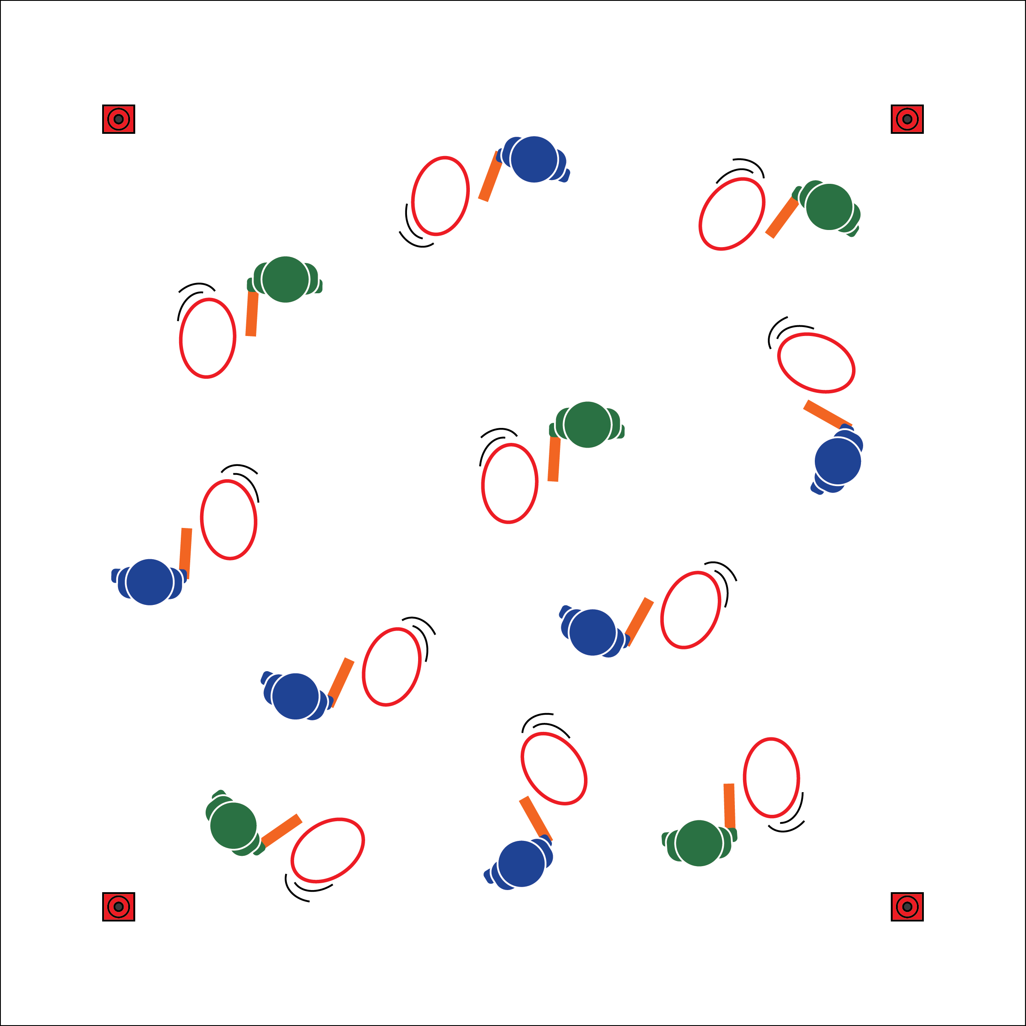

**Equipment:**

* 1 Hula Hoop per student
* 1 two-foot foam noodle per student
* 4 large cones to create boundaries
* 2 half-cones per group to create relay lines
* A variety of obstacles (e.g., cones, pins, ropes)
* One pinnie or colored wrist band per student
* Fitness Challenge Posters

**Set-Up:**

1. Create a large activity area using cones.
2. Each student with a hoop and a foam noodle.
3. Post or project the Emerging Force Fitness Challenges on a wall.
4. Use additional equipment as described in each challenge.

**Activity Procedures:**

1. Today’s activity is called Emerging Force. We are traveling to Africa to continue The OPEN 8 Adventure Challenge. These challenges are adaptations of traditional African hoop-rolling games.
2. We will begin with all students practicing their Hoop Rolling techniques. On the start signal, use your stick (foam noodle) to safety complete the challenge. If your hoop falls or is out of control, stop & restart.
3. **Practice:** 1) Forward roll to stop; 2) Forward w/direction changes; 3) Forward, stop, then backward.
4. **Individual Challenges:** 1) Longest roll: keep your hoop rolling through space for as long as you can. When hoop stops/falls, move to sidelines and complete a fitness challenge. 2) Hoop tag: choose 3 to 5 taggers. Taggers use a stick (noodle) to tap other hoops to make them fall. If tagged, move to the side, complete a fitness challenge, then return.
5. **Team Challenges:** 1) Hoop-rolling relays: teams in relay lines with 2 cones set up. Be the first team to roll all hoops to the cone and back in relay format. If a hoop drops or is out of control, stop, regain control, then continue. 2) Team longest roll with obstacles: as individuals, roll your hoop while navigating obstacles (e.g., cones, pins). If hoop drops or goes out of bounds, walk the perimeter while watching the game. The challenge is over when 1 team remains. 3) Team hoop hackers: format is the same as the longest roll challenge, but players use their hoops/noodles to disrupt other hoops. If your hoop drops or goes out of bounds, walk the perimeter while watching the game. Continue until 1 team remains.

**Grade Level Progression:**

**6:** Practice & individual challenges. **7:** All individual & 1 team challenge. **8:** All challenges.

* Appropriate Force
* Move to Open Space
* Travel Safely
* **Skill:** I will demonstrate control while striking the hoop.
* **Cognitive:** I will discuss striking as a skill used in lifelong physical activities.
* **Fitness:** I will actively engage in Hoop Rolling challenges.
* **Personal & Social Responsibility:** I will demonstrate focus by working with classmates to successfully complete all Emerging Force challenges.

**EMERGING FORCE**

**EMERGING FORCE**



* **Adaptation:** Allow students to use a hand, rather than a noodle, to control the hoop.
* **Extension:** Allow students to create their own challenges with the equipment and skills used in class.

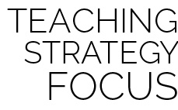

* **DOK 1:** What is striking?
* **DOK 2:** What physical activities require skilled striking? Which of those activities could you play throughout your lifetime?
* **DOK 3:** How is hand-eye coordination related to success when striking and rolling the hula hoop?
* **DOK 1:** What is a cultural experience?
* **DOK 2:** How would you compare/contrast Hoop Rolling from Africa to games that come from American cultures?
* **DOK 3:** How is enjoyment related to cultural activities? Explain your answer.

**Help students examine similarities and differences:** Physical activity for personal and social enjoyment is found in most cultures across the globe. Prompting students to compare, classify, and draw conclusions as they examine physical activity from a cultural perspective can allow them to deepen their thinking and respect all people living in an increasingly global society.



Culture, Force, General Space, Locomotor, Manipulative Skill, Striking



* **Standard** **1 [M6.6-8]:** Performs pivots, fakes, and jab steps designed to create open space during practice tasks (6); Executes at least one of the following designed to create open space during small-sided game play: pivots, fakes, jab steps (7); Executes at least two of the following to create open space during modified game play: pivots, fakes, jab steps, screens (8).
* **Standard 2 [M1.6-8]:** Creates open space by using locomotor movements in combination with movement (e.g., varying pathways; change of speed, direction, or pace) (6); Reduces open space by using locomotor movements (e.g., walking, running, jumping & landing, changing size and shape of the body) in combination with movement concepts (e.g., reducing the angle in the space, reducing distance between player and goal) (7); Opens and closes space during small-sided game play by combining locomotor movements with movement concepts (8).
* **Standard 5 [M4.6-8]** Describes how moving competently in a physical activity setting creates enjoyment (6); Identifies why self-selected physical activities create enjoyment (7); Discusses how enjoyment could be increased in self-selected physical activities (8).