­­

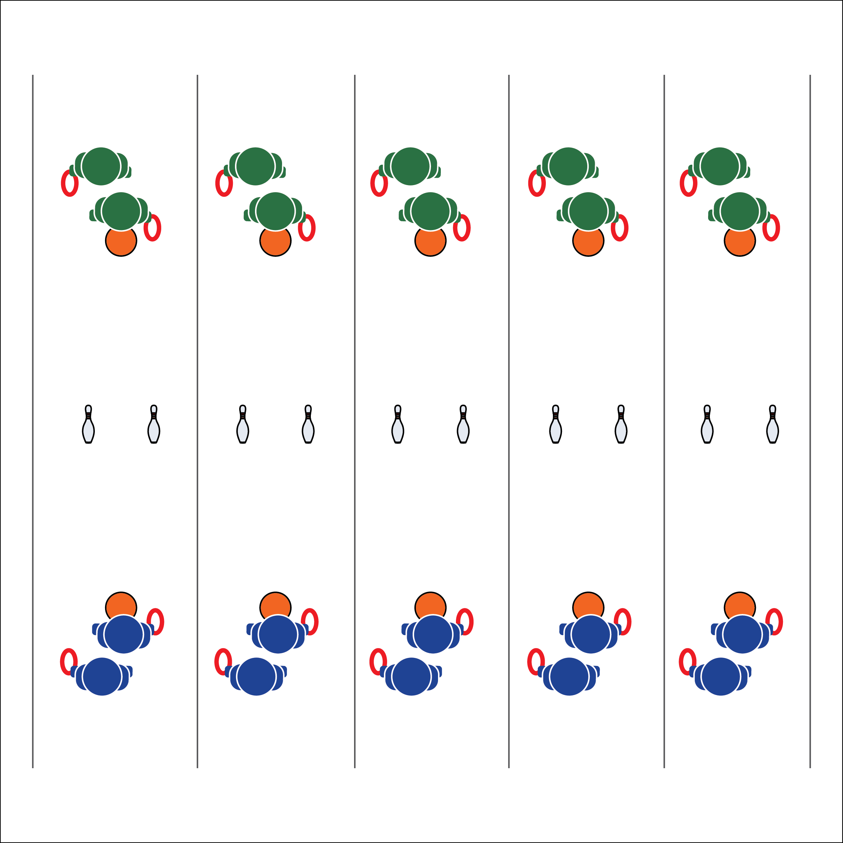

**LIFE OF WATER**

* **Skill:** I will demonstrate hand-eye coordination while rolling the deck ring.
* **Cognitive:** I will discuss the importance of preserving culture through physical activity.
* **Fitness:** I will actively engage with classmates in a cultural game called *Ulu Maika* (Hawaii).
* **Personal & Social Responsibility:** I will demonstrate focus by working with classmates to successful complete the Life of Water challenge.
* Face to Target
* Arm Back
* Step with Opposite Foot
* Release & Follow Through

**Equipment:**

* 2 deck rings or small balls per 2 students
* 2 bowling pins (or cones) per 2 students
* 4 spot markers per 2 students

**Set-Up:**

1. Create 1 playing court for every 4 students. Each court should have 2 bowling pins in the middle of the area, about 6-12 inches apart (depending skill level).
2. Place two poly spots 25-30 feet away from both sides of each cone.
3. Divide the class into pairs. Two pairs per court.

**Activity Procedures:**

1. This is the Life of Water challenge. We are in Hawaii to continue The OPEN 8 Adventure Challenge by playing a traditional Hawaiian game called *Ulu Maika*. It was played during the Makahiki celebration honoring Lono, the god of rain.
2. The object of the activity is to roll a deck ring between the 2 pins without touching either of them. The game was traditionally played with a stone disc.
3. Teams of 2 stand on opposite sides of the court. Each student with 1 deck ring.
4. Teams take turns trying to roll the deck ring between the 2 pins. Teams receive 1 point for every ring that rolls through the pins.
5. The team that scores 21 points first is the Big Kahuna.

**Grade Level Progression:**

**6:** Play the game with no modifications.

**7:** Students can use both underhand rolling or a modified Frisbee toss with the ring sliding across the floor. If successful with a “Frisbee toss,” the throw counts as 2 points.

**8:** Allow students to modify the activity with a new piece of equipment. For example, use a hockey stick to push the ring through the bowling pins for 1 point.

**LIFE OF WATER**



Accurate, Challenging, Cooperate, Culture, Persevere



* **Standard 1 [M18.6-8]:** Executes consistently (70% of the time) a mature underhand pattern for target games such as bowling, bocce, or horseshoes (6-7); Performs consistently (70% of the time) a mature underhand pattern with accuracy and control for one target game such as bowling or bocce (8).
* **Standard 2 [M9.6-8]:** Selects appropriate shot/club based on location of the object in relation to the target (6); Varies the speed and/or trajectory of the shot based on location of the object in relation to the target (7); Varies the speed, force, and trajectory of the shot based on location of the object in relation to the target (8).
* **Standard 5 [M5.6-9]** Identifies how self-expression and physical activity are related (6); Explains the relationship between self-expression and lifelong enjoyment through physical activity (7); Identifies and participates in an enjoyable activity that prompts individual self-expression (8).



* **DOK 1:** What does the word culture mean?
* **DOK 2:** What do you know about the different cultures that can be found in different areas of the United States? North America? The world?
* **DOK 3:** How is physical activity and sport related to culture?
* **DOK 4:** Create a series of interview questions that you might ask a native Hawaiian about the game *Ulu Maika*.

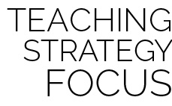

**Help students engage in cognitively complex tasks:** Prompt students to think abstractly by connecting their game-play experience to the larger concept of a global community. As students create interview questions that they might as a native Hawaiian they must apply this abstract process in a way that creates a cognitively complex environment.



* **Adaptation:** Play with larger balls and/or a wider distance between the bowling pins.
* **Extension:** Allow the students to pick their tossing equipment before attempting the challenge.