­­

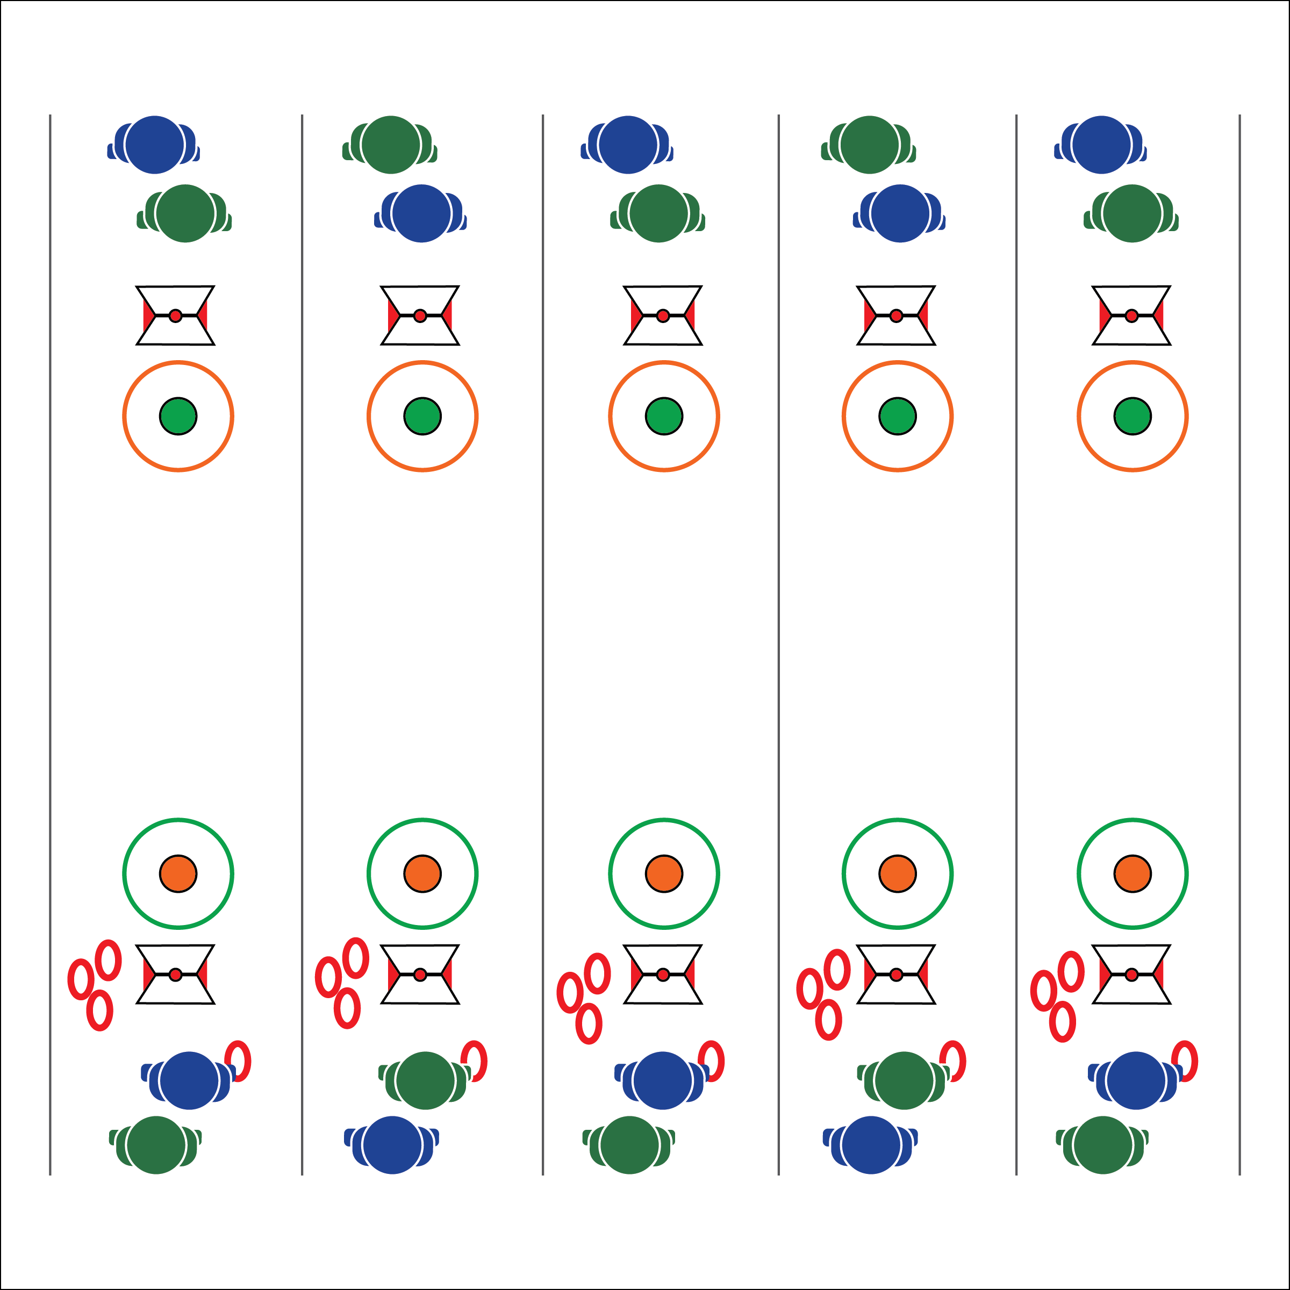

**Equipment:**

* 2 spot markers per group of 4 students
* 2 hula hoops per group of 4 students
* 4 deck rings per group of 4 students
* 1 Life of Wind Exercise Card per 2 students

**Set-Up:**

1. Create 1 playing court for every 4 students. Each court with 2 hoops, 20-40 feet apart (depending on space/skill), and a spot marker in the center of each hoop.
2. Place 4 deck rings at each court.
3. Place 2 Life of Wind Exercise Cards at each court (1 at each end of the court).
4. Divide the class into pairs. 2 pairs per court.

* **Skill:** I will demonstrate hand-eye coordination while tossing.
* **Cognitive:** I will discuss the important connection between social interaction and physical activity.
* **Fitness:** I will actively engage with classmates in cultural game called *Quoits (Greece)*.
* **Personal & Social Responsibility:** I will demonstrate focus by working to complete the Life of Wind challenge.
* Eyes on Target
* Proper Form
* Good Sportsmanship

**Activity Procedures:**

1. This is the Life of Wind Challenge. We’ve landed on the Island of Wight in the English Channel. There are ancient records of Roman occupiers in the British Isles playing an ancient game called Quoits. It’s the earliest known version of Horseshoes.
2. The object is to use proper underhand throwing form to place the ring nearest to the spot marker. Traditionally, the game is played with a stake in the ground.
3. If 1 ring is closest to the spot, 1 point is scored. If 2 rings are closest to the spot, 2 points are scored. The game is played to 21 points.
4. In order to “bank” the points scored, the team with the rings closest to the spot must complete 1 Life of Wind Exercise Challenge.
5. Play Rock, Paper, Scissors to determine which team is first. A member of each team alternates throws from 1 side. After points are scored, players on the other side have a turn.
6. Remind students the importance of safety while throwing and of watching others throw. Students stand 5-10 feet to the side of the spot while watching the activity.

**Grade Level Progression:**

**6:** Play the game as described above.

**7 & 8:** Score only the rings that land on the spot marker or within the hula hoop.

**LIFE OF WIND**

**LIFE OF WIND**



Accurate, Encouragement, Respect, Social Interaction



* **Standard 1 [M18.6-8]:** Executes consistently (70% of the time) a mature underhand pattern for target games such as bowling, bocce, or horseshoes (6-7); Performs consistently (70% of the time) a mature underhand pattern with accuracy and control for one target game such as bowling or bocce (8).
* **Standard 2 [M9.6-8]:** Selects appropriate shot/club based on location of the object in relation to the target (6); Varies the speed and/or trajectory of the shot based on location of the object in relation to the target (7); Varies the speed, force, and trajectory of the shot based on location of the object in relation to the target (8).
* **Standard 5 [M6.6-8]** Demonstrates respect for self and others in activities and games by following the rules, encouraging others and playing within the spirit of the game or activity (6); Demonstrates the importance of social interaction by helping and encouraging others, avoiding trash talk and providing support to classmates (7); Demonstrates respect for self by asking for help and helping others in various physical activities (8).



* **DOK 1:** How would you describe encouragement in a physical activity setting? How would you describe respect?
* **DOK 2:** What did you notice about the social interactions that took place during our game play today?
* **DOK 3:** How are encouragement and respect related to social interaction?
* **DOK 4:** Can we identify any areas that need improvement with respect to our class social interaction? Let’s create a plan for improving those areas.

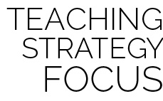

**Help students elaborate on content:** After asking students what they noticed about the class social interactions, challenge them to provide evidence and support for their claims. Allowing students to respond with one or two work answers does not help to extend their thinking beyond a surface reply. Ask probing questions and work to develop their ability to draw inferences from their personal experiences as well as from the experiences of their classmates.



* **Adaptation:** Modify the distance and size of the target to meet the needs of each student. Deck rings can be replaced with bean bags.
* **Extension:** Add cross-curricular lesson components, integrating geography, history, language arts, and science (Laws of Motion or Physiology). This could be co-taught with science teachers.